**FIN F414**

**FINANCIAL RISK ANALYTICS AND MANAGEMENT**

**BITS PILANI, HYDERABAD CAMPUS**



**REPORT**

**List of companies:**

SAKSOFT, SHOPERSTOP, STEELXIND, TCS, TVSSRICHAK, VISAKAIND

**ACKNOWLEDGEMENT**

We want to extend our sincere appreciation to Prof. Nagaraju Thota for granting us this valuable chance to work on this project and for dedicating his precious time to offer essential guidance whenever needed. His insights played a pivotal role in the success of the project. We express gratitude for providing us with this excellent opportunity to apply our academic knowledge to real-life data, gaining practical experience in the process. We are truly grateful for all the assistance he extended to us during the course assignment.

**ABSTRACT**

This project explores the integration of financial models, including the Capital Asset Pricing Model (CAPM), AutoRegressive Integrated Moving Average (ARIMA), Generalized Autoregressive Conditional Heteroskedasticity (GARCH), Exponential GARCH (EGARCH), and Value at Risk (VaR) to analyze and forecast the financial performance and risk of SakSoft Ltd, Shoppers Stop, Steel Exchange India Ltd, TCS Ltd, TVS Srichakra Ltd, Visaka Industries Ltd .

**Table of Contents**

**Acknowledgements** 1

**Abstract** 2

**SakSoft Ltd** 6

Introduction to SAKSOFT Ltd.7

SakSoft : Daily Returns

SakSoft : Weekly Returns18

SakSoft : Monthly Returns28

**Shoppers Stop** 3**7**

Introduction to SHOPERSTOP Ltd. 37

Shoppers Stop : Daily Returns38

Shoppers Stop : Weekly Returns48

Shoppers Stop : Monthly Returns57

**Steel Exchange India Ltd** 66

Introduction to STEELXIND Ltd.67

STEELXIND: Daily Returns68

STEELXIND : Weekly Returns79

STEELXIND : Monthly Returns90

**TCS Ltd** 101

Introduction to TCS Ltd102

TCS : Daily Returns103

TCS : Weekly Returns114

TCS : Monthly Returns124

**TVS Srichakra Ltd** 133

Introduction to TVSSRICHAK Ltd134

TVSSRICHAK : Daily Returns135

TVSSRICHAK : Weekly Returns146

TVSSRICHAK : Monthly Returns156

**Visaka Industries Ltd** 165

Introduction to VISAKAIND Ltd. 166

VISAKAIND : Daily Returns168

VISAKAIND : Weekly Returns178

VISAKAIND : Monthly Returns188

**Value at Risk(VaR)** 198

**Conclusions** 200

**References** 201



**About SakSoft Ltd.**

SakSoft is a prominent operator in the IT services and solutions industry. SakSoft, which was founded in 2000, has made a name for itself in the cutthroat world of technology-driven companies. SakSoft is a privately held firm committed to providing innovative software solutions that enable businesses to prosper in the digital age.

SakSoft was founded by Late Shri Autar Krishna, a visionary leader who saw the growing demand for creative and scalable IT solutions. The company was founded with the intention of tackling the constantly changing technological landscape's issues. Since then, SakSoft has become a reliable partner for businesses operating in the Fintech, Healthtech, Logistics & Transportation, and Utilities domains.

The overall greatness of SakSoft lies not only in its technological prowess but also in its client-centric approach. SakSoft has consistently demonstrated a deep understanding of client needs, providing tailor-made solutions that drive business success. The company's portfolio spans a wide range of industries, showcasing its versatility and ability to meet the unique demands of diverse sectors.

SakSoft's commitment to excellence extends beyond its products and services. The company places a strong emphasis on ethical business practices, fostering long-term relationships with clients and partners. With a focus on continuous innovation, SakSoft remains at the forefront of technological advancements, ensuring that its clients always have a competitive edge in the digital landscape.

In conclusion, SakSoft stands as a testament to the power of innovation and adaptability. With a strong foundation laid in [year], the company continues to push boundaries, providing transformative IT solutions that propel businesses toward sustained success in the fast-paced world of technology.

# **SECTION 2: SAKSOFT(Daily Returns)**

The CAPM model is defined as:

E(R) = Rf + Beta(Rm-Rf)

where,

E(R): Expected return of the firm

Rf: Risk free rate

Rm: Returns of the market

Beta is calculated by regressing expected returns of the stock i.e., SAKSOFT on Market Risk Premium (Rm-Rf). It is the slope parameter that is evaluated from the regression model.

The beta is a measure of how sensitive the security is to the changes in the market index. For index portfolio National Stock Exchange (NSE) was taken into consideration.

For example, a beta of 1.5 means that our portfolio is 50% more sensitive when compared with market index.

**2.1 CAPM Model - Estimating the Beta of the Company**

Figure 3 shows the daily returns of the SAKSOFT stock price from 2nd November 2020 to 25th October 2023, and the CLOSING prices were used to calculate the returns, which are shown in Figure 1.

*Figure 3: Daily Returns of SAKSOFT*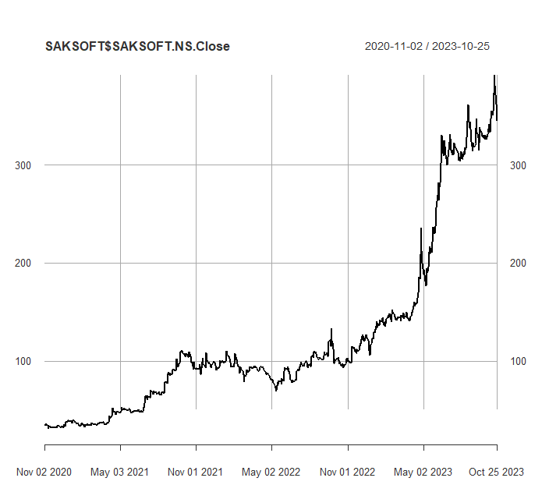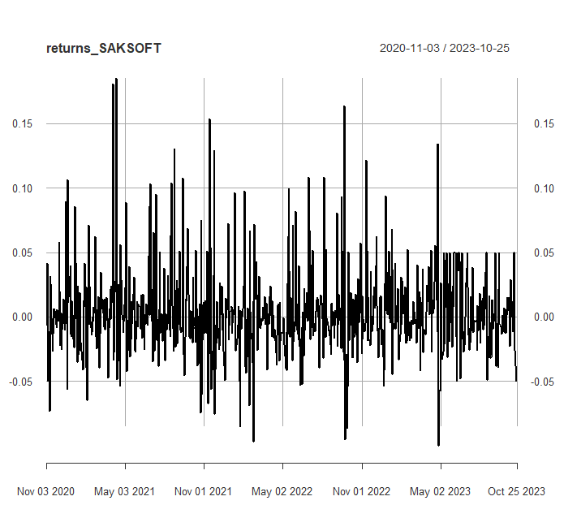

Next, the excess returns, denoted as E(R) - R_f, are subjected to regression against the market risk premium R_m - R_f. The outcomes of this regression are illustrated in Figure 3

*Figure 4: Regression results of CAPM for Daily Returns*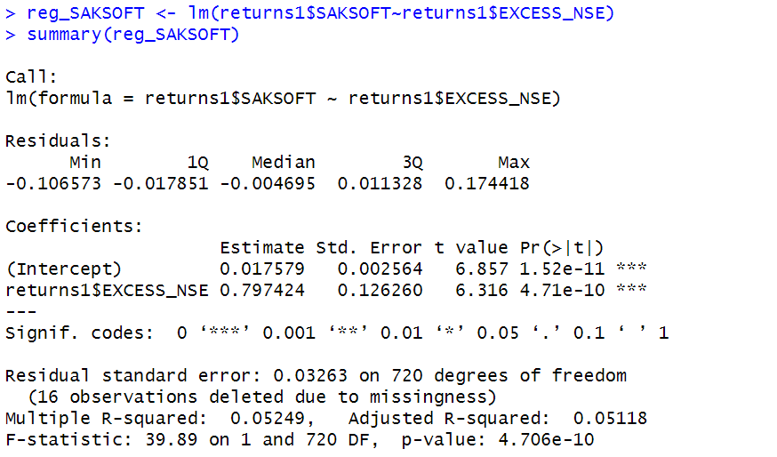

**2.1.1 CAPM Model - Interpretation of Results**

Figure 4 shows that the Beta for daily returns (risk unadjusted) is 0.797424, which means that if the market index portfolio’s daily returns rise by 1%, then the daily returns of SAKSOFT will increase by 0.7%. Moreover, the beta value is statistically significant at both the 95% and 99% confidence levels, given that the p-value is less than 0.01 (p < 0.01).

The intercept value derived from the regression is 0.017579 which means that if the market return is 0%, then SAKSOFT will show a 0.017579% return.

**2.2 Estimating AR and MA coefficients using ARIMA**

The AR and MA coefficients are obtained using the ACF (Auto-correlation function) and PACF (Partial Auto-correlation function) plots. From Figure 2 it can be seen that stock price data is non-stationary while from Figure 3 we can interpret that the returns of the stock seem to be stationary of integrated or order 1 which means first difference is stationary.

**2.2.1 Augmented Dickey-Fuller Test**

An augmented Dickey-Fuller (ADF) test is performed to check for stationarity, whose results are in Figure 6.

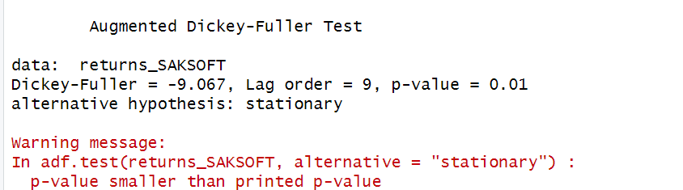

*Figure 6: ADF Test Results for Daily Returns*

The Augmented Dickey-Fuller test null hypothesis states that a unit root exists, i.e. the series is not-stationary, and the corresponding alternative hypothesis is that the series is stationary. Since the p-value of the test shown above is 0.01, the null hypothesis can be rejected; thus, the series is stationary.The value of ADF Test-statistic: -9.067.

**2.2.2 ACF Plot**

The sample Autocorrelation function (ACF) plot is used measure the correlation between the present and the lagged values in the series. Lagged values means the past values of the series. Figure 7 shows the formula for calculating ACF at lag k:

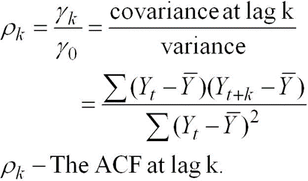

*Figure 7: ACF Formula*

The results for of ACF plot for SAKSOFT are depicted in Figure 8:

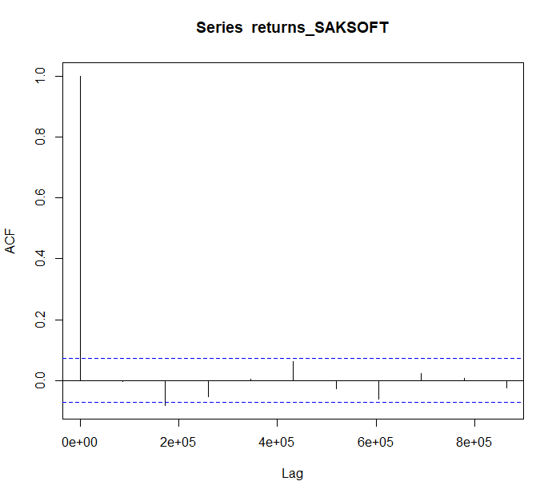

*Figure 8: ACF Plot SAKSOFTfor Daily Returns*

From the above plot it can derived that the series is MA(0) model since no lag term except the 0th lag is significant,following values are not significant.

**2.2.3 PACF Plot**

It measures the correlation between an observation k periods ago and the current observation after controlling the observations at intermediate lags i.e., all the lags which are less than k. PACF plots are used to differentiate between AR & ARMA process. Figure 9 shows the formula for calculating PACF:

*Figure 9: PACF Formula*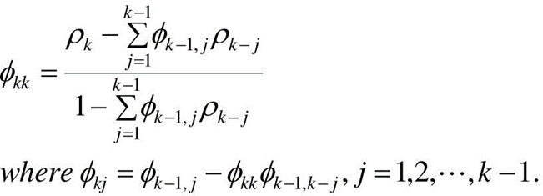

The results of PACF plot for SAKSOFT are depicted in Figure 10:

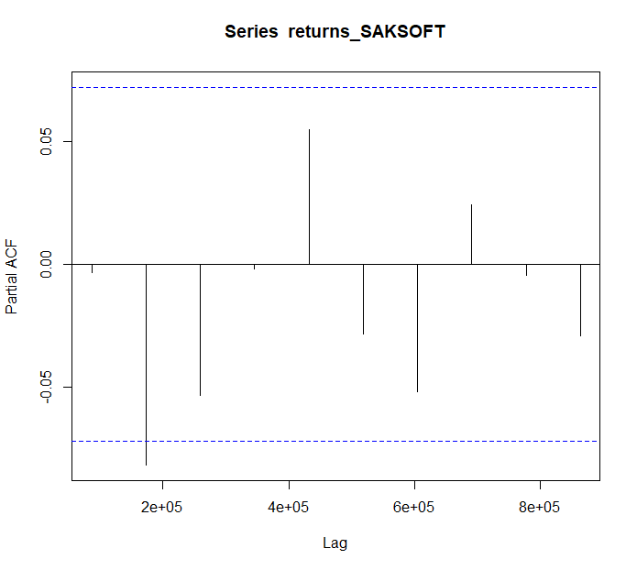

*Figure 10: PACF Plot* SAKSOFT *for Daily Return*

From the above plot it can derived that the series is AR(1) model since only one lag is significant.

**2.2.4 Identification and interpretation of ARIMA model:**

The diagnostic test of the model is shown in Figure.

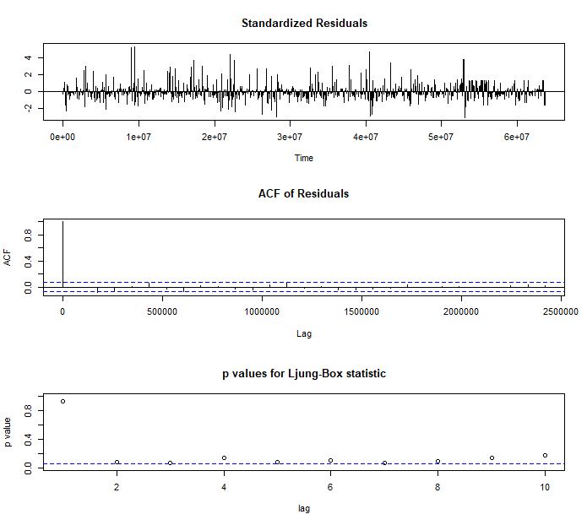

*Figure 11: Diagnostic Results for Daily Returns*

Ljung-Box Test is used for testing the distribution of residuals. Its null hypothesis is that the residuals are independently distributed while alternative hypothesis states that residuals are not independently residuals. From Figure 11(Chart 3) it can be seen that almost all p-values are greater than 0.05 which means that we can’t reject the null hypothesis i.e., residuals are distributed independently. The normalised residuals time series plot looks to be random and does not show a strong trend, therefore it fits the data well. Also, the Residual autocorrelations are all zero except for one spike.

### **2.2.5** **FORECAST WITH ARIMA MODEL**

Using the ARIMA (0,0,0) model the forecast results have been calculated are shown in Figure 12:

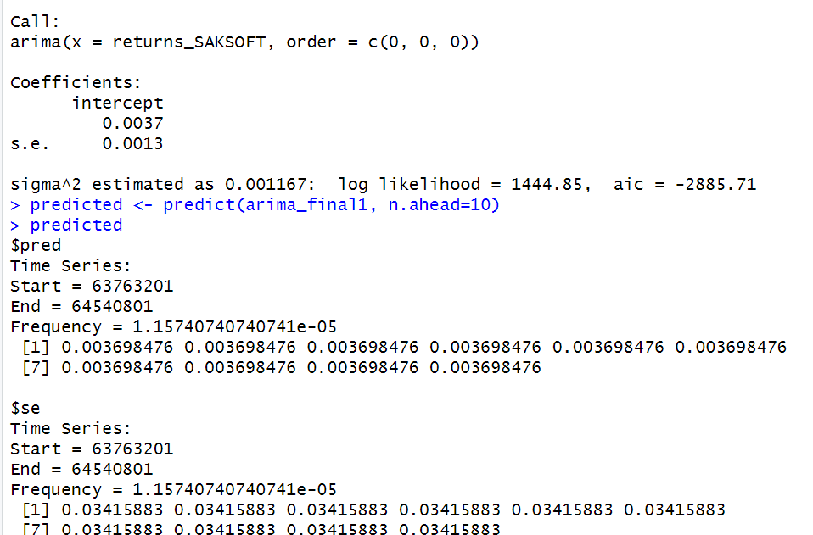

*Figure 12: Forecast for Daily Returns*

Since all the forecasts for returns are positive, the stock price will increase in the future weeks.

**2.3 GARCH and EGARCH models**

GARCH, or Generalised Autoregressive Conditional Heteroskedasticity, is a method for estimating market volatility while EGARCH (Exponential General Autoregressive Conditional Heteroskedasticity) is also a model for estimating market volatility but with less constraints on the parameters. GARCH (1,1) is the most popular GARCH model. Running GARCH on daily return of SAKSOFT yielded the result that are shown in Figure 13:

*Figure 13: GARCH Model for Daily Returns*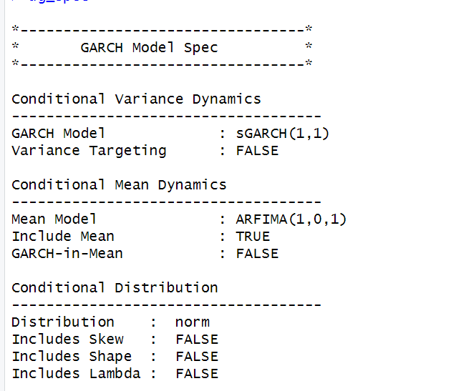

From the Figure 13, we can clearly see that GARCH (1,1) is the most appropriate model and by default, the mean model ARFIMA(1,0,1) is taken.

Now the daily returns of SAKSOFT were run against EGRACH model and the following results were obtained: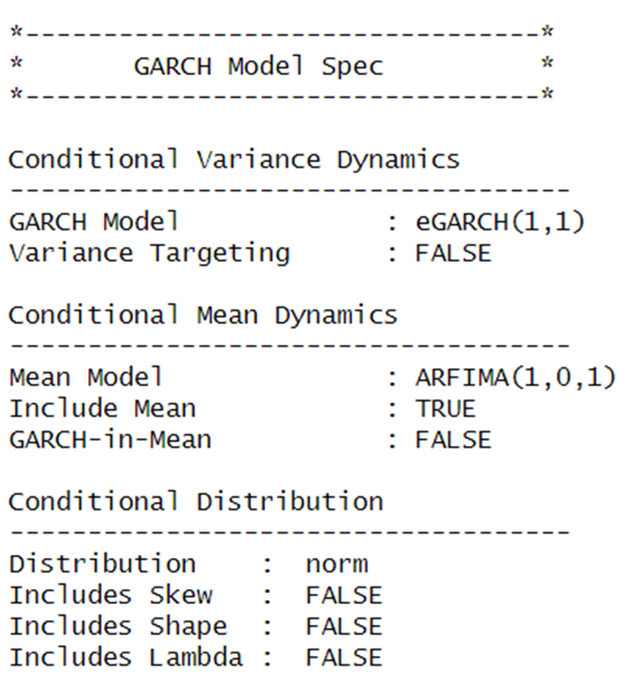

*Figure 14: EGARCH Model for Daily Returns*

From Figure 14, we can see that EGARCH (1,1) model is obtained and again by default ARFIMA (1,0,1) is taken. The results are similar to that of GARCH model.

After creating both GARCH and EGARCH models now we fit the model using

ugarchfit function which yielded the results that are shown in Figure 15. The interpretation of the results are given after Figure 15.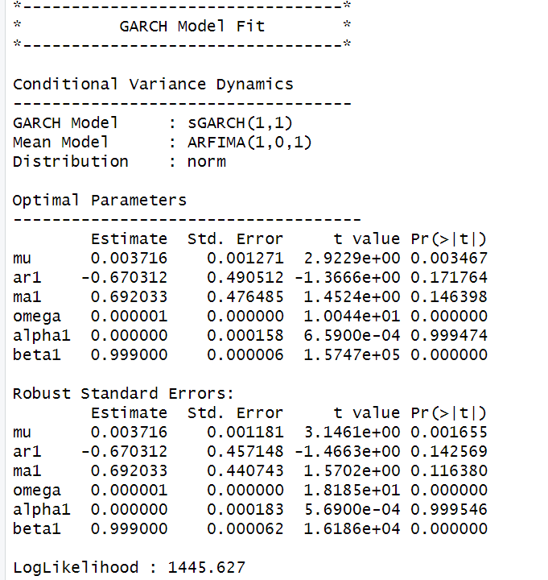

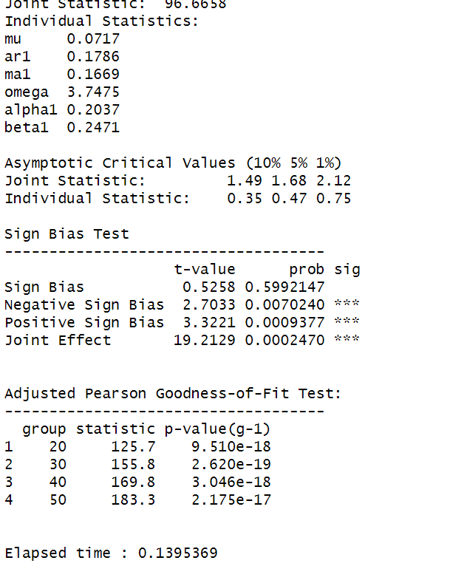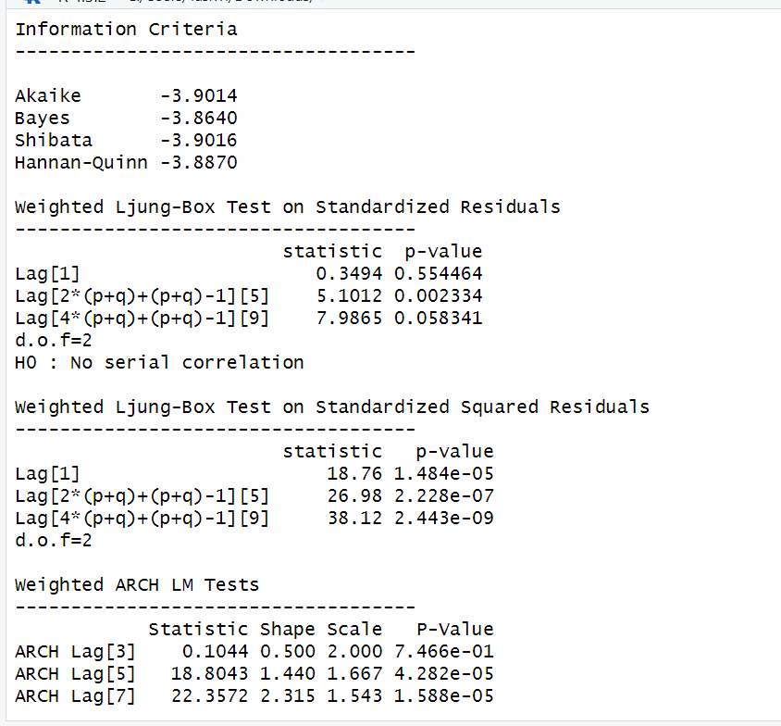

*Figure 15: GARCH Model Fitting for Daily Returns*

### **2.3.1 Interpretation**

• The Log Likelihood obtained from the model is 1445.627.

• GARCH(1,1) is the best fit model for SAKSOFT daily returns.

• The optimal parameters alpha and beta have significant value while omega is insignificant.

• The Alpha, Omega and Beta obtained from estimated robust standard error shows that omega and alpha are insignificant because p-value is greater than 0.05.

• This model provides the best fit with the fewest parameters because its AIC and BIC values are the lowest of all potential models.

• The p-value for both Standardized Residuals and Squared Residuals are greater than 0.05 which means null hypothesis will be accepted i.e., there is no serial correlation which is good for the model.

• Adjusted Pearson Goodness of Fit Test gave all the p-values greater than 0.05 which implies that null hypothesis can’t be rejected which means there is no significant difference between observed value and expected value.

### **2.3.2** **Forecast using GARCH**

The forecasted results using GARCH model are shown in Figure 16. The results show that the returns will be positive for the next 10 days with a value of around 0.37% having a standard deviation close to 3.26%. Positive return means that SAKSOFTstock price will rise in the next 10 days which is same as what was suggested by ARIMA model.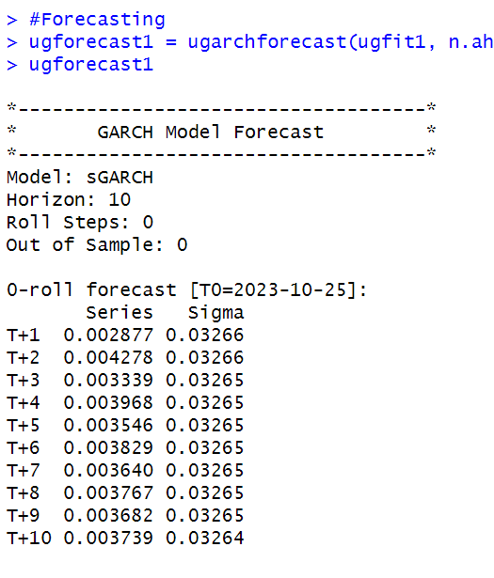

*Figure 16: GARCH Model Prediction for Daily Returns*

# **SECTION 3: SAKSOFT(Weekly Returns)**

Figure 3 shows the weekly returns of the SAKSOFT stock price from 2nd November 2020 to 25th October 2023, and the CLOSING prices were used to calculate the returns, which are shown in Figure 17.

*Figure 17: Weekly Prices of SAKSOFT*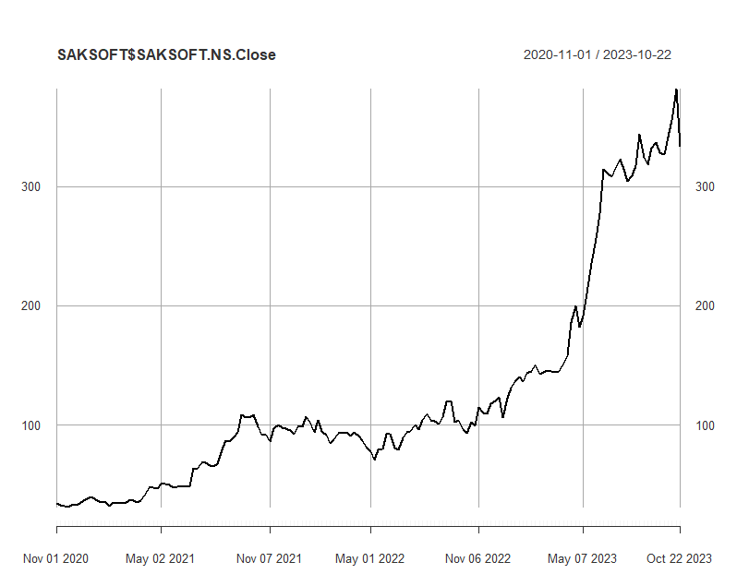

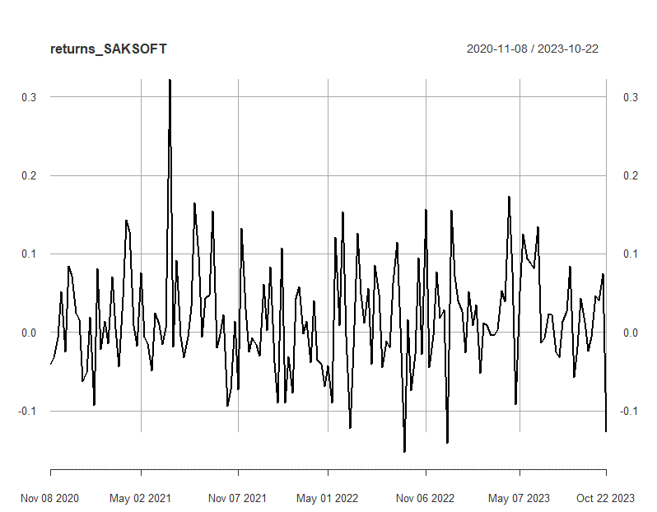

*Figure 18: Weekly Returns of SAKSOFT*

Next, the excess returns, denoted as E(R) - R_f, are subjected to regression against the market risk premium R_m - R_f. The outcomes of this regression are illustrated in Figure 19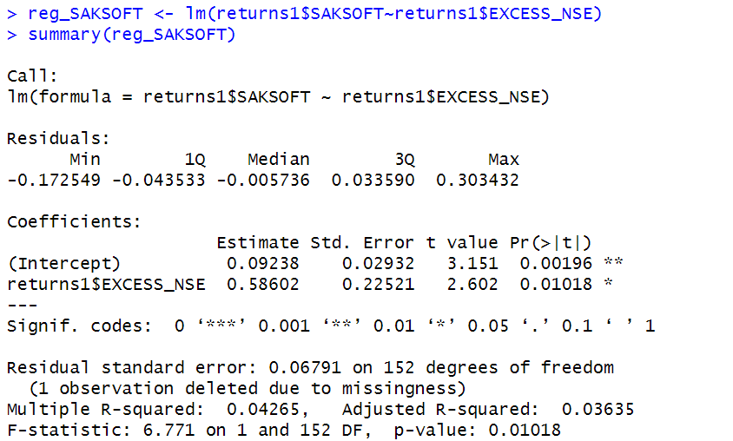

*Figure 19: Regression results of CAPM for Weekly Returns*

**3.1.1 CAPM Model - Interpretation of Results**

The above figure shows that the Beta for weekly returns (risk unadjusted) is 0.58602, which means that if the market index portfolio’s daily returns rise by 1%, then the daily returns of SAKSOFT will increase by 0.58602%. Also, the beta value is significant at 95% but not at 99% since the p-value is greater than 0.01 but less than 0.05 (0.05> p > 0.01)The intercept value derived from the regression is 0.09238 which means that if the market return is 0%, then SAKSOFT will show a 0.09238% return.

## **3.2** **Estimating AR and MA coefficients using ARIMA**

The AR and MA coefficients are obtained using the ACF (Auto-correlation function) and PACF (Partial Auto-correlation function) plots. From Figure 17 it can be seen that stock price data is non-stationary while from Figure 18 we can interpret that the returns of the stock seems to be stationary of integrated or order 1 which means first difference is stationary.

**3.2.1 Augmented Dickey-Fuller Test**

An augmented Dickey-Fuller (ADF) test is performed to check for stationarity, whose results are in Figure 13.

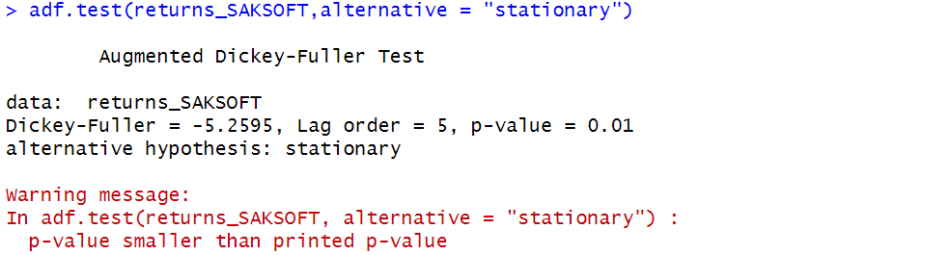

*Figure 20: ADF Test Results for Weekly Returns*

The Augmented Dickey-Fuller test null hypothesis states that a unit root exists, i.e. the series is not-stationary, and the corresponding alternative hypothesis is that the series is stationary. Since the p-value of the test shown above is 0.01, the null hypothesis can be rejected; thus, the series is stationary.The value of ADF Test-statistic: -5.2595.

**3.2.2 ACF Plot**

The sample Autocorrelation function (ACF) plot is used measure the correlation between the present and the lagged values in the series. Lagged values means the past values of the series. Figure 21 shows the formula for calculating ACF at lag k:



*Figure 21: ACF Formula*

The results for of ACF plot for SAKSOFT are depicted in Figure 22:

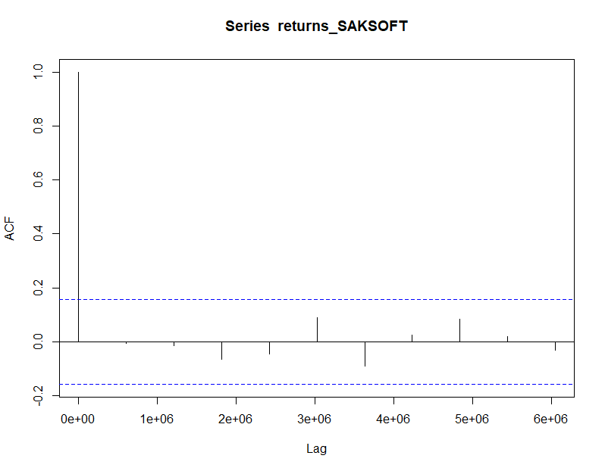

*Figure 22: ACF Plot SAKSOFT for Weekly Returns*

From the above plot it can derived that the series is MA(0) model since no lag term except the 0th lag is significant,following values are not significant.

**3.2.3 PACF Plot**

It measures the correlation between an observation k periods ago and the current observation after controlling the observations at intermediate lags i.e., all the lags which are less than k. PACF plots are used to differentiate between AR & ARMA process. Figure 23 shows the formula for calculating PACF:

*Figure 23: PACF Formula*

The results of PACF plot for SAKSOFT are depicted in Figure 24:

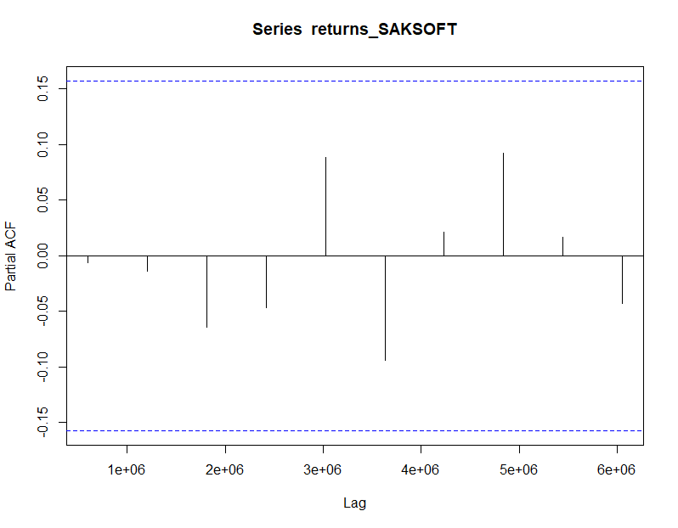

*Figure 24: PACF Plot SAKSOFT for Weekly Return*

From the above plot it can derived that the series is AR(0) model since only no lag is significant.

**3.2.4 Identification and interpretation of ARIMA model:**

The diagnostic test of the model is shown in Figure.

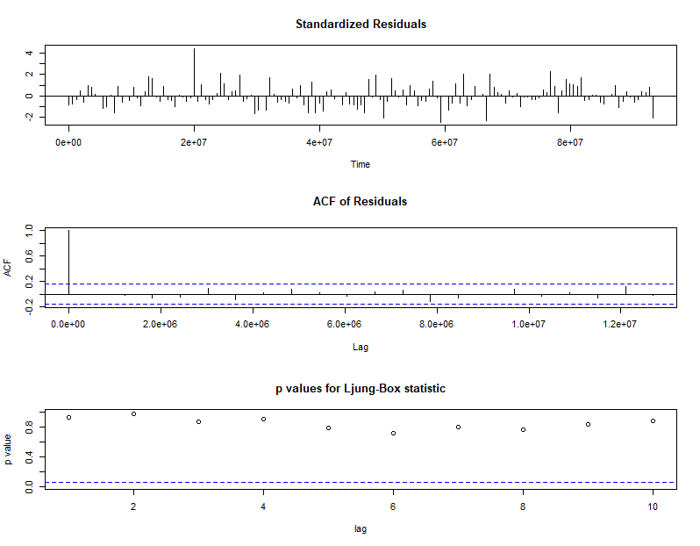

*Figure 25: Diagnostic Results for Daily Returns*

Ljung-Box Test is used for testing the distribution of residuals. Its null hypothesis is that the residuals are independently distributed while alternative hypothesis states that residuals are not independently residuals. From Figure 25 (Chart 3) it can be seen that almost all p-values are greater than 0.05 which means that we can’t reject the null hypothesis i.e., residuals are distributed independently. The normalised residuals time series plot looks to be random and does not show a strong trend, therefore it fits the data well. Also, the Residual autocorrelations are all zero except for one spike.

### **3.2.5** **FORECAST WITH ARIMA MODEL**

Using the ARIMA (0,0,0) model the forecast results have been calculated are shown in Figure 26:

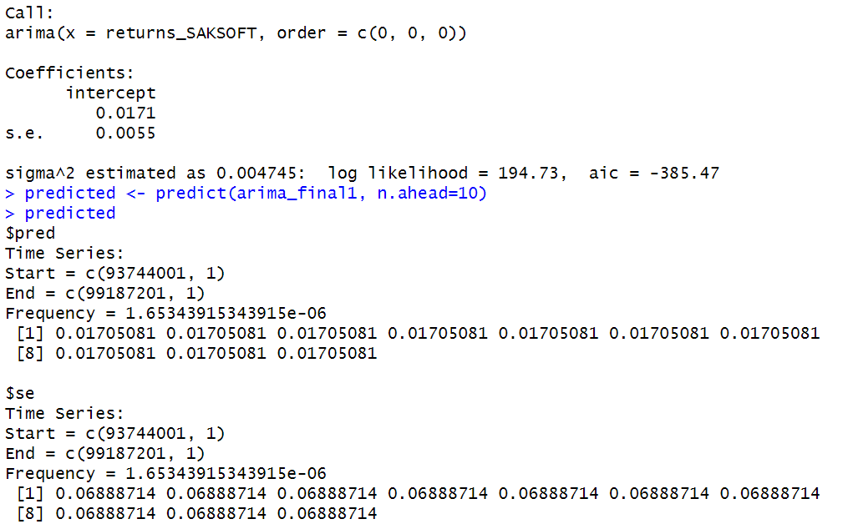

*Figure 27: Forecast for Weekly Returns*

Since all the forecasts for returns are positive, the stock price will increase in the future weeks.

**3.3 GARCH and EGARCH models**

GARCH, or Generalised Autoregressive Conditional Heteroskedasticity, is a method for estimating market volatility while EGARCH (Exponential General Autoregressive Conditional Heteroskedasticity) is also a model for estimating market volatility but with less constraints on the parameters. GARCH (1,1) is the most popular GARCH model. Running GARCH on daily return of SAKSOFT yielded the result that are shown in Figure 28:

*Figure 28: GARCH Model for Weekly Returns*

From the Figure 28, we can clearly see that GARCH (1,1) is the most appropriate model and by default, the mean model ARFIMA(1,0,1) is taken.

Now the daily returns of SAKSOFT were run against EGRACH model and the following results were obtained:

*Figure 29: EGARCH Model for Weekly Returns*

From Figure 29, we can see that EGARCH (1,1) model is obtained and again by default ARFIMA (1,0,1) is taken. The results are similar to that of GARCH model.

After creating both GARCH and EGARCH models now we fit the model using

ugarchfit function which yielded the results that are shown in Figure 30. The interpretation of the results are given after Figure 30.

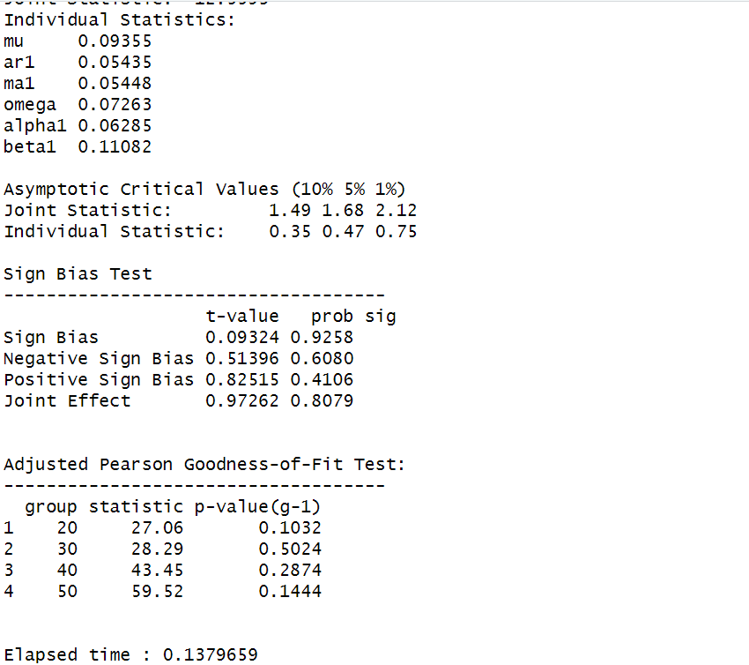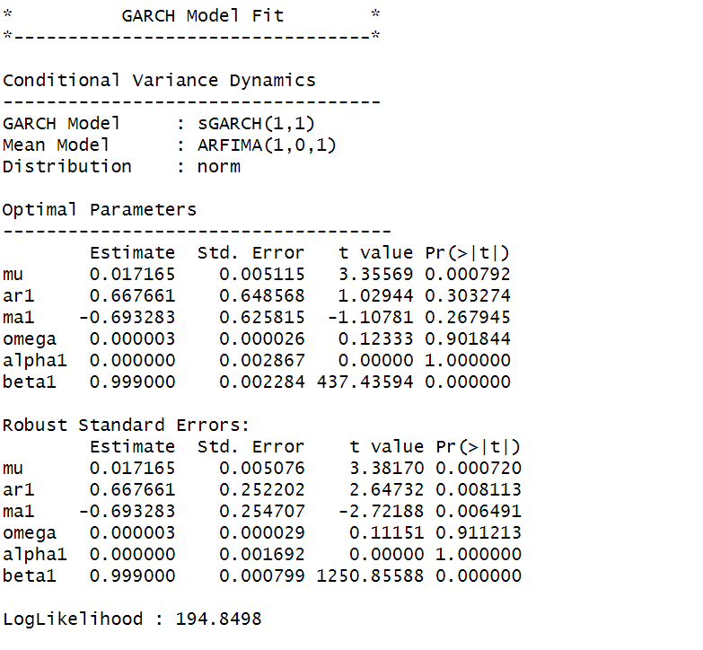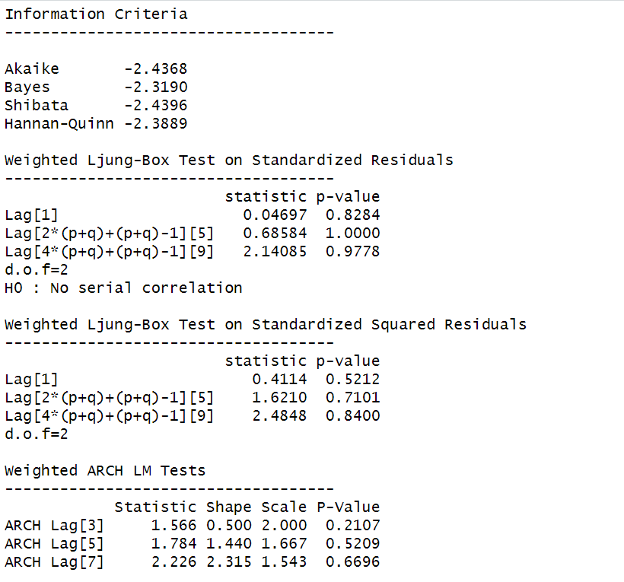

*Figure 30: GARCH Model Fitting for Weekly Returns*

### **3.3.1 Interpretation**

• The Log Likelihood obtained from the model is 194.8498.

• GARCH(1,1) is the best fit model for SAKSOFT weekly returns.

• The optimal parameters alpha and beta have significant value while omega is insignificant.

• The Alpha, Omega and Beta obtained from estimated robust standard error shows that omega and alpha are insignificant because p-value is greater than 0.05.

• This model provides the best fit with the fewest parameters because its AIC and BIC values are the lowest of all potential models.

• The p-value for both Standardized Residuals and Squared Residuals are greater than 0.05 which means null hypothesis will be accepted i.e., there is no serial correlation which is good for the model.

• Adjusted Pearson Goodness of Fit Test gave all the p-values greater than 0.05 which implies that null hypothesis can’t be rejected which means there is no significant difference between observed value and expected value.

### **3.3.2** **Forecast using GARCH**

The forecasted results using GARCH model are shown in Figure 31. The results show that the returns will be positive for the next 10 days with a value of around 1.72% having a standard deviation close to 6.719%. Positive return means that SAKSOFT stock price will rise in the next 10 days which is same as what was suggested by ARIMA model.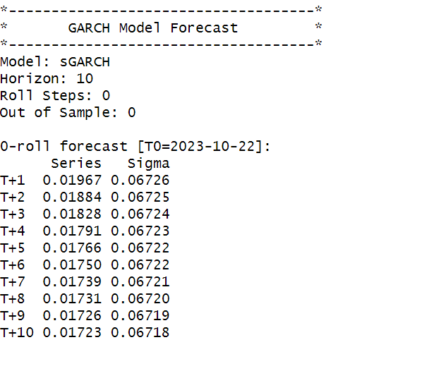

*Figure 31: GARCH Model Prediction for Weekly Return*

**SECTION 4: SAKSOFT(Monthly Returns)**

Figure 33 shows the monthly returns of the SAKSOFT stock price from 2nd November 2020 to 25th October 2023, and the CLOSING prices were used to calculate the returns, which are shown in Figure 32.

*Figure 32: Monthly Prices of SAKSOFT*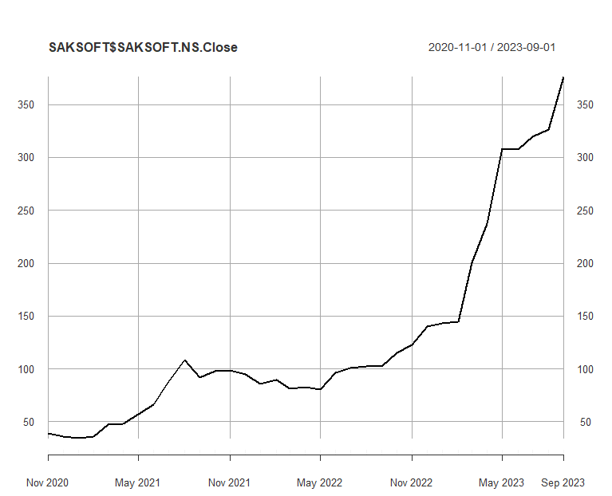

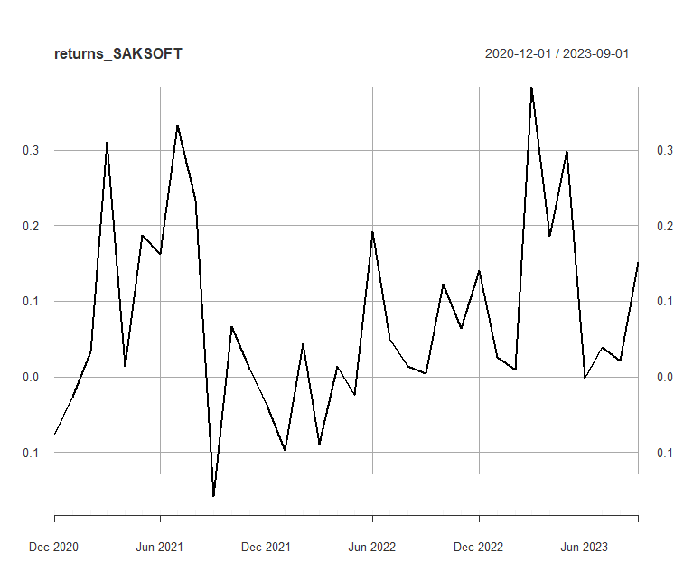

*Figure 33:Monthly Returns of SAKSOFT*

Next, the excess returns, denoted as E(R) - R_f, are subjected to regression against the market risk premium R_m - R_f. The outcomes of this regression are illustrated in Figure 34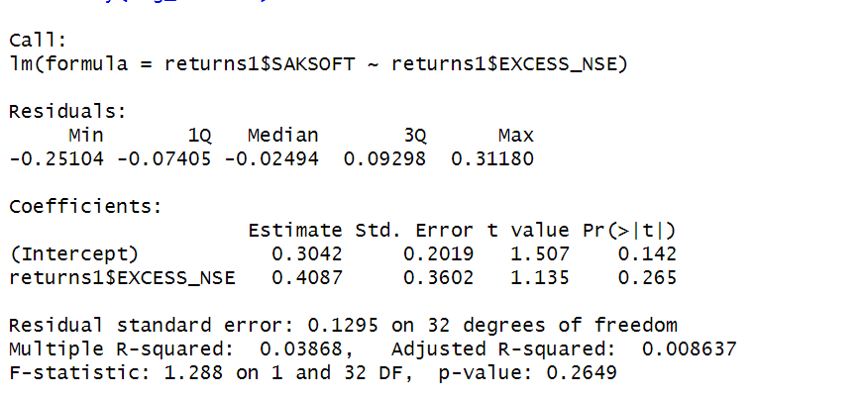

*Figure 34: Regression results of CAPM for Monthly Returns*

**4.1.1 CAPM Model - Interpretation of Results**

Figure shows that the Beta for monthly returns (risk unadjusted) is 0.4087, which means that if the market index portfolio’s daily returns rise by 1%, then the monthly returns of SAKSOFT will increase by 0.4087%.The intercept value derived from the regression is 0.3042, but it is also not statistically significant. Therefore, it may be appropriate to ignore or treat it as 0%, which means that if the market return is 0%, then SAKSOFT will show a 0.3042% return.

## **4.2** **Estimating AR and MA coefficients using ARIMA**

The AR and MA coefficients are obtained using the ACF (Auto-correlation function) and PACF (Partial Auto-correlation function) plots. From Figure 32 it can be seen that stock price data is non-stationary while from Figure 33 we can interpret that the returns of the stock seems to be stationary of integrated or order 1 which means first difference is stationary.

**4.2.1 Augmented Dickey-Fuller Test**

An augmented Dickey-Fuller (ADF) test is performed to check for stationarity, whose results are in Figure 35.

*Figure 35: ADF Test Results for Monthly Returns*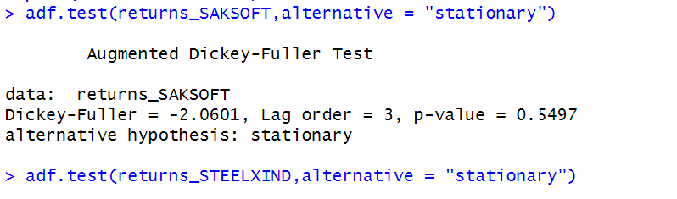

The Augmented Dickey-Fuller test null hypothesis states that a unit root exists, i.e. the series is not-stationary, and the corresponding alternative hypothesis is that the series is stationary. Since the p-value of the test shown above is 0.01, the null hypothesis can be rejected; thus, the series is stationary.The value of ADF Test-statistic: -2.0601.

**4.2.2 ACF Plot**

The sample Autocorrelation function (ACF) plot is used measure the correlation between the present and the lagged values in the series. Lagged values means the past values of the series. Figure 36 shows the formula for calculating ACF at lag k:



*Figure 36: ACF Formula*

The results for of ACF plot for SAKSOFT are depicted in Figure 37:

*Figure 37: ACF Plot SAKSOFT for MonthlyReturns*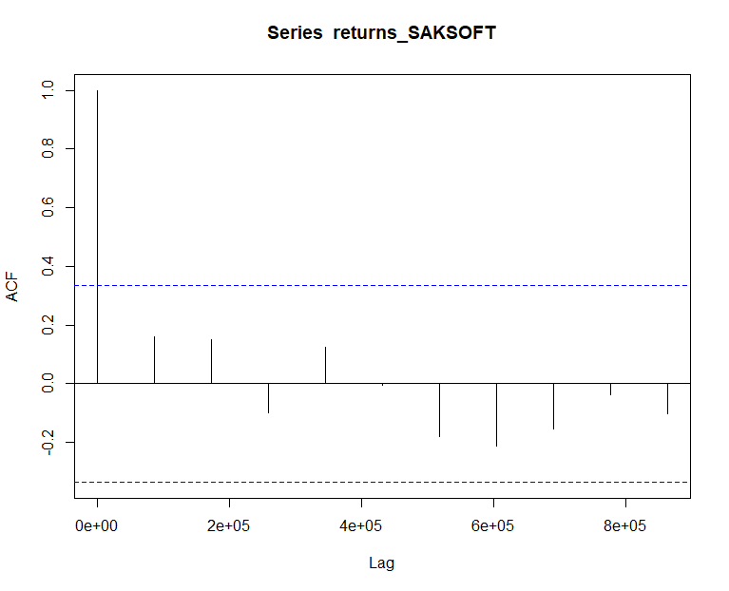

From the above plot it can derived that the series is MA(0) model since no lag term except the 0th lag is significant,following values are not significant.

**4.2.3 PACF Plot**

It measures the correlation between an observation k periods ago and the current observation after controlling the observations at intermediate lags i.e., all the lags which are less than k. PACF plots are used to differentiate between AR & ARMA process. Figure 38 shows the formula for calculating PACF:

*Figure 38: PACF Formula*

The results of PACF plot for SAKSOFT are depicted in Figure 39:

*Figure 39: PACF Plot SAKSOFT for Monthly Return*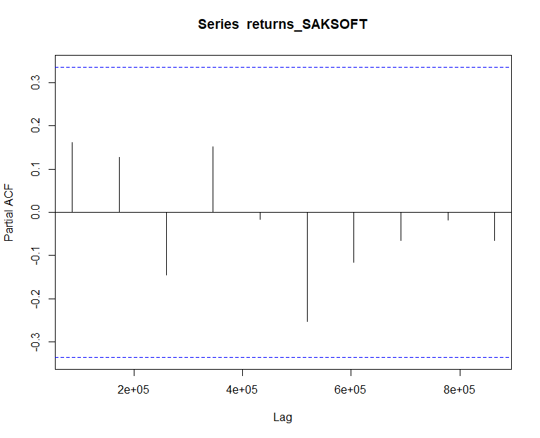

From the above plot it can derived that the series is AR(0) model since only no lag is significant.

**4.2.4 Identification and interpretation of ARIMA model:**

The diagnostic test of the model is shown in Figure.

*Figure 40: Diagnostic Results for Monthly Returns*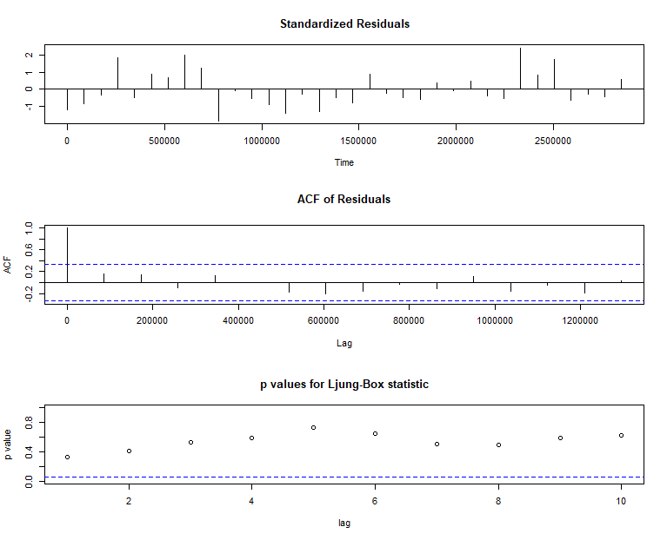

Ljung-Box Test is used for testing the distribution of residuals. Its null hypothesis is that the residuals are independently distributed while alternative hypothesis states that residuals are not independently residuals. From Figure 40(Chart 3) it can be seen that almost all p-values are greater than 0.05 which means that we can’t reject the null hypothesis i.e., residuals are distributed independently. The normalised residuals time series plot looks to be random and does not show a strong trend, therefore it fits the data well. Also, the Residual autocorrelations are all zero except for one spike.

### **4.2.5** **FORECAST WITH ARIMA MODEL**

Using the ARIMA (0,0,0) model the forecast results have been calculated are shown in Figure 41:

*Figure 41: Forecast for Monthly Returns*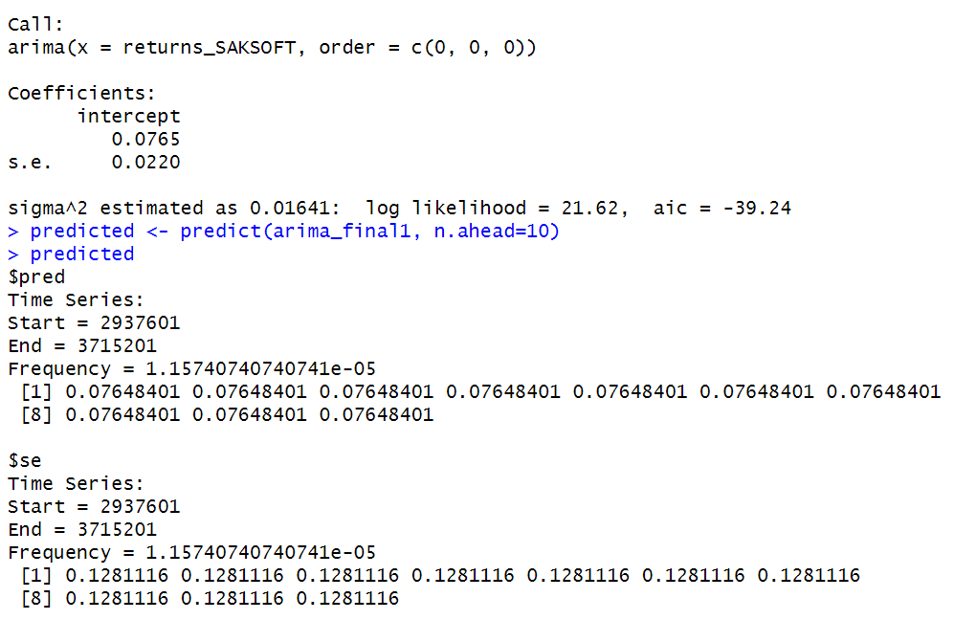

Since all the forecasts for returns are positive, the stock price will increase in the future weeks.

**4.3 GARCH and EGARCH models**

GARCH, or Generalised Autoregressive Conditional Heteroskedasticity, is a method for estimating market volatility while EGARCH (Exponential General Autoregressive Conditional Heteroskedasticity) is also a model for estimating market volatility but with less constraints on the parameters. GARCH (1,1) is the most popular GARCH model. Running GARCH on monthly return of SAKSOFT yielded the result that are shown in Figure 42: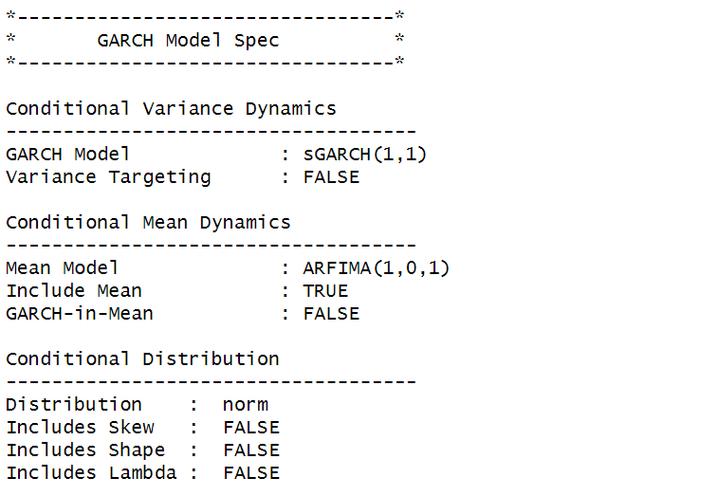

*Figure 42: GARCH Model for Monthly Returns*

From the Figure 42. we can clearly see that GARCH (1,1) is the most appropriate model and by default, the mean model ARFIMA(1,0,1) is taken.

Now the monthly returns of SAKSOFT were run against EGRACH model and the following results were obtained:

*Figure 43: EGARCH Model for Monthly Returns*

From Figure 43, we can see that EGARCH (1,1) model is obtained and again by default ARFIMA (1,0,1) is taken. The results are similar to that of GARCH model.

After creating both GARCH and EGARCH models now we fit the model using

ugarchfit function which yielded the results that are shown in Figure 44. The interpretation of the results are given after Figure 44.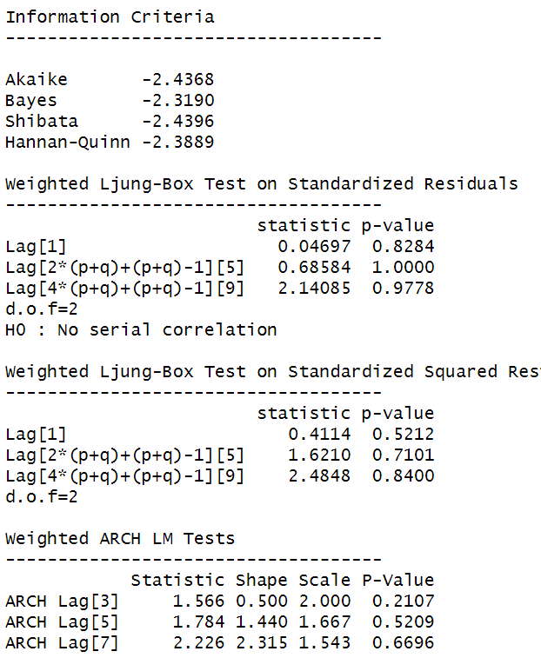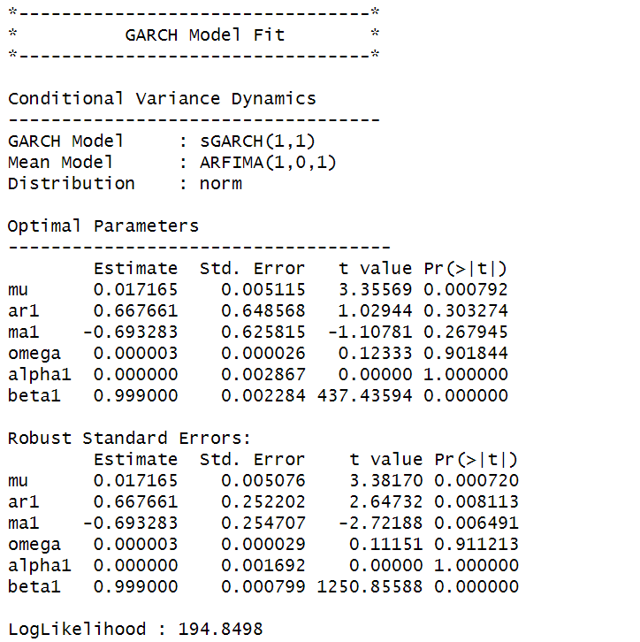

*Figure 44: GARCH Model Fitting for Monthly Returns*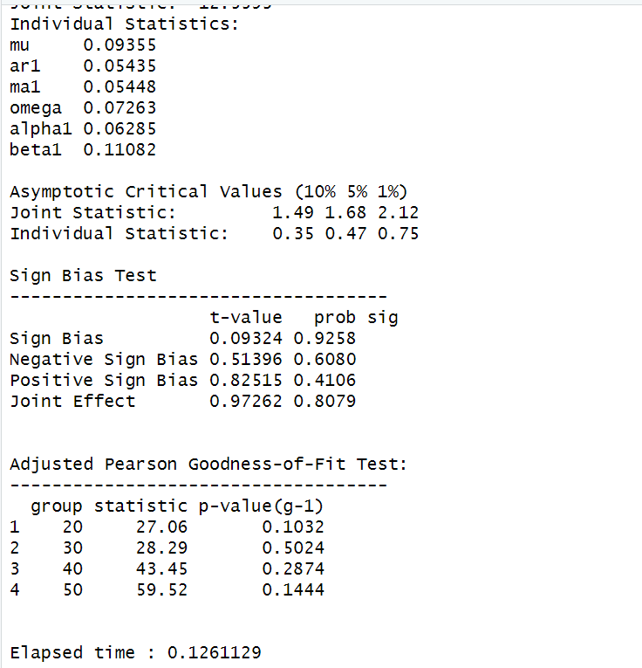

**4.3.1 Interpretation**

• The Log Likelihood obtained from the model is 194.8498.

• GARCH(1,1) is the best fit model for SHOPERSTOP monthly returns.

• The optimal parameters alpha and beta have significant value while omega is insignificant.

• The Alpha, Omega and Beta obtained from estimated robust standard error shows that omega and alpha are insignificant because p-value is greater than 0.05.

• This model provides the best fit with the fewest parameters because its AIC and BIC values are the lowest of all potential models.

• The p-value for both Standardized Residuals and Squared Residuals are greater than 0.05 which means null hypothesis will be accepted i.e., there is no serial correlation which is good for the model.

• Adjusted Pearson Goodness of Fit Test gave all the p-values greater than 0.05 which implies that null hypothesis can’t be rejected which means there is no significant difference between observed value and expected value.

### **4.3.2** **Forecast using GARCH**

The forecasted results using GARCH model are shown in Figure 45. The results show that the returns will be positive for the next 10 days with a value of around 1.72% having a standard deviation close to 6.718%. Positive return means that SHOPERSTOP stock price will rise in the next 10 days which is same as what was suggested by ARIMA model.

is a prestigious brand in the retail sector, that is associated with elegance, superior products, and an unmatched shopping experience. Shoppers Stop, a

**ABOUT SHOPERSTOP:**

Shoperstop, a retail icon since 1991, provides a carefully curated assortment of products for lifestyle, beauty, and fashion. Shoppers Stop, a publicly traded company, is dedicated to providing exceptional customer service and establishing industry standards for excellence in the retail industry.

The goal of Shoppers Stop when it first opened was to change the retail scene by giving fashion fans a single location to visit. B. S. Nagesh led the company's founding, and it rose to prominence fast by providing a wide selection of high-end brands and fostering an engaging retail atmosphere. Convenience, variety, and quality were all intended to be combined for the benefit of the clientele at the time of establishment.

Shoppers Stop's ability to stay ahead of fashion trends and its dedication to customer satisfaction are two things that make it great overall. Since its founding, the business has made a commitment to comprehending and foreseeing the changing preferences of its clients, guaranteeing a flawless shopping experience that goes beyond transactions to forge enduring relationships.

Shoppers Stop has embraced digital transformation in addition to its retail expertise, providing online shopping options to meet the changing demands of tech-savvy customers. Shoppers Stop is positioned as a leader in both traditional retail and e-commerce thanks to this multi-channel strategy.

To sum up, Shoppers Stop is a retail industry trailblazer that offers an engaging shopping experience that goes above and beyond the norm. Since its founding in [year], the business has set trends by fusing innovation and custom to satisfy its affluent clientele's constantly shifting needs. With every year that goes by, Shoppers Stop continues to be a representation of fashion, dependability, and customer-focused ness—defining the direction of retail.

# 

# **SECTION 5: SHOPERSTOP (Daily Returns)**

The CAPM model is defined as:

E(R) = Rf + Beta(Rm-Rf)

where,

E(R): Expected return of the firm

Rf: Risk free rate

Rm: Returns of the market

Beta is calculated by regressing expected returns of the stock i.e., SHOPERSTOP on Market Risk Premium (Rm-Rf). It is the slope parameter that is evaluated from the regression model.

The beta is a measure of how sensitive the security is to the changes in the market index. For index portfolio National Stock Exchange (NSE) was taken into consideration.

For example, a beta of 1.5 means that our portfolio is 50% more sensitive when compared with market index.

**5.1 CAPM Model - Estimating the Beta of the Company**

Figure 3 shows the daily returns of the SHOPERSTOP stock price from 2nd November 2020 to 25th October 2023, and the CLOSING prices were used to calculate the returns, which are shown in Figure 1.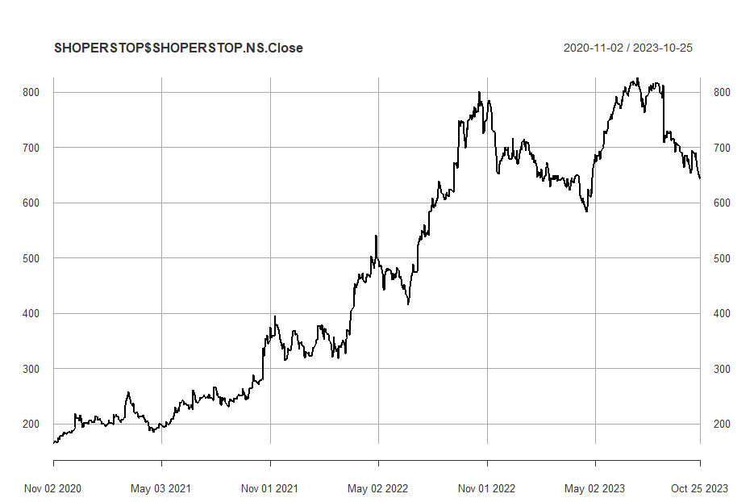

*Figure 46: Daily Prices of SHOPERSTOP*

*Figure 47: Daily Returns of SHOPERSTOP*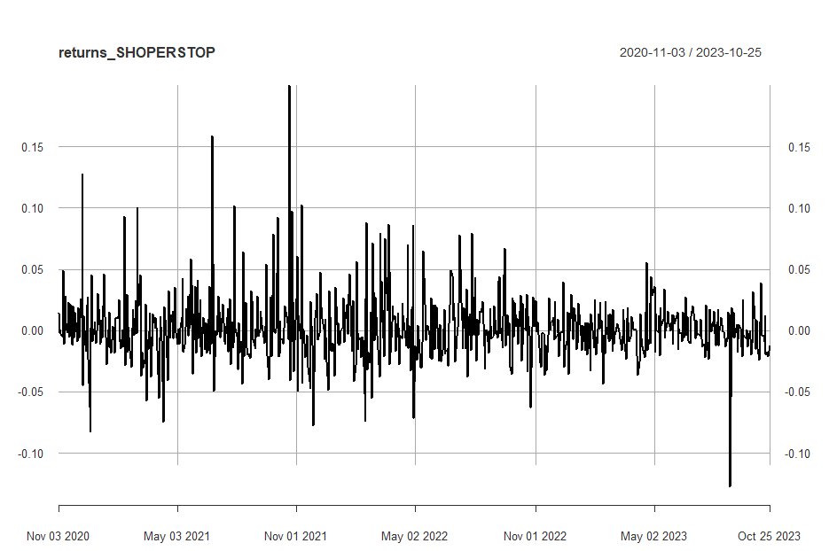

Next, the excess returns, denoted as E(R) - R_f, are subjected to regression against the market risk premium R_m - R_f. The outcomes of this regression are illustrated in Figure 48

*Figure 48: Regression results of CAPM for Daily Returns*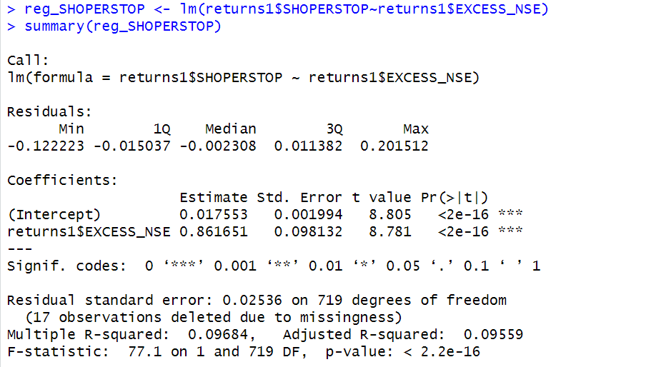

**5.1.1 CAPM Model - Interpretation of Results**

Figure shows that the Beta for daily returns (risk unadjusted) is 0.861651, which means that if the market index portfolio’s daily returns rise by 1%, then the daily returns of SHOPERSTOP will increase by 0.861651%. Moreover, the beta value is statistically significant at both the 95% and 99% confidence levels, given that the p-value is less than 0.01 (p < 0.01).

The intercept value derived from the regression is 0.0175553 which means that if the market return is 0%, then SHOPERSTOP will show a 0.017553% return.

**5.2 Estimating AR and MA coefficients using ARIMA**

The AR and MA coefficients are obtained using the ACF (Auto-correlation function) and PACF (Partial Auto-correlation function) plots. From Figure 46 it can be seen that stock price data is non-stationary while from Figure 47 we can interpret that the returns of the stock seem to be stationary of integrated or order 1 which means first difference is stationary.

**5.2.1 Augmented Dickey-Fuller Test**

An augmented Dickey-Fuller (ADF) test is performed to check for stationarity, whose results are in Figure 48

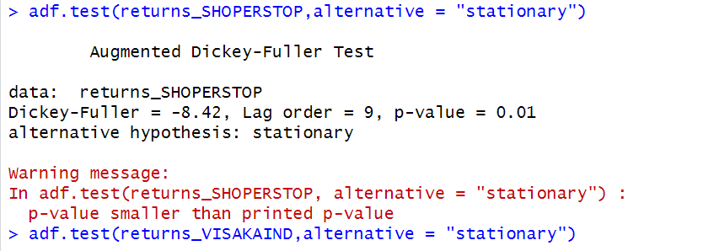

*Figure 49: ADF Test Results for Daily Returns*

The Augmented Dickey-Fuller test null hypothesis states that a unit root exists, i.e. the series is not-stationary, and the corresponding alternative hypothesis is that the series is stationary. Since the p-value of the test shown above is 0.01, the null hypothesis can be rejected; thus, the series is stationary.The value of ADF Test-statistic: -8.42.

**5.2.2 ACF Plot**

The sample Autocorrelation function (ACF) plot is used measure the correlation between the present and the lagged values in the series. Lagged values means the past values of the series. Figure 7 shows the formula for calculating ACF at lag k:



*Figure 50: ACF Formula*

The results for of ACF plot for SHOPERSTOP are depicted in Figure 51:

*Figure 51: ACF Plot SHOPERSTOP for Daily Returns*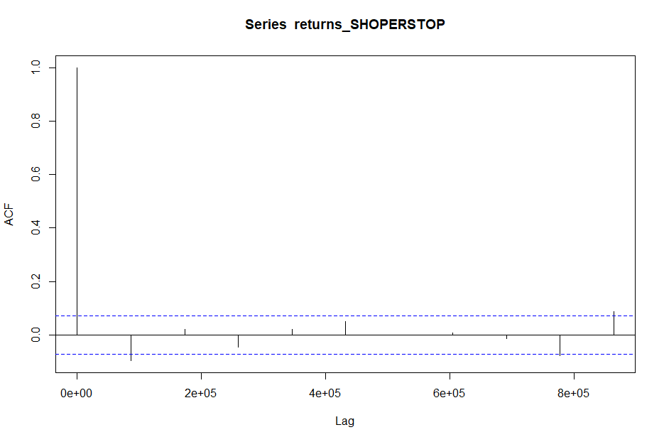

From the above plot it can derived that the series is MA(0) model since no lag term except the 0th lag is significant,following values are not significant.

**5.2.3 PACF Plot**

It measures the correlation between an observation k periods ago and the current observation after controlling the observations at intermediate lags i.e., all the lags which are less than k. PACF plots are used to differentiate between AR & ARMA process. Figure 52 shows the formula for calculating PACF:

*Figure 52: PACF Formula*

The results of PACF plot for SHOPERSTOP are depicted in Figure 53:

*Figure 53: PACF Plot* SHOPERSTOP *for Daily Return*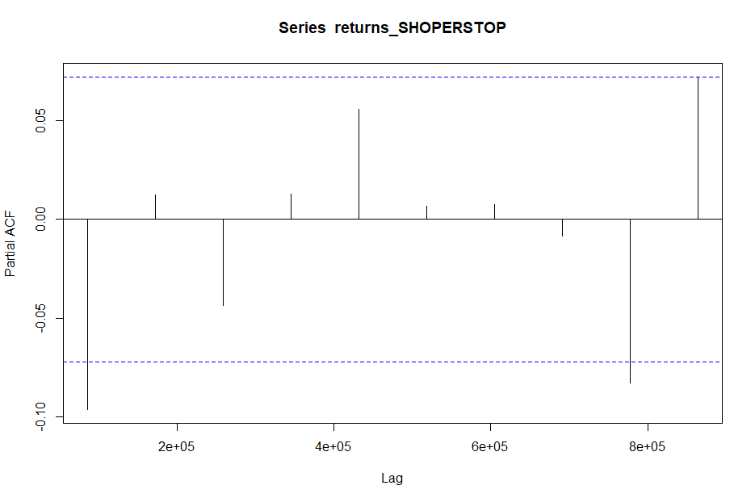

From the above plot it can derived that the series is AR(1) model since only one lag is significant.

**2.2.4 Identification and interpretation of ARIMA model:**

The diagnostic test of the model is shown in Figure.



*Figure 54: Diagnostic Results for Daily Returns*

Ljung-Box Test is used for testing the distribution of residuals. Its null hypothesis is that the residuals are independently distributed while alternative hypothesis states that residuals are not independently residuals. From Figure 54(Chart 3) it can be seen that almost all p-values are greater than 0.05 which means that we can’t reject the null hypothesis i.e., residuals are distributed independently. The normalised residuals time series plot looks to be random and does not show a strong trend, therefore it fits the data well. Also, the Residual autocorrelations are all zero except for one spike.

### **2.2.5** **FORECAST WITH ARIMA MODEL**

Using the ARIMA (0,0,0) model the forecast results have been calculated are shown in Figure 55:

*Figure 55: Forecast for Daily Returns*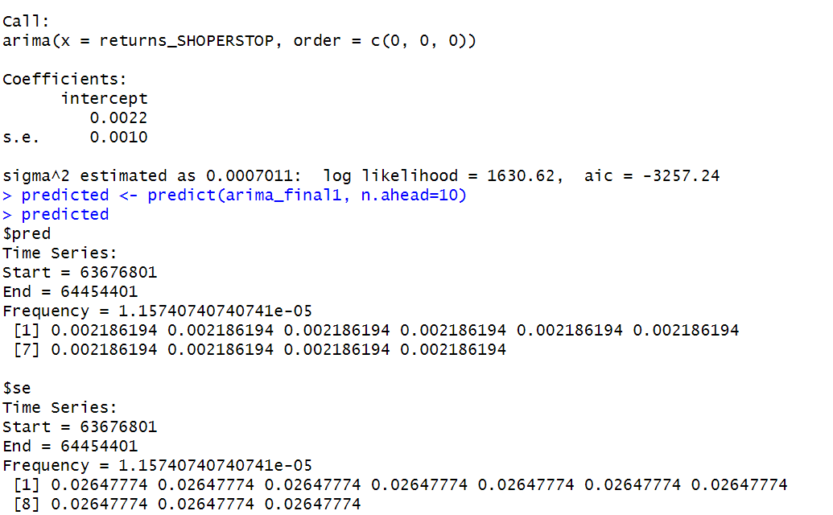

Since all the forecasts for returns are positive, the stock price will increase in the future weeks.

**5.3 GARCH and EGARCH models**

GARCH, or Generalised Autoregressive Conditional Heteroskedasticity, is a method for estimating market volatility while EGARCH (Exponential General Autoregressive Conditional Heteroskedasticity) is also a model for estimating market volatility but with less constraints on the parameters. GARCH (1,1) is the most popular GARCH model. Running GARCH on daily return of SHOPERSTOP yielded the result that are shown in Figure 56: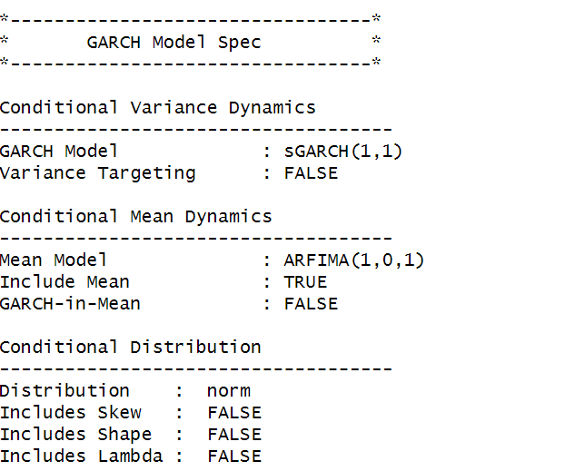

*Figure 56: GARCH Model for Daily Returns*

From the Figure 56, we can clearly see that GARCH (1,1) is the most appropriate model and by default, the mean model ARFIMA(1,0,1) is taken.

Now the daily returns of SHOPERSTOP were run against EGRACH model and the following results were obtained:

*Figure 57: EGARCH Model for Daily Returns*

From Figure 57, we can see that EGARCH (1,1) model is obtained and again by default ARFIMA (1,0,1) is taken. The results are similar to that of GARCH model.

After creating both GARCH and EGARCH models now we fit the model using

ugarchfit function which yielded the results that are shown in Figure 58. The interpretation of the results are given after Figure 58.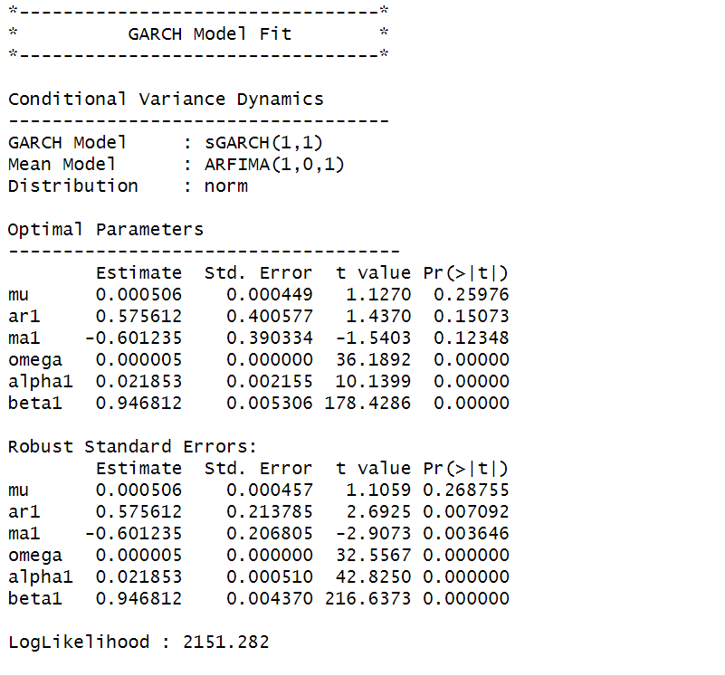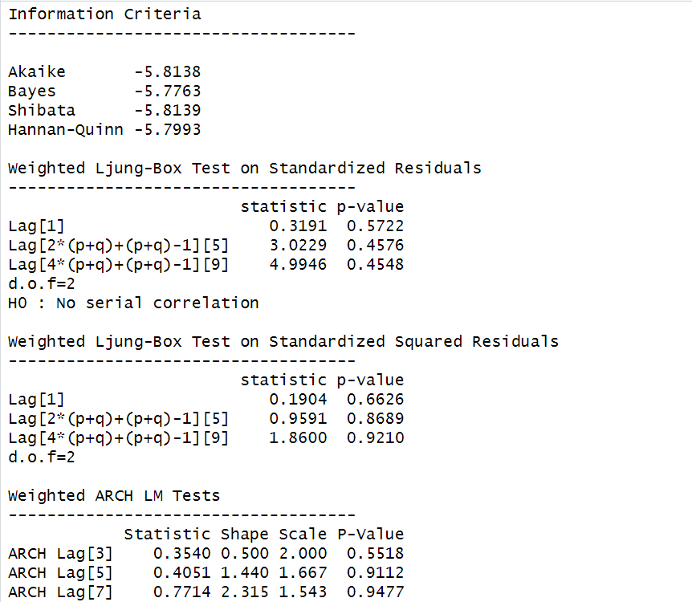

*Figure 58: GARCH Model Fitting for Daily Returns*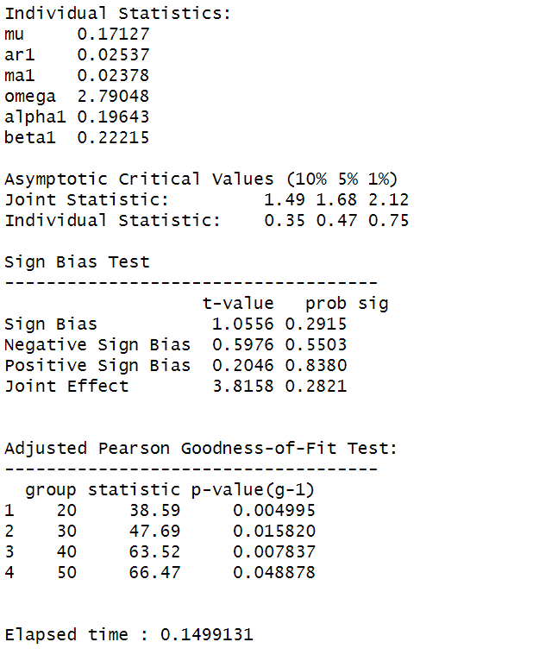

**5.3.1 Interpretation**

• The Log Likelihood obtained from the model is 2151.282

• GARCH(1,1) is the best fit model for SHOPERSTOP daily returns.

• The optimal parameters alpha and beta have significant value while omega is insignificant.

• The Alpha, Omega and Beta obtained from estimated robust standard error shows that omega and alpha are insignificant because p-value is greater than 0.05.

• This model provides the best fit with the fewest parameters because its AIC and BIC values are the lowest of all potential models.

• The p-value for both Standardized Residuals and Squared Residuals are greater than 0.05 which means null hypothesis will be accepted i.e., there is no serial correlation which is good for the model.

• Adjusted Pearson Goodness of Fit Test gave all the p-values greater than 0.05 which implies that null hypothesis can’t be rejected which means there is no significant difference between observed value and expected value.

### **5.3.2** **Forecast using GARCH**

The forecasted results using GARCH model are shown in Figure 59. The results show that the returns will be positive for the next 10 days with a value of around 0.05% having a standard deviation close to 1.24%. Positive return means that SHOPERSTOP stock price will rise in the next 10 days which is same as what was suggested by ARIMA model.

*Figure 59: GARCH Model Prediction for Daily Returns*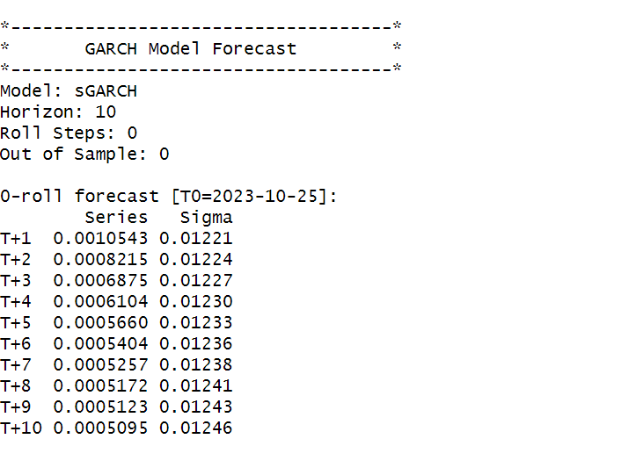

# 

# 

# 

# 

# 

# 

# 

# 

# 

# 

# **SECTION 6: SHOPERSTOP (Weekly Returns)**

Figure 61 shows the weekly returns of the SHOPERSTOP stock price from 2nd November 2020 to 25th October 2023, and the CLOSING prices were used to calculate the returns, which are shown in Figure 60.

*Figure 60 Weekly Prices of SHOPERSTOP*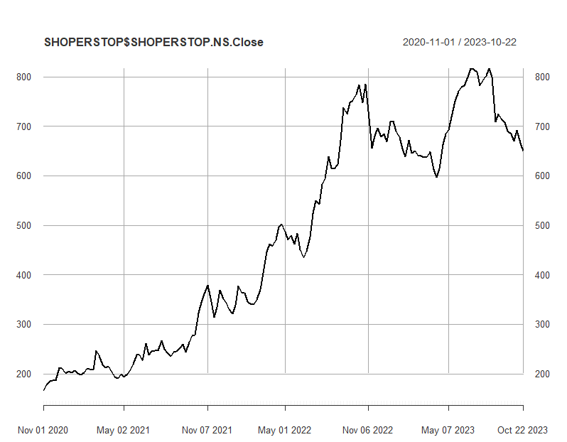

*Figure 61: Weekly Returns of SHOPERSTOP*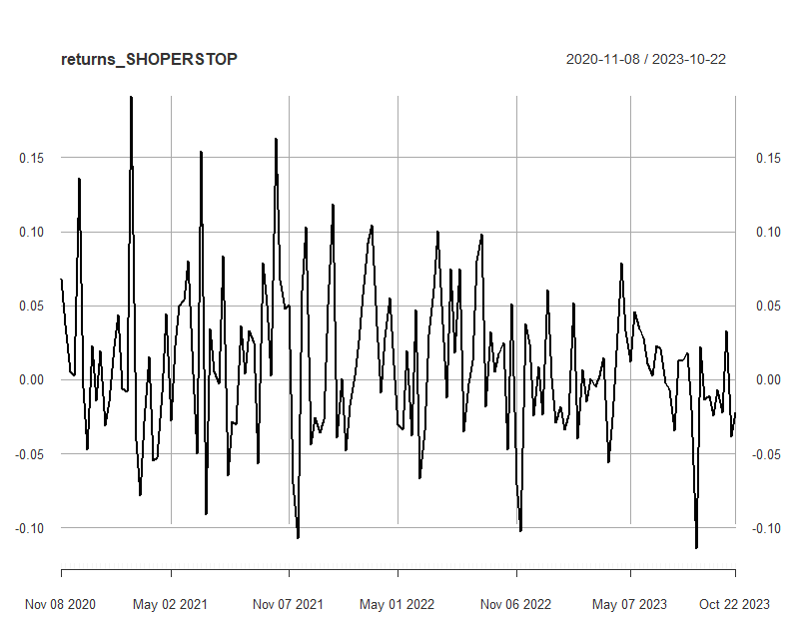

Next, the excess returns, denoted as E(R) - R_f, are subjected to regression against the market risk premium R_m - R_f. The outcomes of this regression are illustrated in Figure 62.

*Figure 62: Regression results of CAPM for Weekly Returns*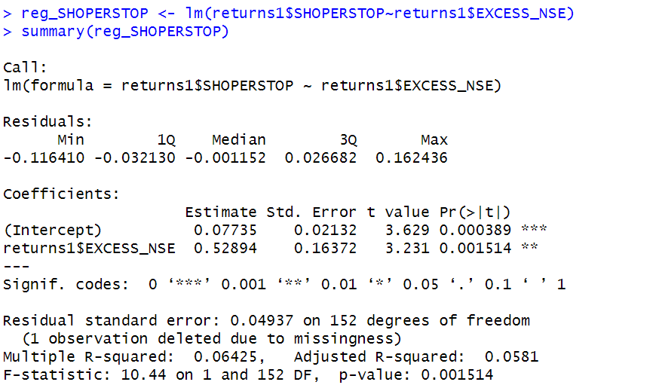

**6.1.1 CAPM Model - Interpretation of Results**

The above figure shows that the Beta for weekly returns (risk unadjusted) is 0.52894, which means that if the market index portfolio’s daily returns rise by 1%, then the weekly returns of SHOPERSTOP will increase by 0.52894%. Also, the beta value is significant at 95% but not at 99% since the p-value is greater than 0.01 but less than 0.05 (0.05> p > 0.01)The intercept value derived from the regression is 0.07735 which means that if the market return is 0%, then SHOPERSTOP will show a 0.07735% return.

## **6.2** **Estimating AR and MA coefficients using ARIMA**

The AR and MA coefficients are obtained using the ACF (Auto-correlation function) and PACF (Partial Auto-correlation function) plots. From Figure 60 it can be seen that stock price data is non-stationary while from Figure 61 we can interpret that the returns of the stock seems to be stationary of integrated or order 1 which means first difference is stationary.

**6.2.1 Augmented Dickey-Fuller Test**

An augmented Dickey-Fuller (ADF) test is performed to check for stationarity, whose results are in Figure 13.

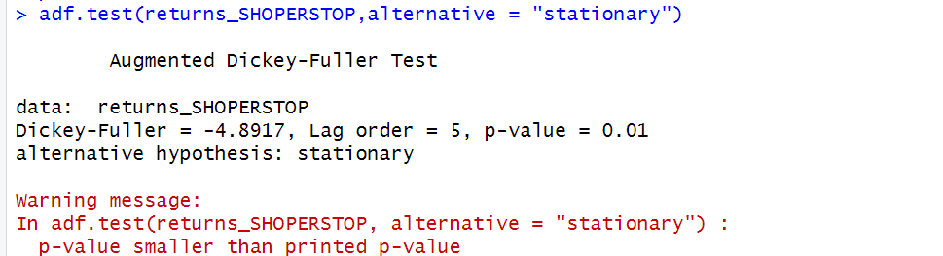

*Figure 63: ADF Test Results for Weekly Returns*

The Augmented Dickey-Fuller test null hypothesis states that a unit root exists, i.e. the series is not-stationary, and the corresponding alternative hypothesis is that the series is stationary. Since the p-value of the test shown above is 0.01, the null hypothesis can be rejected; thus, the series is stationary.The value of ADF Test-statistic: -4.8917.

**6.2.2 ACF Plot**

The sample Autocorrelation function (ACF) plot is used measure the correlation between the present and the lagged values in the series. Lagged values means the past values of the series. Figure 64 shows the formula for calculating ACF at lag k:



*Figure 64: ACF Formula*

The results for of ACF plot for SHOPERSTOPare depicted in Figure 65:

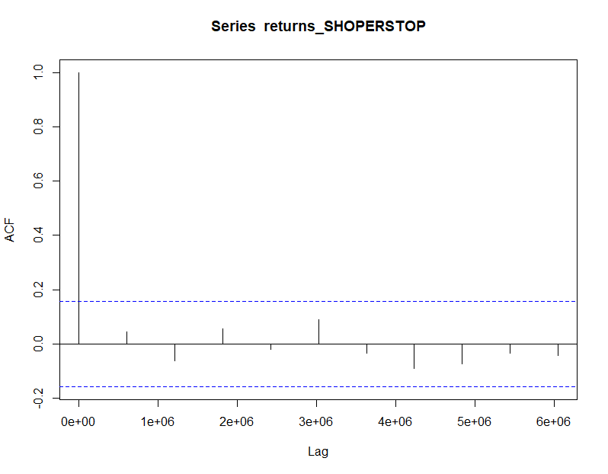

*Figure 65: ACF Plot SHOPERSTOP for Weekly Returns*

From the above plot it can derived that the series is MA(0) model since no lag term except the 0th lag is significant,following values are not significant.

**6.2.3 PACF Plot**

It measures the correlation between an observation k periods ago and the current observation after controlling the observations at intermediate lags i.e., all the lags which are less than k. PACF plots are used to differentiate between AR & ARMA process. Figure 66 shows the formula for calculating PACF:

*Figure 66: PACF Formula*

The results of PACF plot for SHOPERSTOP are depicted in Figure 67:

*Figure 67: PACF Plot SHOPERSTOP for Weekly Return*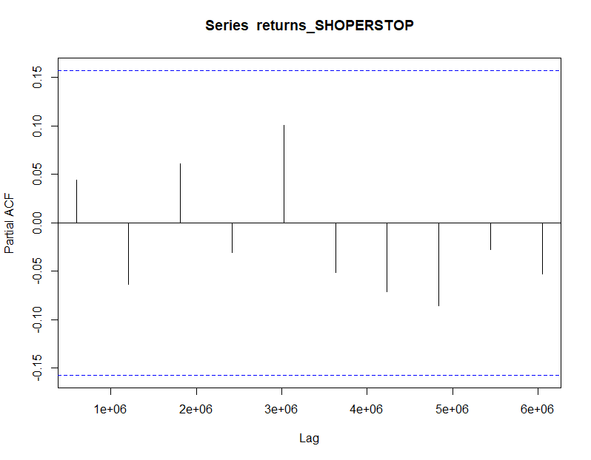

From the above plot it can derived that the series is AR(0) model since only no lag is significant.

**6.2.4 Identification and interpretation of ARIMA model:**

The diagnostic test of the model is shown in Figure.

*Figure 68: Diagnostic Results for Daily Returns*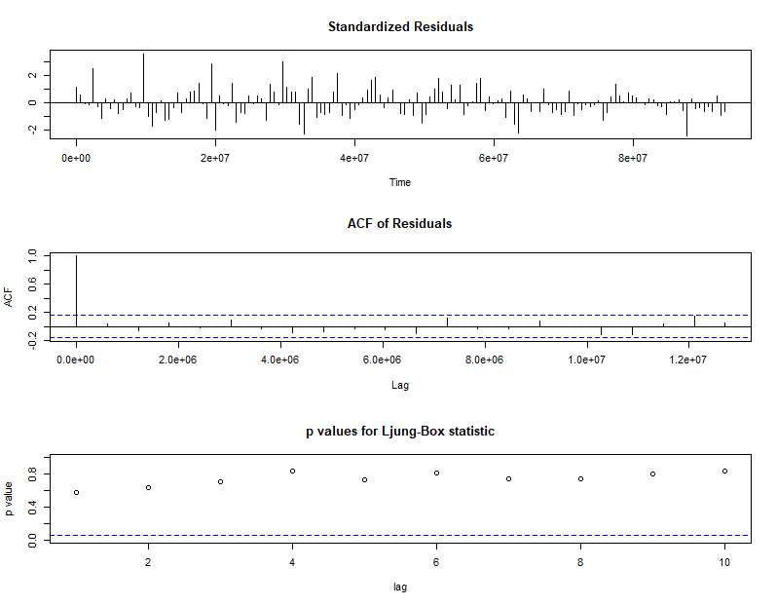

Ljung-Box Test is used for testing the distribution of residuals. Its null hypothesis is that the residuals are independently distributed while alternative hypothesis states that residuals are not independently residuals. From Figure 68 (Chart 3) it can be seen that almost all p-values are greater than 0.05 which means that we can’t reject the null hypothesis i.e., residuals are distributed independently. The normalised residuals time series plot looks to be random and does not show a strong trend, therefore it fits the data well. Also, the Residual autocorrelations are all zero except for one spike.

### **6.2.5** **FORECAST WITH ARIMA MODEL**

Using the ARIMA (0,0,0) model the forecast results have been calculated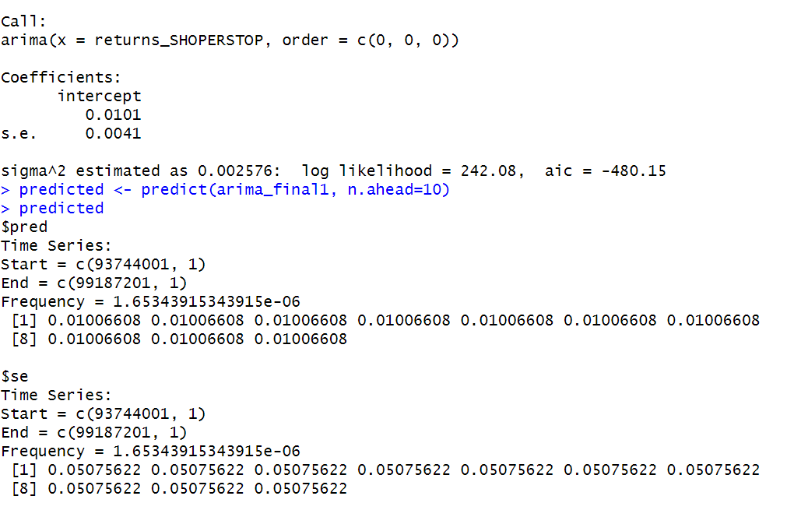

*Figure 69: Forecast for Weekly Returns*

Since all the forecasts for returns are positive, the stock price will increase in the future weeks.

**6.3 GARCH and EGARCH models**

GARCH, or Generalised Autoregressive Conditional Heteroskedasticity, is a method for estimating market volatility while EGARCH (Exponential General Autoregressive Conditional Heteroskedasticity) is also a model for estimating market volatility but with less constraints on the parameters. GARCH (1,1) is the most popular GARCH model. Running GARCH on daily return of SHOPERSTOP yielded the result that are shown in Figure 70: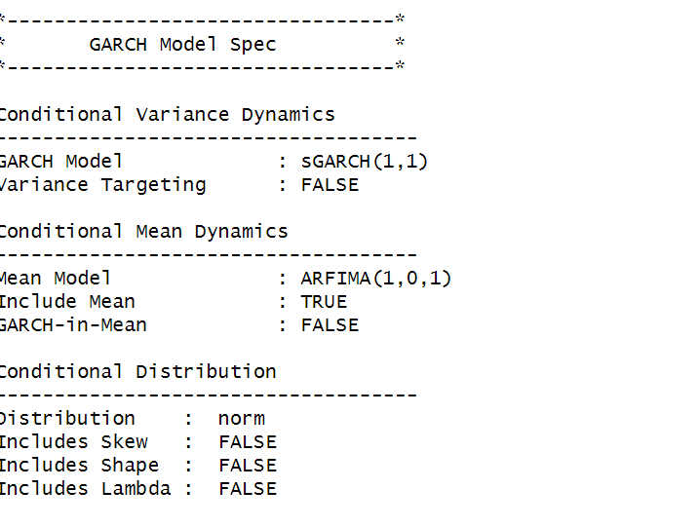

*Figure 70: GARCH Model for Weekly Returns*

From the Figure 70, we can clearly see that GARCH (1,1) is the most appropriate model and by default, the mean model ARFIMA(1,0,1) is taken.

Now the daily returns of SHOPERSTOP were run against EGRACH model and the following results were obtained:

*Figure 71: EGARCH Model for Weekly Returns*

From Figure 71, we can see that EGARCH (1,1) model is obtained and again by default ARFIMA (1,0,1) is taken. The results are similar to that of GARCH model.

After creating both GARCH and EGARCH models now we fit the model using

ugarchfit function which yielded the results that are shown in Figure 72. The interpretation of the results are given after Figure 72.

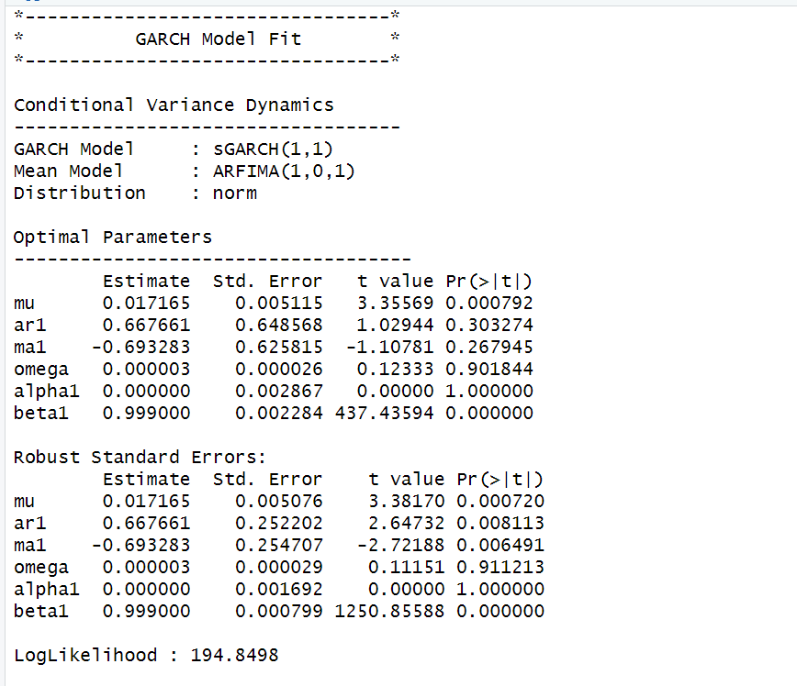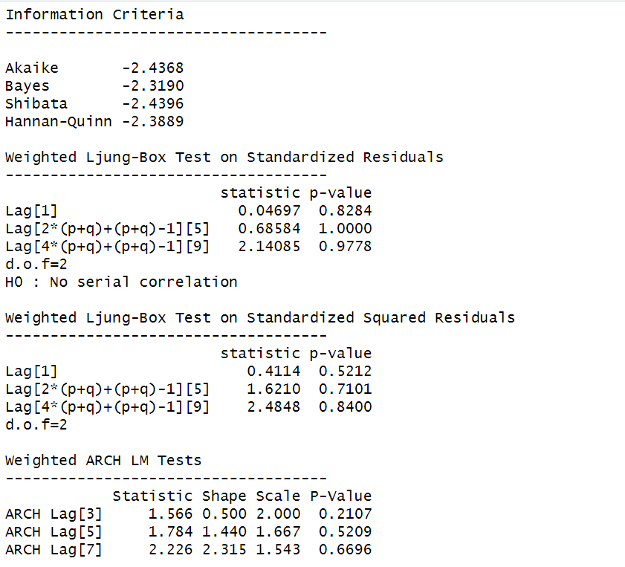

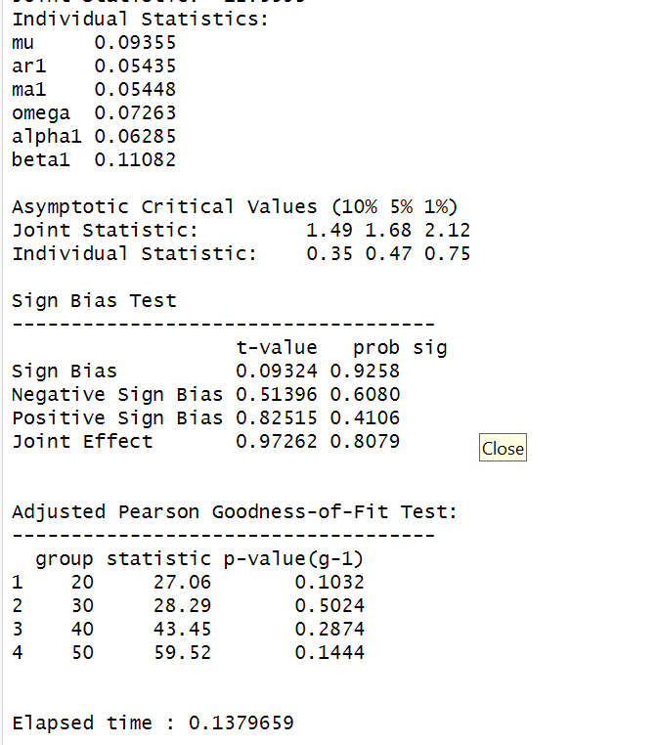

*Figure 72: GARCH Model Fitting for Weekly Returns*

### **6.3.1 Interpretation**

• The Log Likelihood obtained from the model is 194.8498.

• GARCH(1,1) is the best fit model for SHOPERSTOP weekly returns.

• The optimal parameters alpha and beta have significant value while omega is insignificant.

• The Alpha, Omega and Beta obtained from estimated robust standard error shows that omega and alpha are insignificant because p-value is greater than 0.05.

• This model provides the best fit with the fewest parameters because its AIC and BIC values are the lowest of all potential models.

• The p-value for both Standardized Residuals and Squared Residuals are greater than 0.05 which means null hypothesis will be accepted i.e., there is no serial correlation which is good for the model.

• Adjusted Pearson Goodness of Fit Test gave all the p-values greater than 0.05 which implies that null hypothesis can’t be rejected which means there is no significant difference between observed value and expected value.

### **6.3.2** **Forecast using GARCH**

The forecasted results using GARCH model are shown in Figure 31. The results show that the returns will be positive for the next 10 days with a value of around 1.72% having a standard deviation close to 6.718%. Positive return means that SHOPERSTOP stock price will rise in the next 10 days which is same as what was suggested by ARIMA model.

*Figure 73: GARCH Model Prediction for Weekly Return*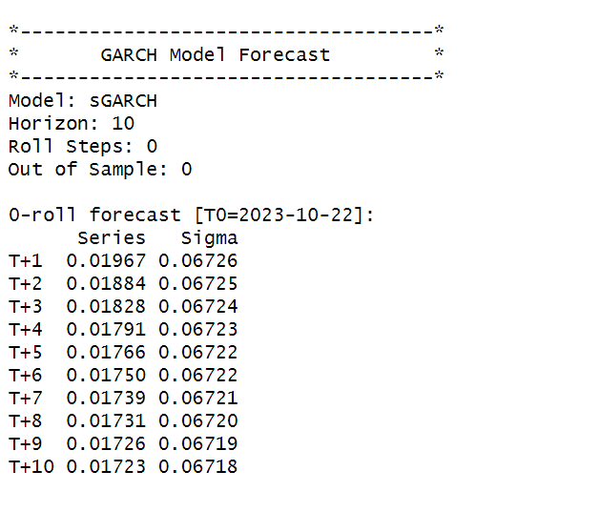

**SECTION 7:SHOPERSTOP(Monthly Returns)**

Figure 75 shows the monthly returns of the SHOPERSTOPstock price from 2nd November 2020 to 25th October 2023, and the CLOSING prices were used to calculate the returns, which are shown in Figure 74.



*Figure 74: Monthly Prices of SHOPERSTOP*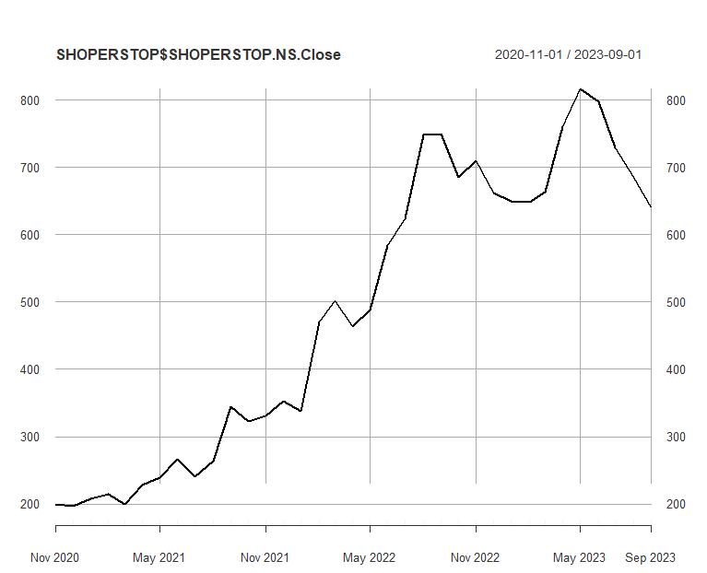

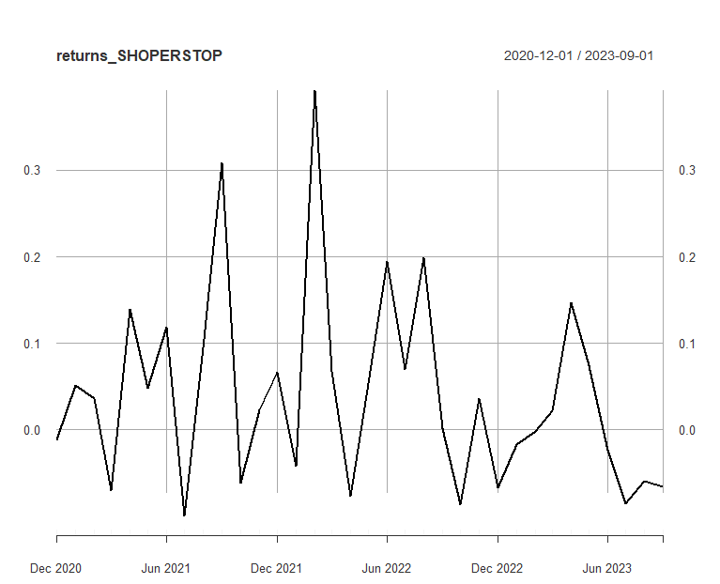

*Figure 75:Monthly Returns of SHOPERSTOP*

Next, the excess returns, denoted as E(R) - R_f, are subjected to regression against the market risk premium R_m - R_f. The outcomes of this regression are illustrated in Figure 76.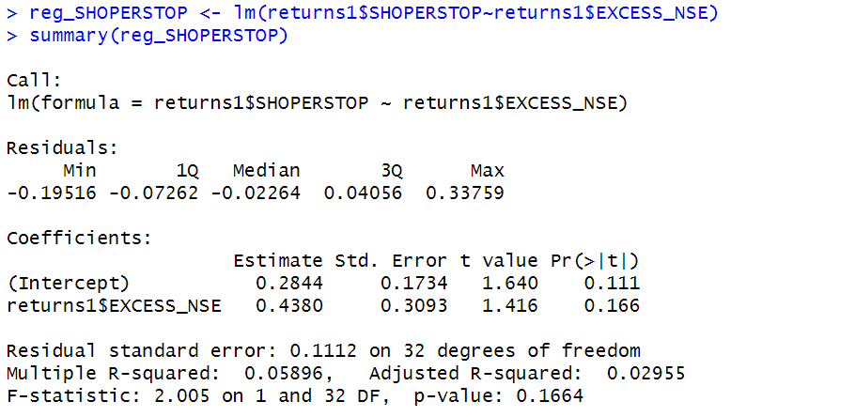

*Figure 76: Regression results of CAPM for Monthly Returns*

**7.1.1 CAPM Model - Interpretation of Results**

Figure shows that the Beta for monthly returns (risk unadjusted) is 0.4380, which means that if the market index portfolio’s daily returns rise by 1%, then the monthly returns of SHOPERSTOP will increase by 0.4380%.The intercept value derived from the regression is 0.2844, but it is also not statistically significant. Therefore, it may be appropriate to ignore or treat it as 0%, which means that if the market return is 0%, then SHOPERSTOP will show a 0.2844% return.

## **7.2** **Estimating AR and MA coefficients using ARIMA**

The AR and MA coefficients are obtained using the ACF (Auto-correlation function) and PACF (Partial Auto-correlation function) plots. From Figure 74 it can be seen that stock price data is non-stationary while from Figure 75 we can interpret that the returns of the stock seems to be stationary of integrated or order 1 which means first difference is stationary.

**7.2.1 Augmented Dickey-Fuller Test**

An augmented Dickey-Fuller (ADF) test is performed to check for stationarity, whose results are in Figure 35.

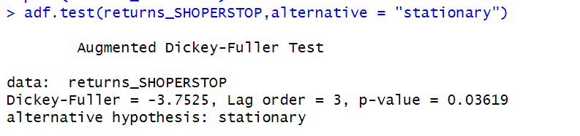 *Figure 77: ADF Test Results for Monthly Returns*

The Augmented Dickey-Fuller test null hypothesis states that a unit root exists, i.e. the series is not-stationary, and the corresponding alternative hypothesis is that the series is stationary. The obtained p-value of 0.03619 suggests that we fail to reject the null hypothesis, indicating that the series is non-stationary. TThe value of ADF Test-statistic: -3.7525.

**7.2.2 ACF Plot**

The sample Autocorrelation function (ACF) plot is used measure the correlation between the present and the lagged values in the series. Lagged values means the past values of the series. Figure 78 shows the formula for calculating ACF at lag k:



*Figure 78: ACF Formula*

The results for of ACF plot for SHOPERSTOP are depicted in Figure 79:

*Figure 79: ACF Plot SHOPERSTOP for MonthlyReturns*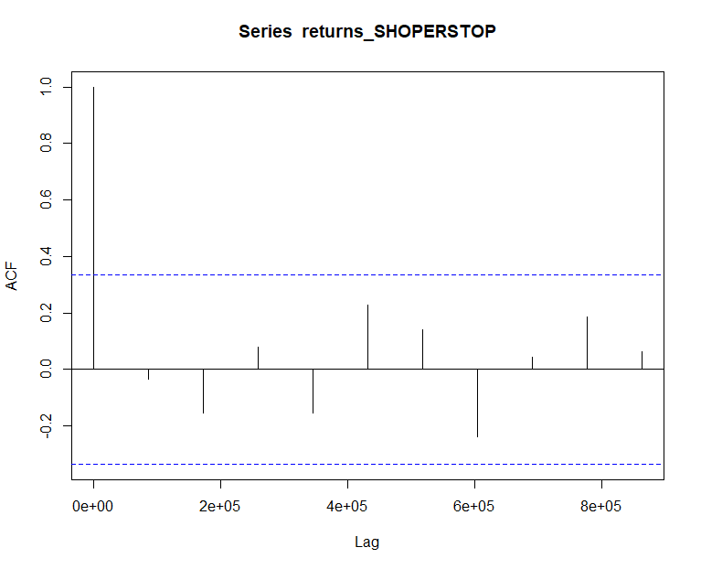

From the above plot it can derived that the series is MA(0) model since no lag term except the 0th lag is significant,following values are not significant.

**7.2.3 PACF Plot**

It measures the correlation between an observation k periods ago and the current observation after controlling the observations at intermediate lags i.e., all the lags which are less than k. PACF plots are used to differentiate between AR & ARMA process. Figure 80 shows the formula for calculating PACF:

*Figure 80: PACF Formula*

The results of PACF plot for SHOPERSTOP are depicted in Figure 81:

*Figure 81: PACF Plot SHOPERSTOP for Monthly Return*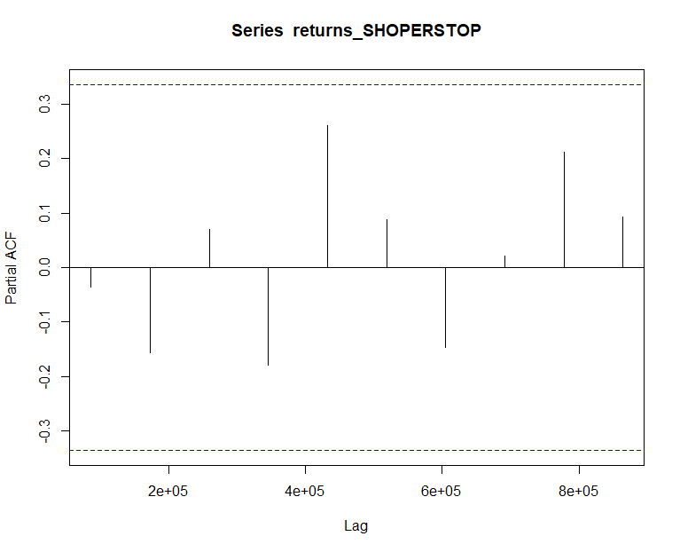

From the above plot it can derived that the series is AR(0) model since only no lag is significant.

**7.2.4 Identification and interpretation of ARIMA model:**

The diagnostic test of the model is shown in Figure.

*Figure 82: Diagnostic Results for Monthly Returns*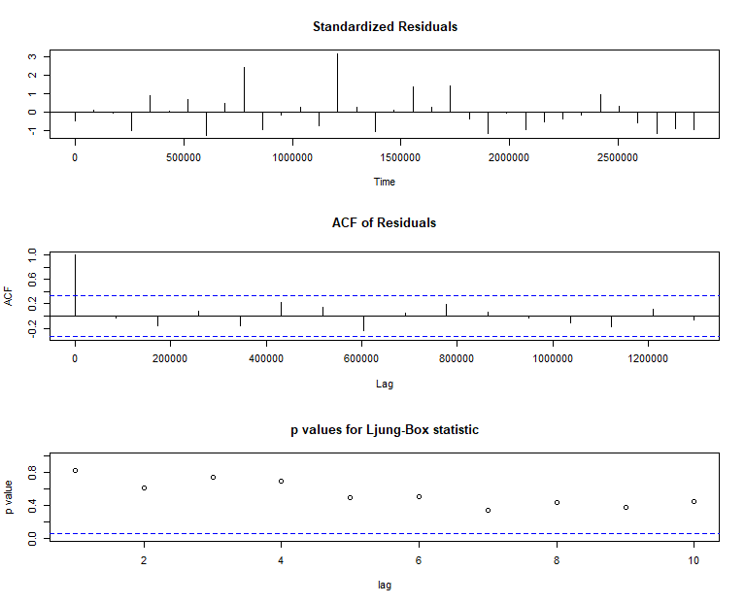

Ljung-Box Test is used for testing the distribution of residuals. Its null hypothesis is that the residuals are independently distributed while alternative hypothesis states that residuals are not independently residuals. From Figure 82(Chart 3) it can be seen that almost all p-values are greater than 0.05 which means that we can’t reject the null hypothesis i.e., residuals are distributed independently. The normalised residuals time series plot looks to be random and does not show a strong trend, therefore it fits the data well. Also, the Residual autocorrelations are all zero except for one spike.

### **7.2.5** **FORECAST WITH ARIMA MODEL**

Using the ARIMA (0,0,0) model the forecast results have been calculated are shown in Figure 83:

*Figure 83: Forecast for Monthly Returns*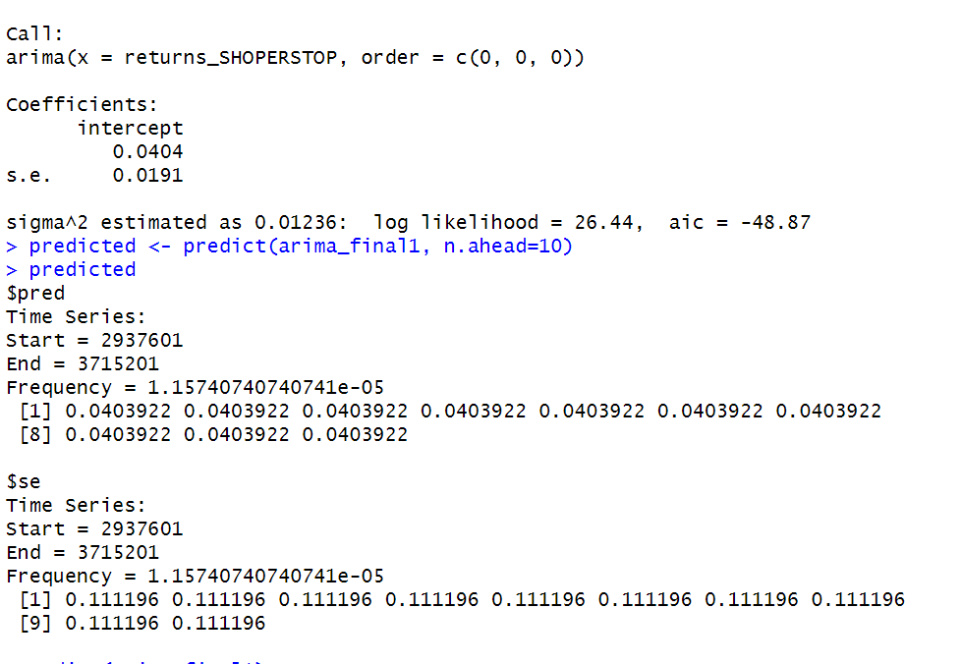

Since all the forecasts for returns are positive, the stock price will increase in the future weeks.

**7.3 GARCH and EGARCH models**

GARCH, or Generalised Autoregressive Conditional Heteroskedasticity, is a method for estimating market volatility while EGARCH (Exponential General Autoregressive Conditional Heteroskedasticity) is also a model for estimating market volatility but with less constraints on the parameters. GARCH (1,1) is the most popular GARCH model. Running GARCH on monthly return of SHOPERSTOP yielded the result that are shown in Figure 84: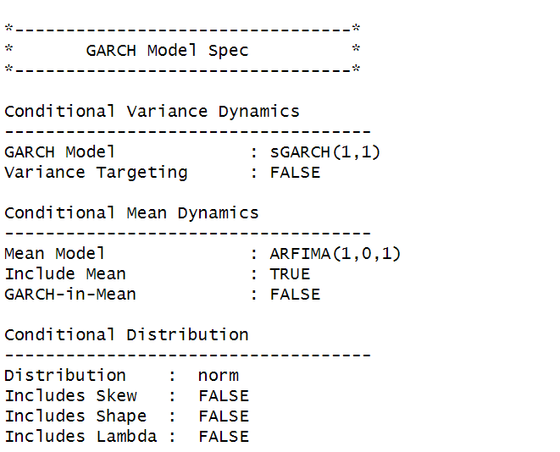

*Figure 84: GARCH Model for Monthly Returns*

From the Figure 42. we can clearly see that GARCH (1,1) is the most appropriate model and by default, the mean model ARFIMA(1,0,1) is taken.

Now the monthly returns of SHOPERSTOP were run against EGRACH model and the following results were obtained:

*Figure 85: EGARCH Model for Monthly Returns*

From Figure 85, we can see that EGARCH (1,1) model is obtained and again by default ARFIMA (1,0,1) is taken. The results are similar to that of GARCH model.

After creating both GARCH and EGARCH models now we fit the model using

ugarchfit function which yielded the results that are shown in Figure 86. The interpretation of the results are given after Figure 86.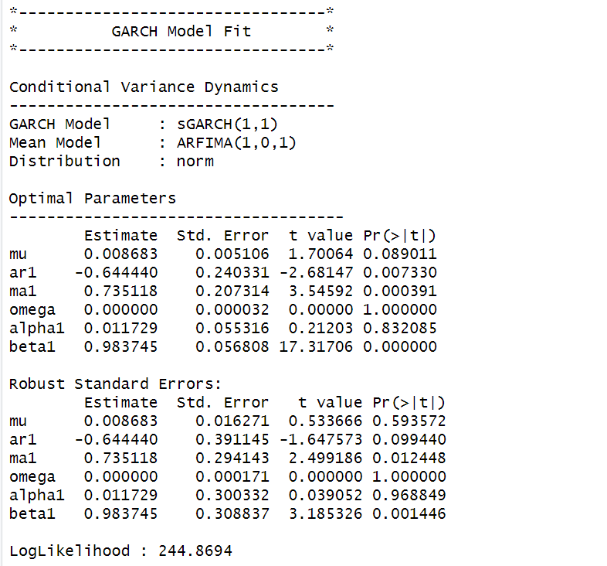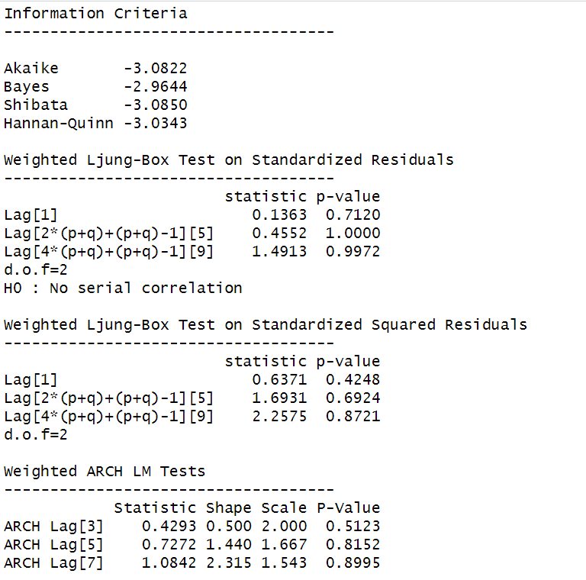

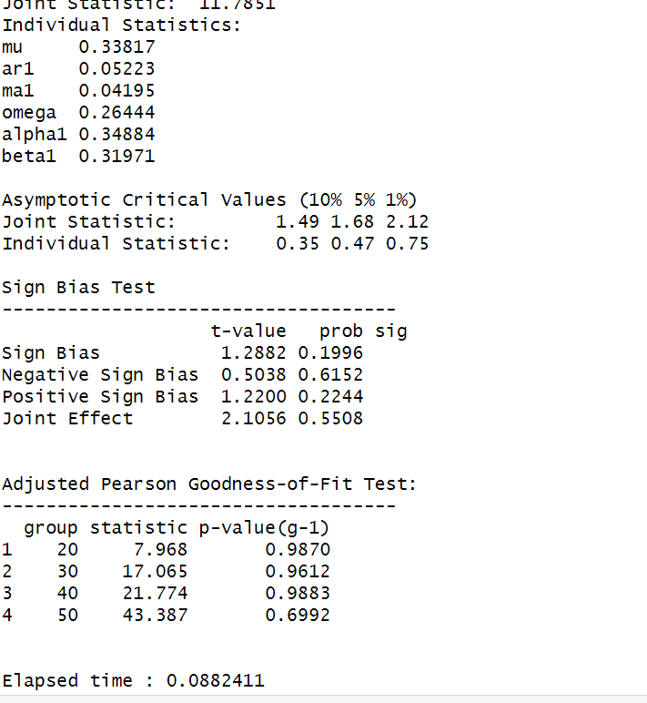

*Figure 86: GARCH Model Fitting for Monthly Returns*

**7.3.1 Interpretation**

• The Log Likelihood obtained from the model is 244.8694.

• GARCH(1,1) is the best fit model for SHOPERSTOP monthly returns.

• The optimal parameters alpha and beta have significant value while omega is insignificant.

• The Alpha, Omega and Beta obtained from estimated robust standard error shows that omega and alpha are insignificant because p-value is greater than 0.05.

• This model provides the best fit with the fewest parameters because its AIC and BIC values are the lowest of all potential models.

• The p-value for both Standardized Residuals and Squared Residuals are greater than 0.05 which means null hypothesis will be accepted i.e., there is no serial correlation which is good for the model.

• Adjusted Pearson Goodness of Fit Test gave all the p-values greater than 0.05 which implies that null hypothesis can’t be rejected which means there is no significant difference between observed value and expected value.

### **7.3.2** **Forecast using GARCH**

The forecasted results using GARCH model are shown in Figure 87.. The results show that the returns will be positive for the next 10 days with a value of around 0.86% having a standard deviation close to 3.76%. Positive return means that SHOPERSTOP stock price will rise in the next 10 days which is same as what was suggested by ARIMA model.

*Figure 87: GARCH Model Prediction for Monthly Return*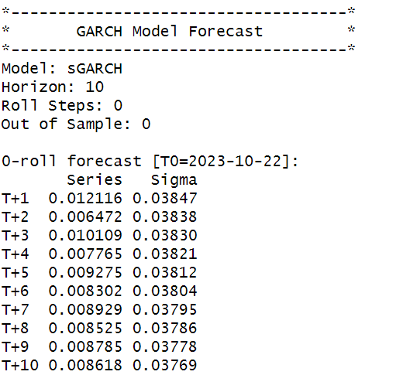



**About STEELXIND**

As a leader in the steel sector, Steel Exchange India Ltd. is dedicated to providing top-notch steel products and advancing the country's infrastructure development. It was founded in 1999 and has grown to become a major force in the steel industry by demonstrating excellence, innovation, and a strong dedication to the project.

Steel Exchange India Ltd., a publicly traded corporation that specialises in producing and distributing a wide variety of steel products, has profoundly influenced the steel industry's current state. At its foundation was a vision to address the expanding need in the rapidly developing Indian market for durable and sustainable steel solutions.

Steel Exchange India Ltd. was established under the visionary leadership of Satish Kumar Bandi and has since expanded and strengthened, adjusting to market trends and technological developments. The fact that steel is so important to the manufacturing, infrastructure, and construction industries drove the conditions that led to its founding.

The company's steadfast dedication to product quality, innovation, and customer satisfaction demonstrates the company's overall greatness. The company serves a broad range of industries, including infrastructure, automotive, construction, and more, with its extensive product portfolio.

By continuously making investments in cutting-edge technology and environmentally friendly operations, Steel Exchange India Ltd has established itself as a reputable and progressive force in the steel sector. The company's commitment to corporate responsibility and business excellence is demonstrated by its observance of strict quality standards and environmentally friendly practices.

In conclusion, Steel Exchange India Ltd. has been a vital supplier of steel solutions, playing a significant role in India's industrial development. The company has a history of integrity, innovation, and societal development, and it is still a major player in the development of the Indian steel industry. Steel Exchange India Ltd is well-positioned for a future characterised by sustained expansion, technological progress, and an unwavering dedication to excellence in the steel sector.

**SECTION 8: STEELXIND (Daily Returns)**

The CAPM model is defined as:

E(R) = Rf + Beta(Rm-Rf)

where,

E(R): Expected return of the firm

Rf: Risk free rate

Rm: Returns of the market

Beta is calculated by regressing expected returns of the stock i.e., STEELXIND on Market Risk Premium (Rm-Rf). It is the slope parameter that is evaluated from the regression model.

The beta is a measure of how sensitive the security is to the changes in the market index. For index portfolio National Stock Exchange (NSE) was taken into consideration.

For example, a beta of 1.5 means that our portfolio is 50% more sensitive when compared with market index.

**8.1 CAPM Model - Estimating the Beta of the Company**

Figure 89 shows the daily returns of the STEELXIND stock price from 2nd November 2020 to 25th October 2023, and the CLOSING prices were used to calculate the returns, which are shown in Figure 88.

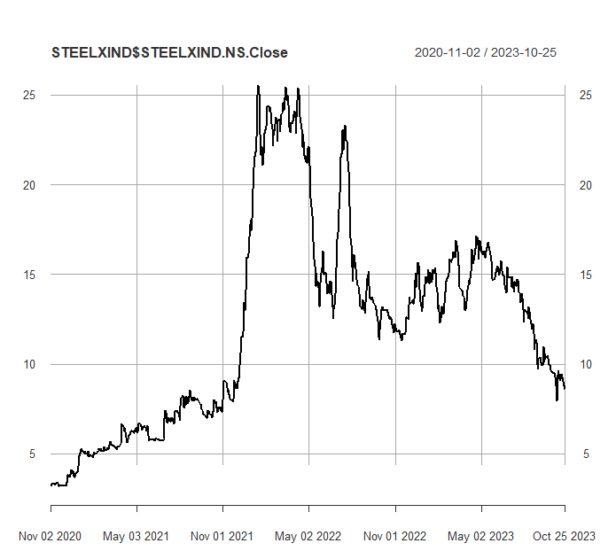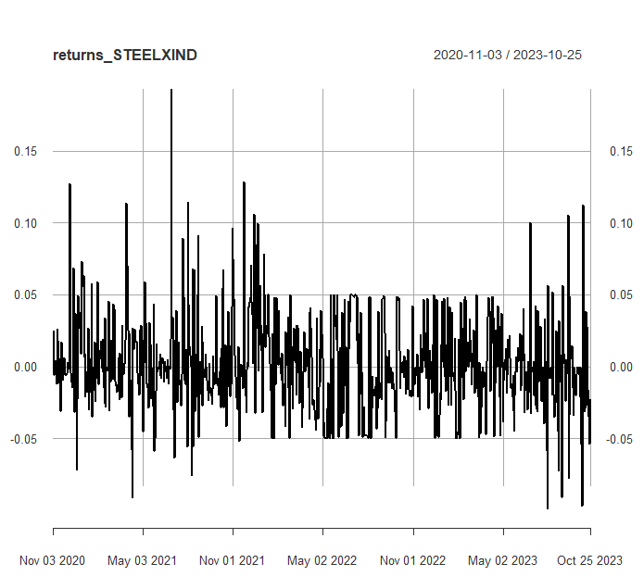

*Figure 89: Daily Returns of STEELXIND*

Next, the excess returns, denoted as E(R) - R_f, are subjected to regression against the market risk premium R_m - R_f. The outcomes of this regression are illustrated in Figure 90.

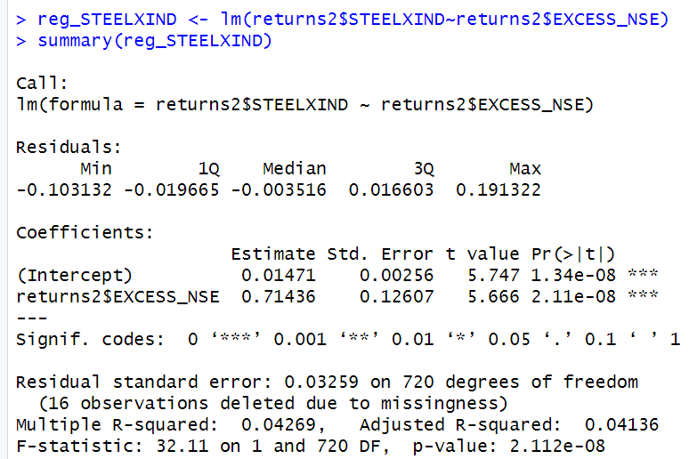 *Figure 90: Regression results of CAPM for Daily Returns*

**8.1.1 CAPM Model - Interpretation of Results**

Figure 4 shows that the Beta for daily returns (risk unadjusted) is 0.71436, which means that if the market index portfolio’s daily returns rise by 1%, then the daily returns of STEELXIND will increase by 0.7%. Moreover, the beta value is statistically significant at both the 95% and 99% confidence levels, given that the p-value is less than 0.01 (p < 0.01).

The intercept value derived from the regression is 0.01471 which means that if the market return is 0%, then STEELXIND will show a 0.01471% return.

**8.2 Estimating AR and MA coefficients using ARIMA**

The AR and MA coefficients are obtained using the ACF (Auto-correlation function) and PACF (Partial Auto-correlation function) plots. From Figure 2 it can be seen that stock price data is non-stationary while from Figure 3 we can interpret that the returns of the stock seem to be stationary of integrated or order 1 which means first difference is stationary.

**8.2.1 Augmented Dickey-Fuller Test**

An augmented Dickey-Fuller (ADF) test is performed to check for stationarity, whose results are in Figure 91.

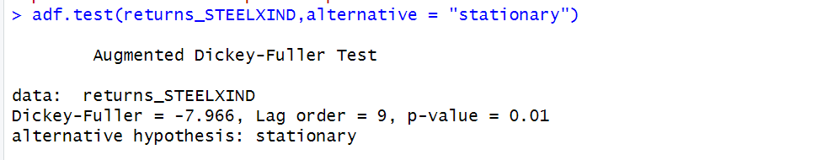

*Figure 91: ADF Test Results for Daily Returns*

The Augmented Dickey-Fuller test null hypothesis states that a unit root exists, i.e. the series is not-stationary, and the corresponding alternative hypothesis is that the series is stationary. Since the p-value of the test shown above is 0.01, the null hypothesis can be rejected; thus, the series is stationary.The value of ADF Test-statistic: -7.966.

**8.2.2 ACF Plot**

The sample Autocorrelation function (ACF) plot is used measure the correlation between the present and the lagged values in the series. Lagged values means the past values of the series. Figure 7 shows the formula for calculating ACF at lag k:



*Figure 92: ACF Formula*

The results for of ACF plot for STEELXIND are depicted in Figure 93:

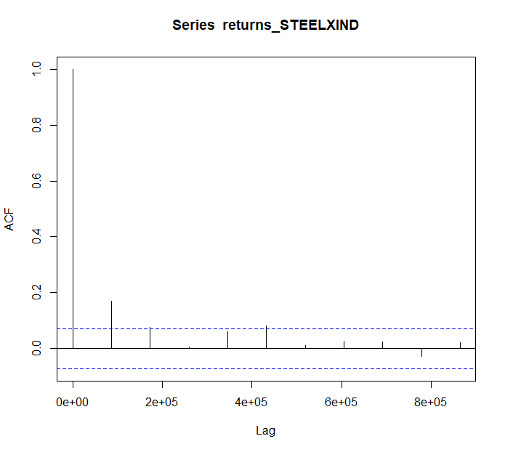

*Figure 93: ACF Plot STEELXIND for Daily Returns*

From the above plot it can derived that the series is MA(0) model since no lag term except the 0th lag is significant,following values are not significant.

**2.2.3 PACF Plot**

It measures the correlation between an observation k periods ago and the current observation after controlling the observations at intermediate lags i.e., all the lags which are less than k. PACF plots are used to differentiate between AR & ARMA process. Figure 94 shows the formula for calculating PACF:

*Figure 94: PACF Formula*

The results of PACF plot for STEELXIND are depicted in Figure 95:

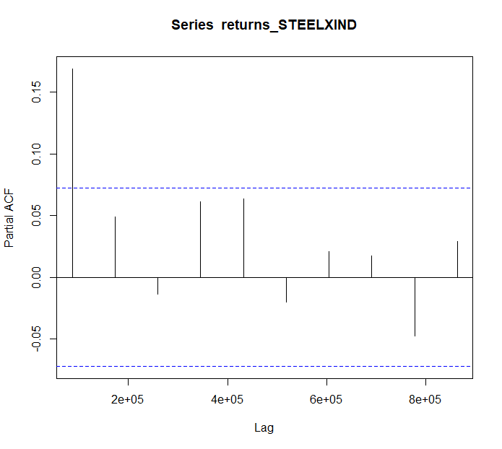

*Figure 95: PACF Plot STEELXIND* *for Daily Return*

From the above plot it can derived that the series is AR(1) model since only one lag is significant.

**2.2.4 Identification and interpretation of ARIMA model:**

The diagnostic test of the model is shown in Figure.

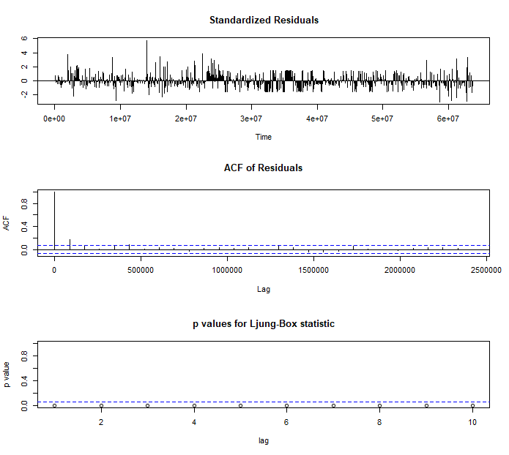

*Figure 96: Diagnostic Results for Daily Returns*

Ljung-Box Test is used for testing the distribution of residuals. Its null hypothesis is that the residuals are independently distributed while alternative hypothesis states that residuals are not independently residuals. From Figure 96(Chart 3) it can be seen that almost all p-values are greater than 0.05 which means that we can’t reject the null hypothesis i.e., residuals are distributed independently. The normalised residuals time series plot looks to be random and does not show a strong trend, therefore it fits the data well. Also, the Residual autocorrelations are all zero except for one spike.

### **2.2.5** **FORECAST WITH ARIMA MODEL**

Using the ARIMA (0,0,0) model the forecast results have been calculated are shown in Figure 97:

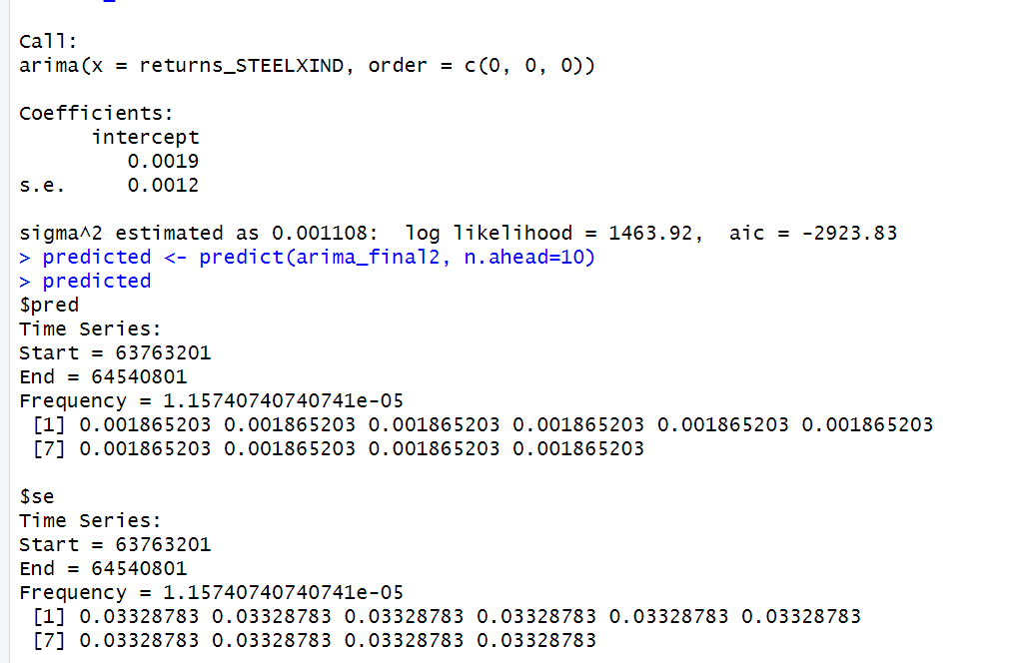

*Figure 97: Forecast for Daily Returns*

Since all the forecasts for returns are positive, the stock price will increase in the future weeks.

**8.3 GARCH and EGARCH models**

GARCH, or Generalised Autoregressive Conditional Heteroskedasticity, is a method for estimating market volatility while EGARCH (Exponential General Autoregressive Conditional Heteroskedasticity) is also a model for estimating market volatility but with less constraints on the parameters. GARCH (1,1) is the most popular GARCH model. Running GARCH on daily return of STEELXIND yielded the result that are shown in Figure 98:

*Figure 98: GARCH Model for Daily Returns*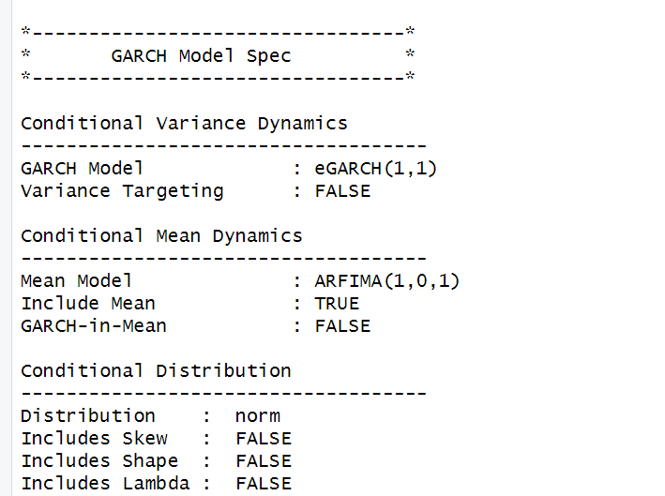

From the Figure 98, we can clearly see that GARCH (1,1) is the most appropriate model and by default, the mean model ARFIMA(1,0,1) is taken.

Now the daily returns of STEELXIND were ru against EGRACH model and the following results were obtained:

*Figure 99: EGARCH Model for Daily Returns*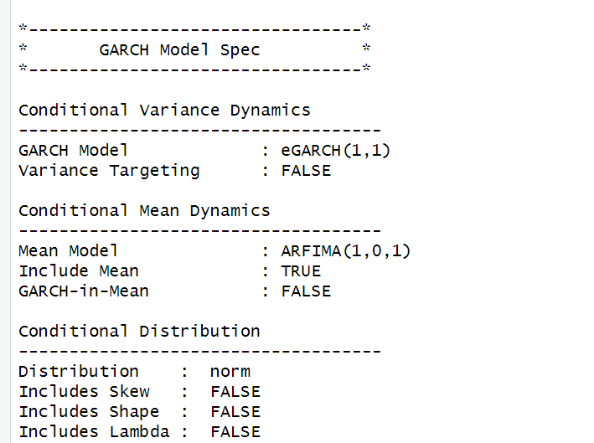

From Figure 99, we can see that EGARCH (1,1) model is obtained and again by default ARFIMA (1,0,1) is taken. The results are similar to that of GARCH model.

After creating both GARCH and EGARCH models now we fit the model using

ugarchfit function which yielded the results that are shown in Figure 100. The interpretation of the results are given after Figure 100.

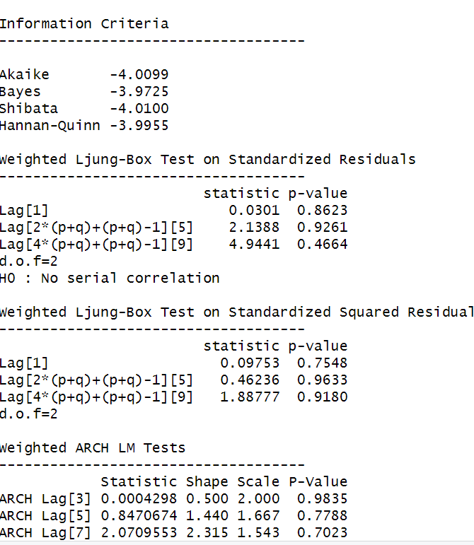

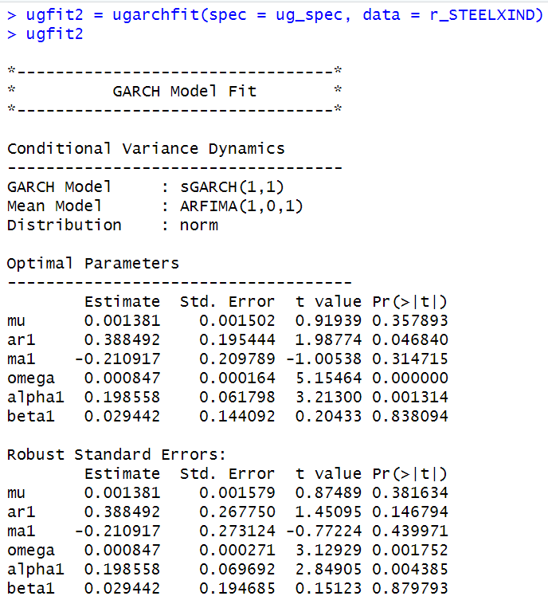

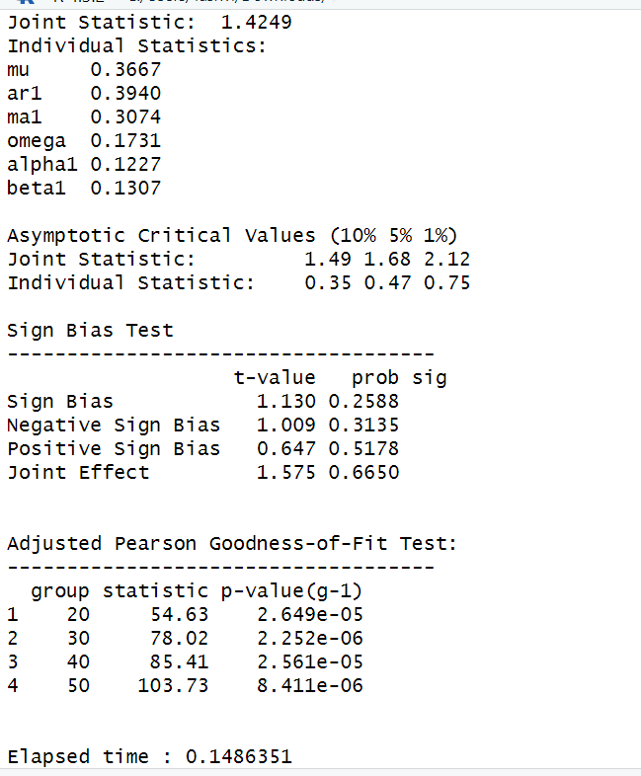

*Figure 100: GARCH Model Fitting for Daily Returns*

### **8.3.1 Interpretation**

• The Log Likelihood obtained from the model is 1445.627.

• GARCH(1,1) is the best fit model for STEELXIND daily returns.

• The optimal parameters alpha and beta have significant value while omega is insignificant.

• The Alpha, Omega and Beta obtained from estimated robust standard error shows that omega and alpha are insignificant because p-value is greater than 0.05.

• This model provides the best fit with the fewest parameters because its AIC and BIC values are the lowest of all potential models.

• The p-value for both Standardized Residuals and Squared Residuals are greater than 0.05 which means null hypothesis will be accepted i.e., there is no serial correlation which is good for the model.

• Adjusted Pearson Goodness of Fit Test gave all the p-values greater than 0.05 which implies that null hypothesis can’t be rejected which means there is no significant difference between observed value and expected value.

### **8.3.2** **Forecast using GARCH**

The forecasted results using GARCH model are shown in Figure 101. The results show that the returns will be positive for the next 10 days with a value of around 0.137% having a standard deviation close to 3.312%. Positive return means that STEELXIND stock price will rise in the next 10 days which is same as what was suggested by ARIMA model.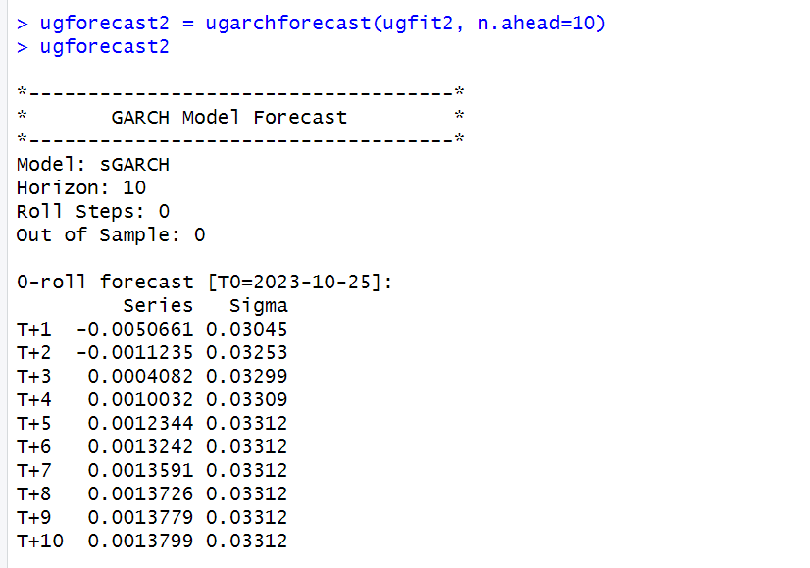

*Figure 101: GARCH Model Prediction for Daily Returns*

**SECTION 9: STEELXIND (Weekly Returns)**

Figure 103 shows the weekly returns of the STEELXIND stock price from 2nd November 2020 to 25th October 2023, and the CLOSING prices were used to calculate the returns, which are shown in Figure 102.

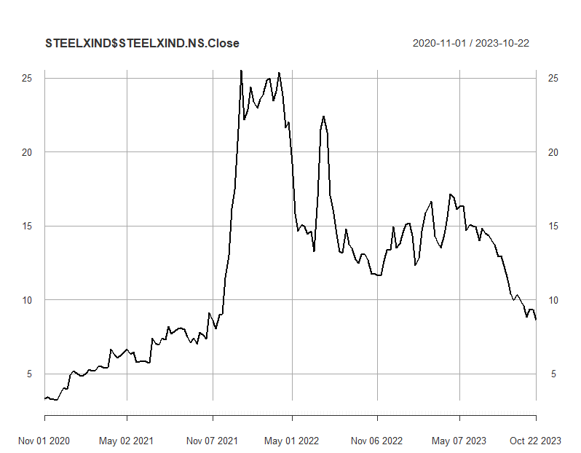

*Figure 102: Weekly Prices of STEELXIND*

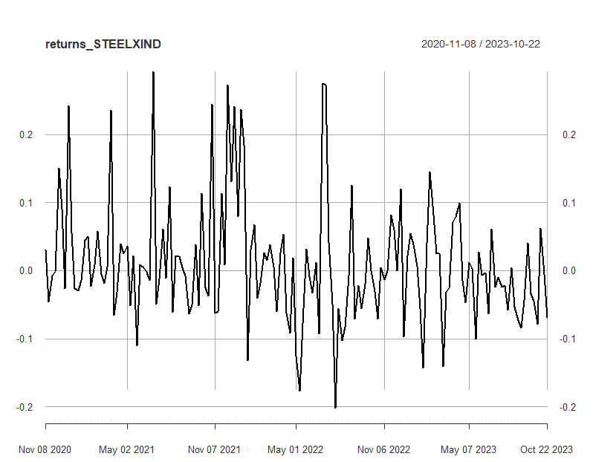

*Figure 103: Weekly Returns of STEELXIND*

Next, the excess returns, denoted as E(R) - R_f, are subjected to regression against the market risk premium R_m - R_f. The outcomes of this regression are illustrated in Figure 104

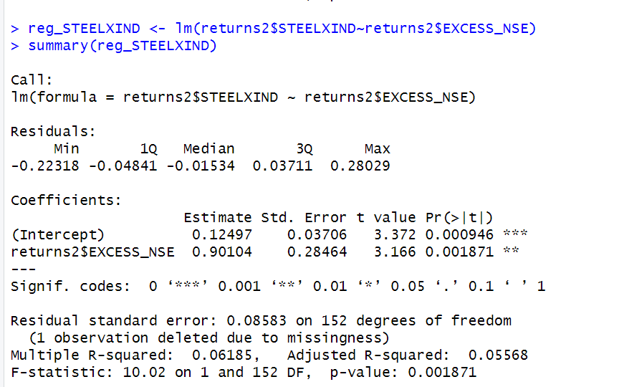  *Figure 104: Regression results of CAPM for Weekly Returns*

**9.1.1 CAPM Model - Interpretation of Results**

The above figure shows that the Beta for weekly returns (risk unadjusted) is 0.90104, which means that if the market index portfolio’s daily returns rise by 1%, then the daily returns of STEELXIND will increase by 0.90104%. Also, the beta value is significant at 95% but not at 99% since the p-value is greater than 0.01 but less than 0.05 (0.05> p > 0.01)The intercept value derived from the regression is 0.12497 which means that if the market return is 0%, then STEELXIND will show a 0.12497% return.

## **9.2** **Estimating AR and MA coefficients using ARIMA**

The AR and MA coefficients are obtained using the ACF (Auto-correlation function) and PACF (Partial Auto-correlation function) plots. From Figure 102 it can be seen that stock price data is non-stationary while from Figure 103 we can interpret that the returns of the stock seems to be stationary of integrated or order 1 which means first difference is stationary.

**9.2.1 Augmented Dickey-Fuller Test**

An augmented Dickey-Fuller (ADF) test is performed to check for stationarity, whose results are in Figure 104.

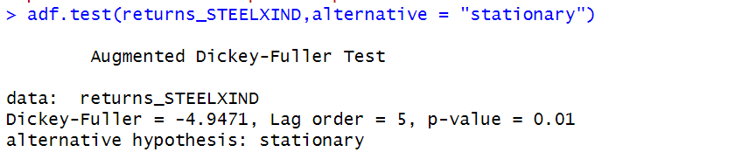

*Figure 105: ADF Test Results for Weekly Returns*

The Augmented Dickey-Fuller test null hypothesis states that a unit root exists, i.e. the series is not-stationary, and the corresponding alternative hypothesis is that the series is stationary. Since the p-value of the test shown above is 0.01, the null hypothesis can be rejected; thus, the series is stationary.The value of ADF Test-statistic: -4.9471.

**9.2.2 ACF Plot**

The sample Autocorrelation function (ACF) plot is used measure the correlation between the present and the lagged values in the series. Lagged values means the past values of the series. Figure 106 shows the formula for calculating ACF at lag k:



*Figure 106: ACF Formula*

The results for of ACF plot for STEELXIND are depicted in Figure 107:

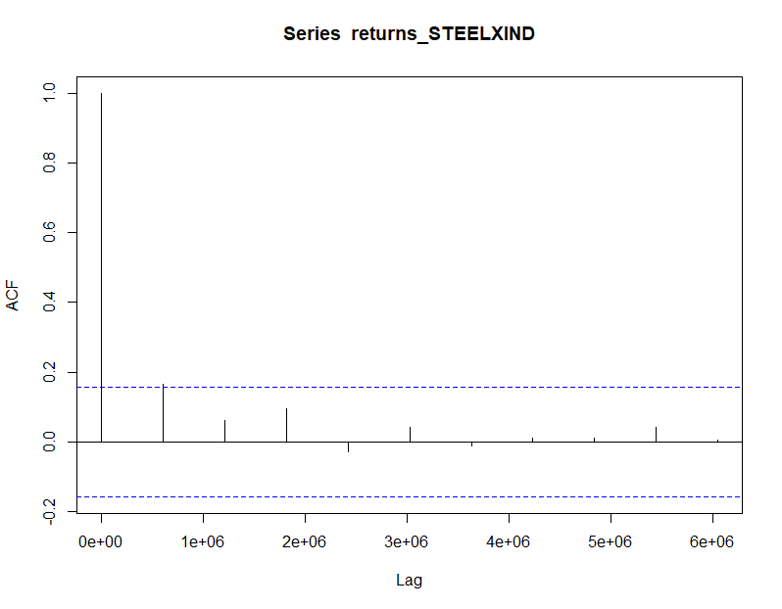

*Figure 107: ACF Plot STEELXIND for Weekly Returns*

From the above plot it can derived that the series is MA(0) model since no lag term except the 0th lag is significant,following values are not significant.

**9.2.3 PACF Plot**

It measures the correlation between an observation k periods ago and the current observation after controlling the observations at intermediate lags i.e., all the lags which are less than k. PACF plots are used to differentiate between AR & ARMA process. Figure 108 shows the formula for calculating PACF:

*Figure 108: PACF Formula*

The results of PACF plot for STEELXIND are depicted in Figure 109:

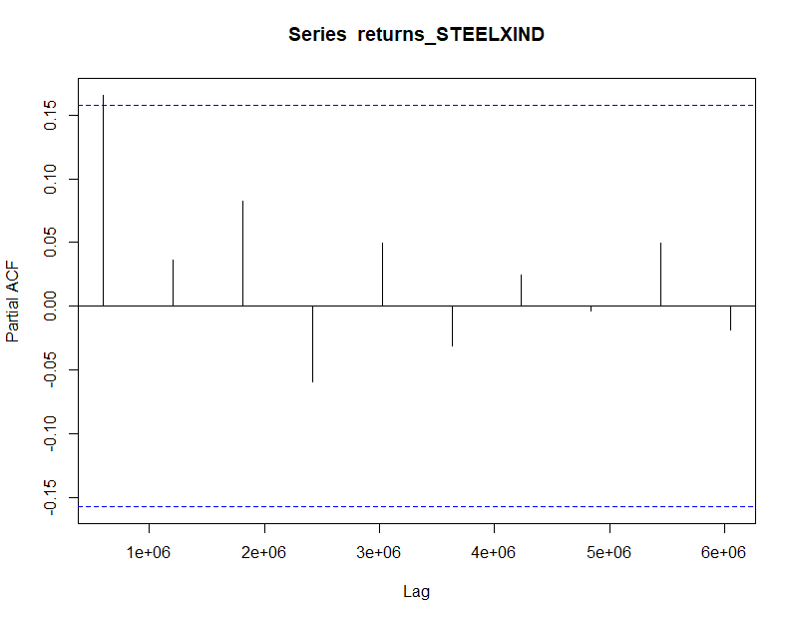

*Figure 109: PACF Plot STEELXIND for Weekly Return*

From the above plot it can derived that the series is AR(0) model since only no lag is significant.

**9.2.4 Identification and interpretation of ARIMA model:**

The diagnostic test of the model is shown in Figure.

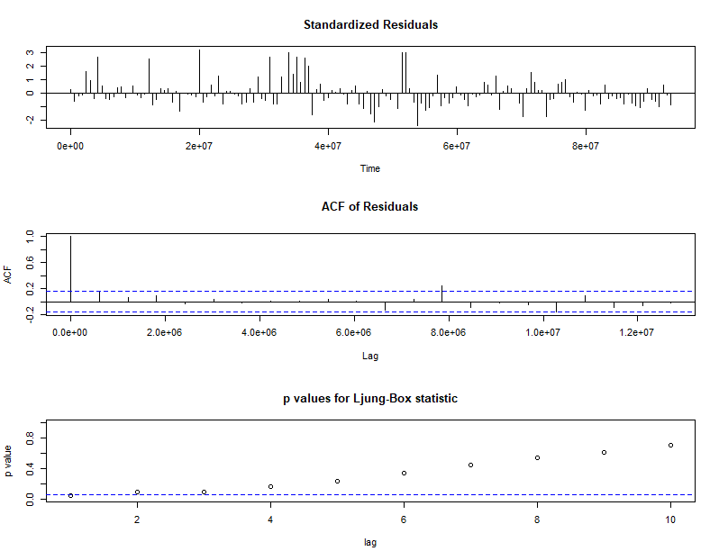

*Figure 110: Diagnostic Results for Weekly Returns*

Ljung-Box Test is used for testing the distribution of residuals. Its null hypothesis is that the residuals are independently distributed while alternative hypothesis states that residuals are not independently residuals. From Figure 110 (Chart 3) it can be seen that almost all p-values are greater than 0.05 which means that we can’t reject the null hypothesis i.e., residuals are distributed independently. The normalised residuals time series plot looks to be random and does not show a strong trend, therefore it fits the data well. Also, the Residual autocorrelations are all zero except for one spike.

### **9.2.5** **FORECAST WITH ARIMA MODEL**

Using the ARIMA (0,0,0) model the forecast results have been calculated are shown in Figure 111:

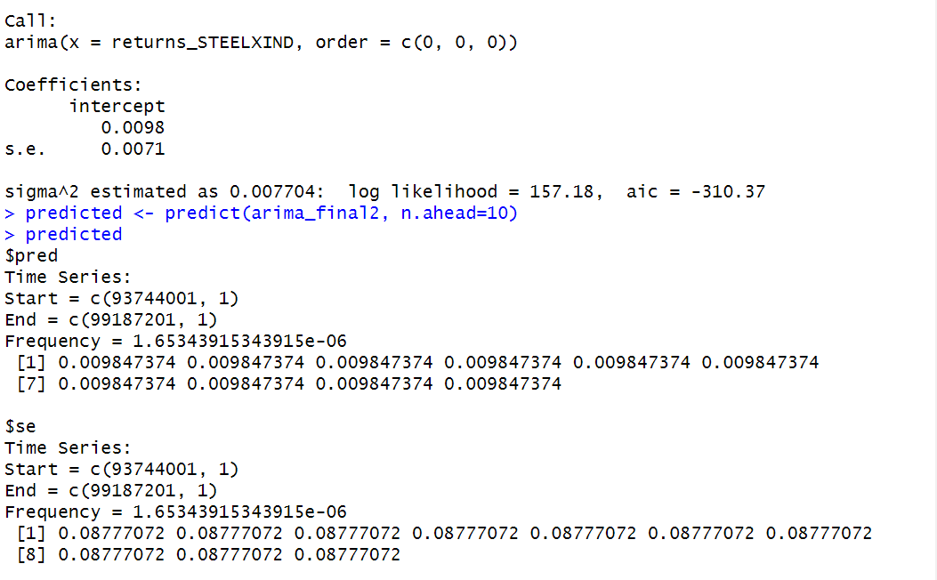

*Figure 111: Forecast for Weekly Returns*

Since all the forecasts for returns are positive, the stock price will increase in the future weeks.

**9.3 GARCH and EGARCH models**

GARCH, or Generalised Autoregressive Conditional Heteroskedasticity, is a method for estimating market volatility while EGARCH (Exponential General Autoregressive Conditional Heteroskedasticity) is also a model for estimating market volatility but with less constraints on the parameters. GARCH (1,1) is the most popular GARCH model. Running GARCH on daily return of STEELXIND yielded the result that are shown in Figure 112:

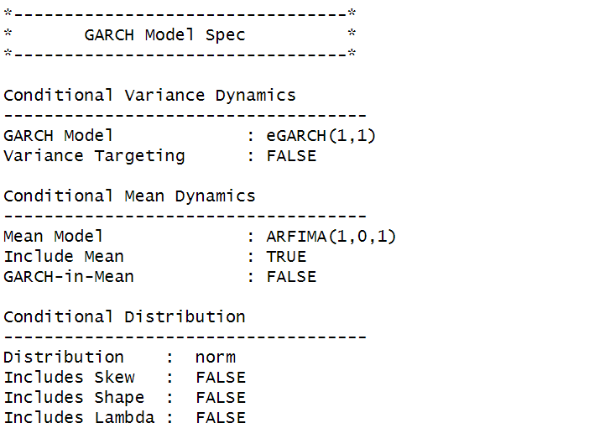

*Figure 113: GARCH Model for Weekly Returns*

From the Figure 113, we can clearly see that GARCH (1,1) is the most appropriate model and by default, the mean model ARFIMA(1,0,1) is taken.

Now the daily returns of STEELXIND were run against EGRACH model and the following results were obtained:

*Figure 114: EGARCH Model for Weekly Returns*

From Figure 114, we can see that EGARCH (1,1) model is obtained and again by default ARFIMA (1,0,1) is taken. The results are similar to that of GARCH model.

After creating both GARCH and EGARCH models now we fit the model using

ugarchfit function which yielded the results that are shown in Figure 115. The interpretation of the results are given after Figure 115.

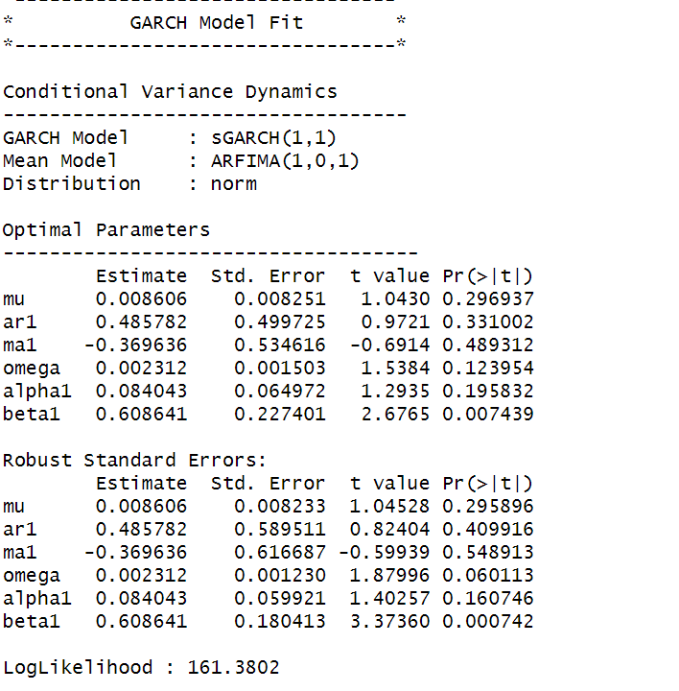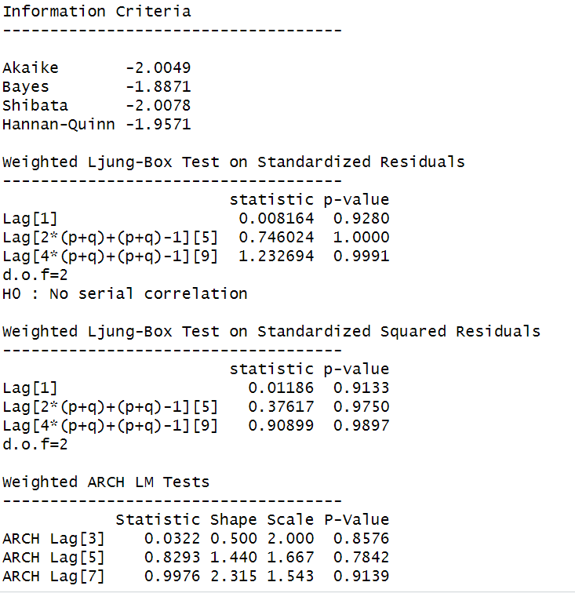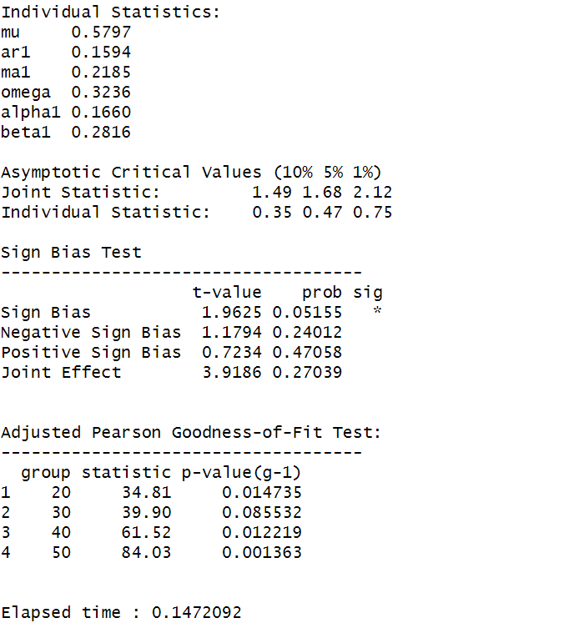

*Figure 116: GARCH Model Fitting for Weekly Returns*

### **9.3.1 Interpretation**

• The Log Likelihood obtained from the model is 161.3802.

• GARCH(1,1) is the best fit model for STEELXIND weekly returns.

• The optimal parameters alpha and beta have significant value while omega is insignificant.

• The Alpha, Omega and Beta obtained from estimated robust standard error shows that omega and alpha are insignificant because p-value is greater than 0.05.

• This model provides the best fit with the fewest parameters because its AIC and BIC values are the lowest of all potential models.

• The p-value for both Standardized Residuals and Squared Residuals are greater than 0.05 which means null hypothesis will be accepted i.e., there is no serial correlation which is good for the model.

• Adjusted Pearson Goodness of Fit Test gave all the p-values greater than 0.05 which implies that null hypothesis can’t be rejected which means there is no significant difference between observed value and expected value.

### **9.3.2** **Forecast using GARCH**

The forecasted results using GARCH model are shown in Figure 31. The results show that the returns will be positive for the next 10 days with a value of around 0.859% having a standard deviation close to 8.657%. Positive return means that STEELXIND stock price will rise in the next 10 days which is same as was suggested by the ARIMA model.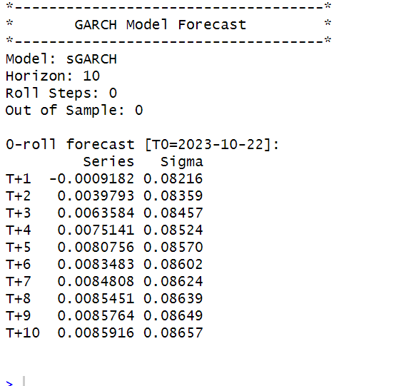

*Figure 117: GARCH Model Prediction for Weekly Returns*

**SECTION 10: STEELXIND (Monthly Returns)**

Figure 33 shows the monthly returns of the STEELXIND stock price from 2nd November 2020 to 25th October 2023, and the CLOSING prices were used to calculate the returns, which are shown in Figure 118.

*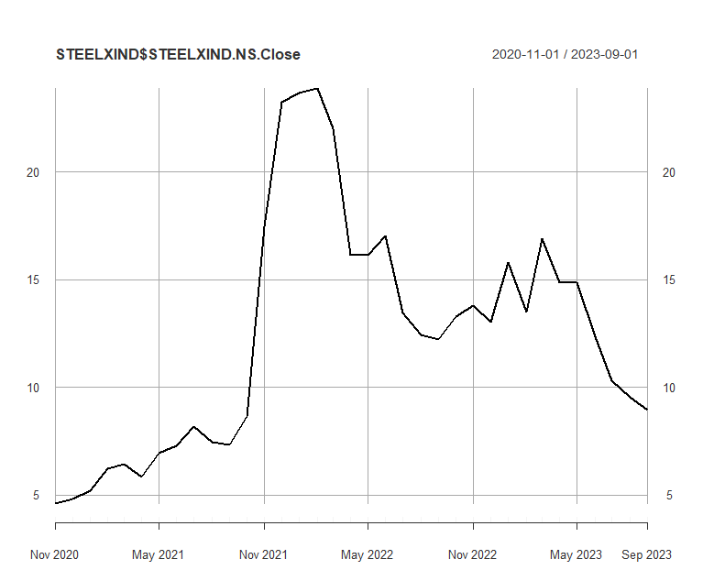 Figure 118: Monthly Prices of STEELXIND*

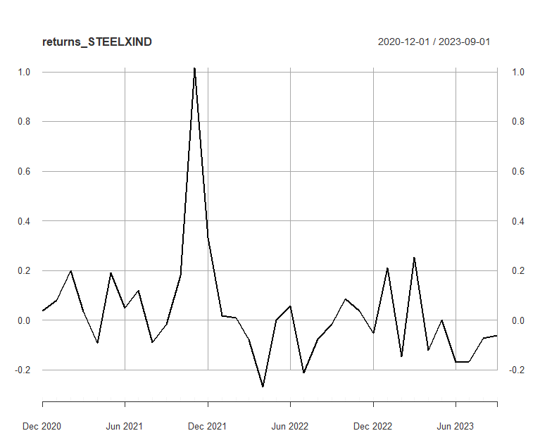

*Figure 119:Monthly Returns of STEELXIND*

Next, the excess returns, denoted as E(R) - R_f, are subjected to regression against the market risk premium R_m - R_f. The outcomes of this regression are illustrated in Figure 120.

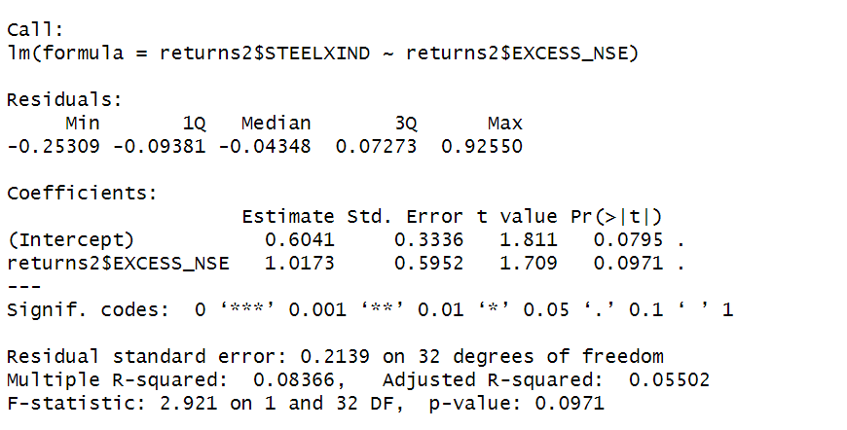

*Figure 121: Regression results of CAPM for Monthly Returns*

**10.1.1 CAPM Model - Interpretation of Results**

Figure shows that the Beta for monthly returns (risk unadjusted) is 1.0173, which means that if the market index portfolio’s daily returns rise by 1%, then the monthly returns of STEELXIND will increase by 1.0173%.The intercept value derived from the regression is 0.6041, but it is also not statistically significant. Therefore, it may be appropriate to ignore or treat it as 0%, which means that if the market return is 0%, then STEELXIND will show a 1.0173% return.

## **10.2** **Estimating AR and MA coefficients using ARIMA**

The AR and MA coefficients are obtained using the ACF (Auto-correlation function) and PACF (Partial Auto-correlation function) plots. From Figure 32 it can be seen that stock price data is non-stationary while from Figure 33 we can interpret that the returns of the stock seems to be stationary of integrated or order 1 which means first difference is stationary.

**10.2.1 Augmented Dickey-Fuller Test**

An augmented Dickey-Fuller (ADF) test is performed to check for stationarity, whose results are in Figure 122.

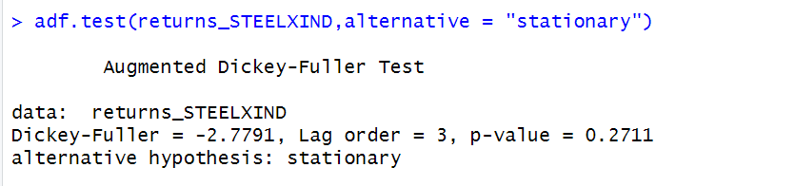 *Figure 122: ADF Test Results for Monthly Returns*

The Augmented Dickey-Fuller test null hypothesis states that a unit root exists, i.e. the series is not-stationary, and the corresponding alternative hypothesis is that the series is stationary. Since the p-value of the test shown above is 0.01, the null hypothesis can be rejected; thus, the series is stationary.The value of ADF Test-statistic: -2.7791.

**10.2.2 ACF Plot**

The sample Autocorrelation function (ACF) plot is used measure the correlation between the present and the lagged values in the series. Lagged values means the past values of the series. Figure 123 shows the formula for calculating ACF at lag k:



*Figure 123: ACF Formula*

The results for of ACF plot for STEELXIND are depicted in Figure 124:

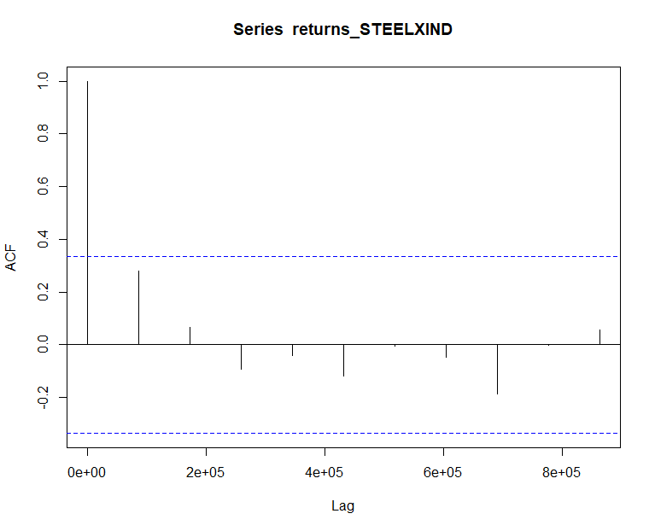 *Figure 124: ACF Plot STEELXIND for Monthly Returns*

From the above plot it can derived that the series is MA(0) model since no lag term except the 0th lag is significant,following values are not significant.

**10.2.3 PACF Plot**

It measures the correlation between an observation k periods ago and the current observation after controlling the observations at intermediate lags i.e., all the lags which are less than k. PACF plots are used to differentiate between AR & ARMA process. Figure 38 shows the formula for calculating PACF:

*Figure 125: PACF Formula*

The results of PACF plot for STEELXIND

are depicted in Figure 126:

*Figure 126: PACF Plot STEELXIND for Monthly Return*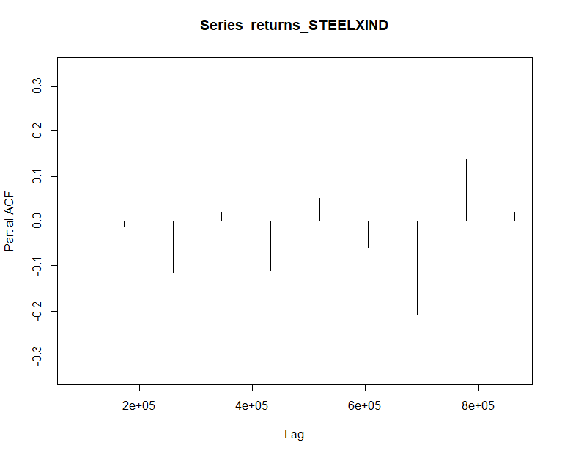

From the above plot it can derived that the series is AR(0) model since only no lag is significant.

**10.2.4 Identification and interpretation of ARIMA model:**

The diagnostic test of the model is shown in Figure.

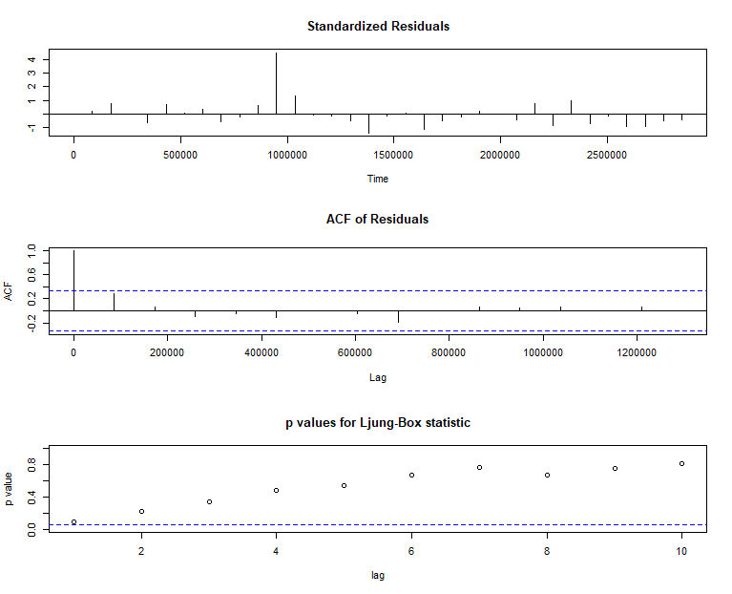 *Figure 127: Diagnostic Results for Monthly Returns*

Ljung-Box Test is used for testing the distribution of residuals. Its null hypothesis is that the residuals are independently distributed while alternative hypothesis states that residuals are not independently residuals. From Figure 127(Chart 3) it can be seen that almost all p-values are greater than 0.05 which means that we can’t reject the null hypothesis i.e., residuals are distributed independently. The normalised residuals time series plot looks to be random and does not show a strong trend, therefore it fits the data well. Also, the Residual autocorrelations are all zero except for one spike.

### **10.2.5** **FORECAST WITH ARIMA MODEL**

Using the ARIMA (0,0,0) model the forecast results have been calculated are shown in Figure 128:

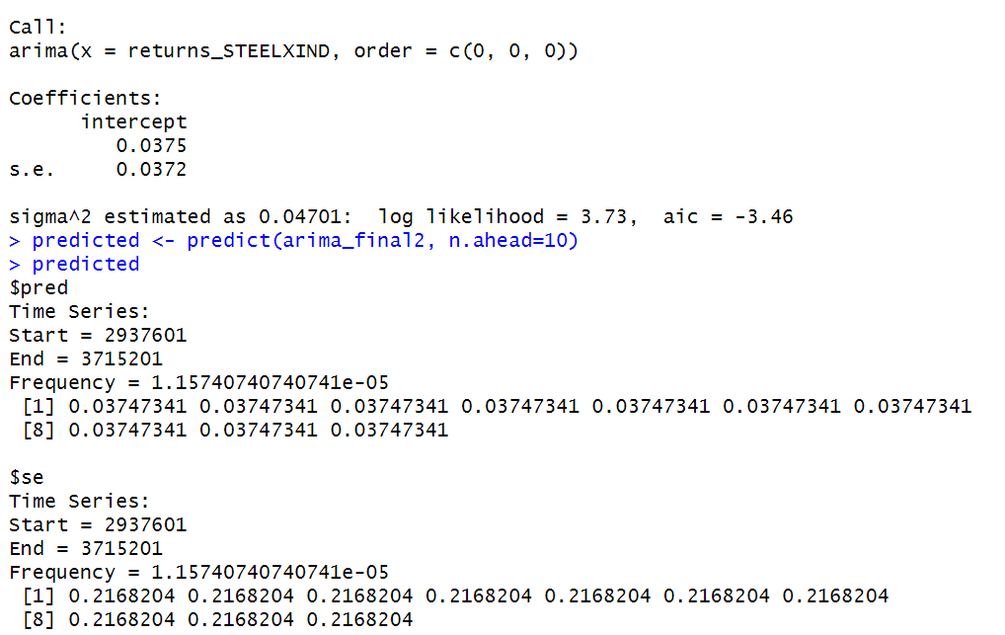 *Figure 128: Forecast for Monthly Returns*

Since all the forecasts for returns are positive, the stock price will increase in the future weeks.

**10.3 GARCH and EGARCH models**

GARCH, or Generalised Autoregressive Conditional Heteroskedasticity, is a method for estimating market volatility while EGARCH (Exponential General Autoregressive Conditional Heteroskedasticity) is also a model for estimating market volatility but with less constraints on the parameters. GARCH (1,1) is the most popular GARCH model. Running GARCH on monthly return of STEELXIND yielded the result that are shown in Figure 129:

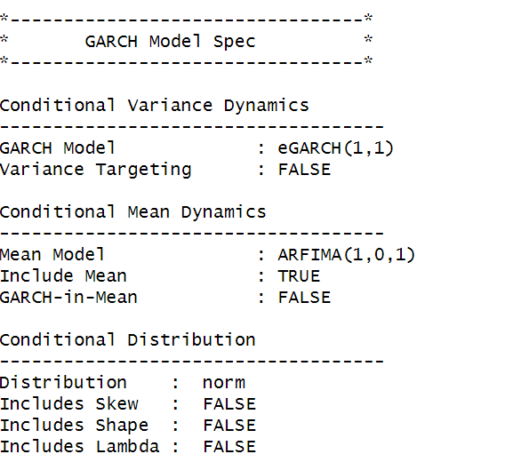

*Figure 129: GARCH Model for Monthly Returns*

From the Figure 129, we can clearly see that GARCH (1,1) is the most appropriate model and by default, the mean model ARFIMA(1,0,1) is taken.

Now the monthly returns of STEELXIND were run against EGRACH model and the following results were obtained:



*Figure 130: EGARCH Model for Monthly Returns*

From Figure 130, we can see that EGARCH (1,1) model is obtained and again by default ARFIMA (1,0,1) is taken. The results are similar to that of GARCH model.

After creating both GARCH and EGARCH models now we fit the model using

ugarchfit function which yielded the results that are shown in Figure 131. The interpretation of the results are given after Figure 131.

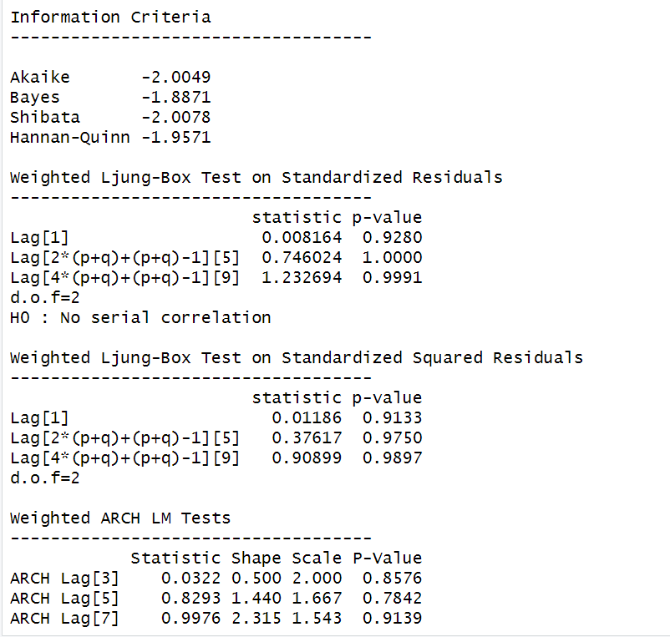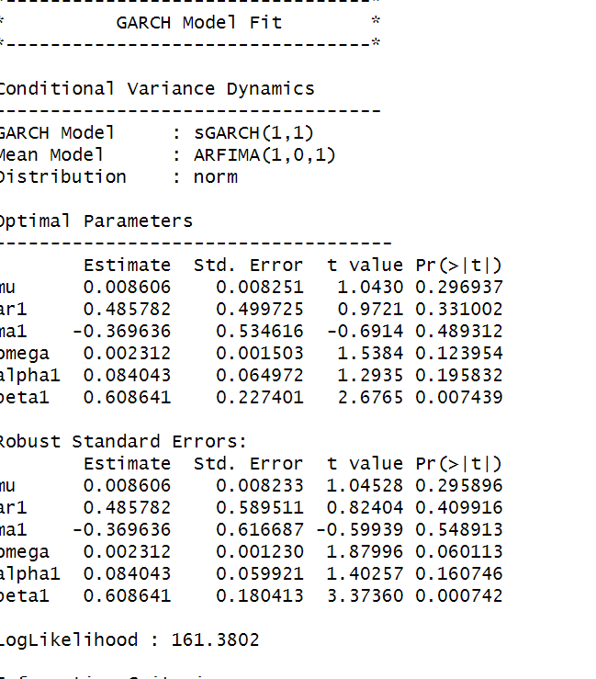

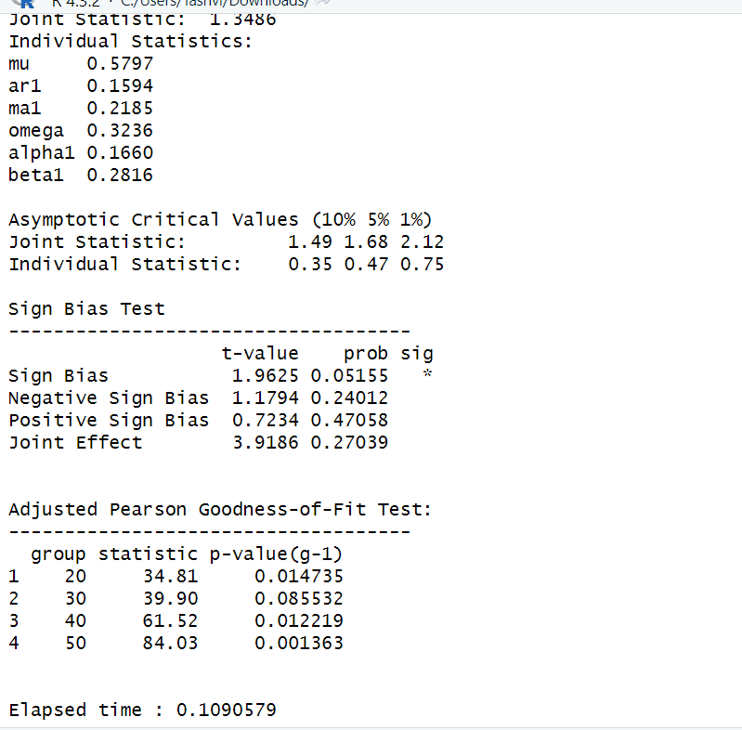

*Figure 131: GARCH Model Fitting for Monthly Returns*

**10.3.1 Interpretation**

• The Log Likelihood obtained from the model is 161.3802.

• GARCH(1,1) is the best fit model for STEELXIND monthly returns.

• The optimal parameters alpha and beta have significant value while omega is insignificant.

• The Alpha, Omega and Beta obtained from estimated robust standard error shows that omega and alpha are insignificant because p-value is greater than 0.05.

• This model provides the best fit with the fewest parameters because its AIC and BIC values are the lowest of all potential models.

• The p-value for both Standardized Residuals and Squared Residuals are greater than 0.05 which means null hypothesis will be accepted i.e., there is no serial correlation which is good for the model.

• Adjusted Pearson Goodness of Fit Test gave all the p-values greater than 0.05 which implies that null hypothesis can’t be rejected which means there is no significant difference between observed value and expected value.

### **10.3.2** **Forecast using GARCH**

The forecasted results using GARCH model are shown in Figure . The results show that the returns will be positive for the next 10 days with a value of around 0.859% having a standard deviation close to 8.657%. Positive return means that STEELXIND stock price will rise in the next 10 days which is same as what was suggested by ARIMA model.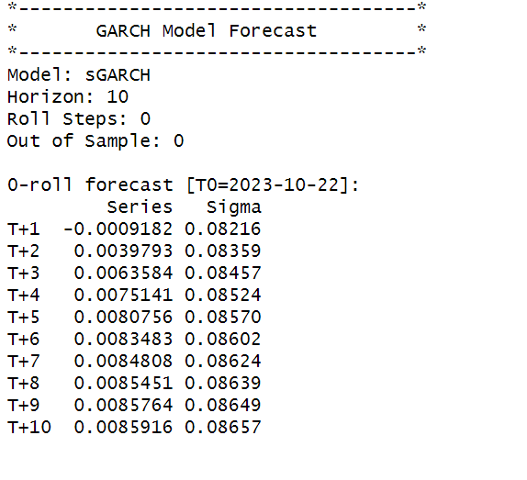



**About TCS**

Tata Consultancy Services (TCS) is a leading global provider of business solutions, consulting, and information technology services. Since its founding in 1968, TCS has significantly influenced the development of the digital world and has come to be associated with innovation, dependability, and game-changing technological solutions.

TCS is a publicly traded company that is a member of the Tata Group and has a strong commitment to corporate governance, transparency, and providing value to its stakeholders. The founder of the Tata Group, J.R.D. Tata, provided the company with visionary leadership from the outset, and TCS's founding was a groundbreaking event in the Indian IT sector.

TCS has been at the forefront of the IT revolution since its founding with the goal of utilising technology to solve difficult business challenges. The vision for the establishment of a top-tier IT consulting and services company that would advance India's development while also having a global influence drove the circumstances surrounding its founding.

The vast array of services that TCS offers—from software development and infrastructure support to business solutions and IT consulting—reflects the company's overall excellence. As a reliable partner to businesses across the globe, TCS has continuously proven its capacity to adjust to changing technological trends.

TCS's dedication to quality extends beyond its technological aptitude. The organization prioritizes sustainability, ethical business practices, and corporate social responsibility. TCS actively participates in community development programs, improving the societies in which it conducts business. With a diverse workforce and a global presence, TCS continues to be a shining example of success in the IT sector.

In conclusion, Tata Consultancy Services (TCS) has shaped the digital future since its founding in 1968 and is regarded as a trailblazer in the IT sector. TCS has a long history of driving technological advancement and developing solutions that benefit businesses and societies all over the world. Its foundations are integrity, customer-centricity, and continuous innovation.

**SECTION 11: TCS (Daily Returns)**

The CAPM model is defined as:

E(R) = Rf + Beta(Rm-Rf)

where,

E(R): Expected return of the firm

Rf: Risk free rate

Rm: Returns of the market

Beta is calculated by regressing expected returns of the stock i.e., TCS on Market Risk Premium (Rm-Rf). It is the slope parameter that is evaluated from the regression model.

The beta is a measure of how sensitive the security is to the changes in the market index. For index portfolio National Stock Exchange (NSE) was taken into consideration.

For example, a beta of 1.5 means that our portfolio is 50% more sensitive when compared with market index.

**11.1 CAPM Model - Estimating the Beta of the Company**

Figure 133 shows the daily returns of the TCS stock price from 2nd November 2020 to 25th October 2023, and the CLOSING prices were used to calculate the returns, which are shown in Figure 132.

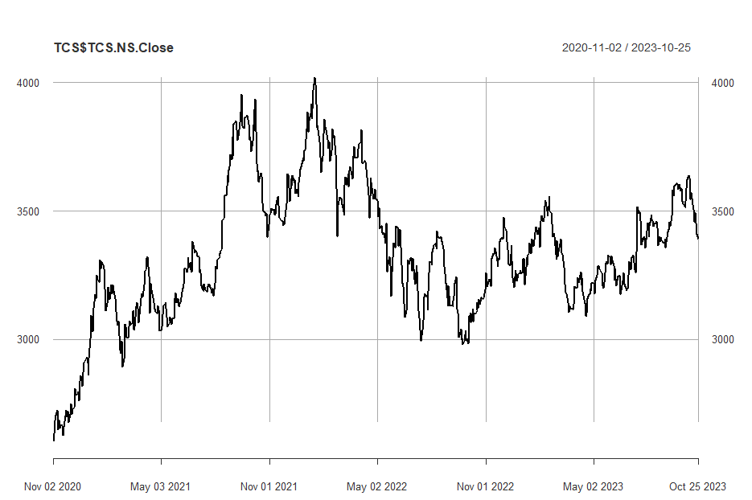

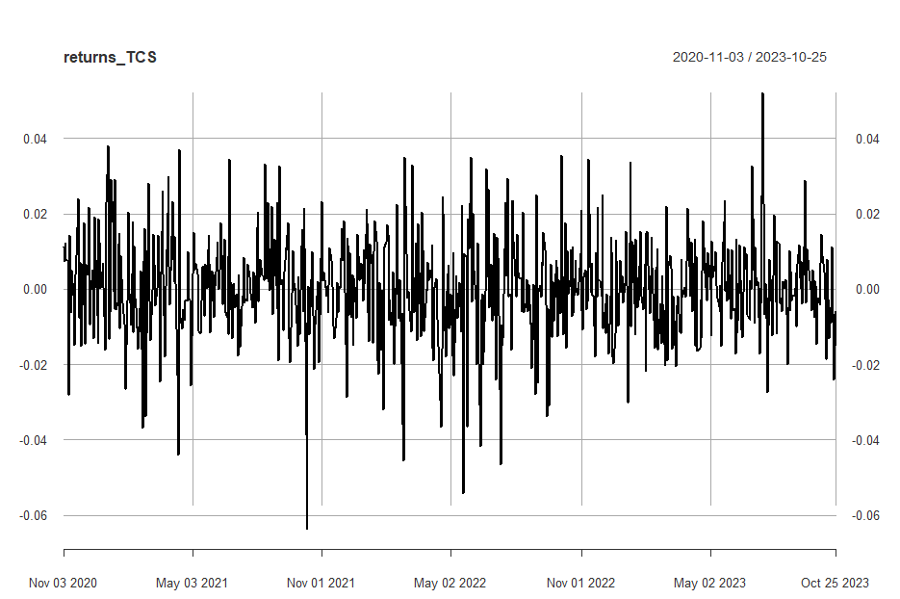

*Figure 133: Daily Returns of TCS*

Next, the excess returns, denoted as E(R) - R_f, are subjected to regression against the market risk premium R_m - R_f. The outcomes of this regression are illustrated in Figure 134

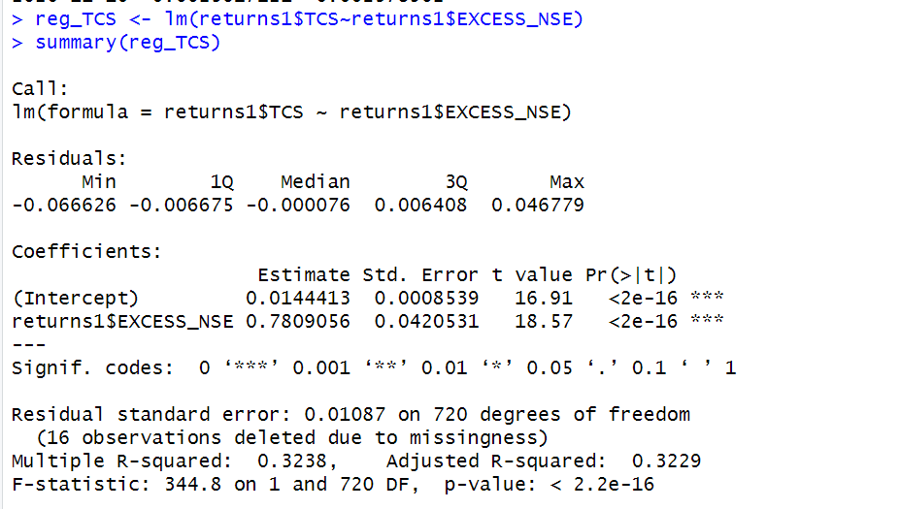

*Figure 134: Regression results of CAPM for Daily Returns*

**11.1.1 CAPM Model - Interpretation of Results**

Figure 4 shows that the Beta for daily returns (risk unadjusted) is 0.780905, which means that if the market index portfolio’s daily returns rise by 1%, then the daily returns of TCS will increase by 0.7%. Moreover, the beta value is statistically significant at both the 95% and 99% confidence levels, given that the p-value is less than 0.01 (p < 0.01).

The intercept value derived from the regression is 0.0144413 which means that if the market return is 0%, then TCS will show a 0.01444% return.

**11.2 Estimating AR and MA coefficients using ARIMA**

The AR and MA coefficients are obtained using the ACF (Auto-correlation function) and PACF (Partial Auto-correlation function) plots. From Figure 2 it can be seen that stock price data is non-stationary while from Figure 3 we can interpret that the returns of the stock seem to be stationary of integrated or order 1 which means first difference is stationary.

**11.2.1 Augmented Dickey-Fuller Test**

An augmented Dickey-Fuller (ADF) test is performed to check for stationarity, whose results are in Figure 135.

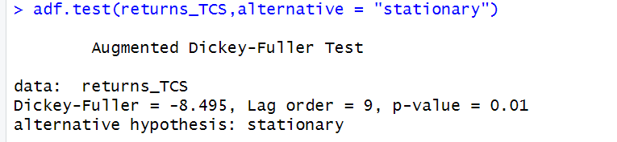

*Figure 135: ADF Test Results for Daily Returns*

The Augmented Dickey-Fuller test null hypothesis states that a unit root exists, i.e. the series is not-stationary, and the corresponding alternative hypothesis is that the series is stationary. Since the p-value of the test shown above is 0.01, the null hypothesis can be rejected; thus, the series is stationary. The value of ADF Test-statistic: -8.495.

**11.2.2 ACF Plot**

The sample Autocorrelation function (ACF) plot is used measure the correlation between the present and the lagged values in the series. Lagged values means the past values of the series. Figure 136 shows the formula for calculating ACF at lag k:

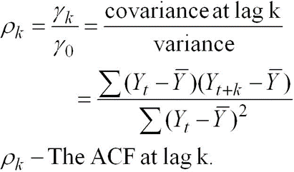

*Figure 136: ACF Formula*

The results for of ACF plot for TCS are depicted in Figure 137:

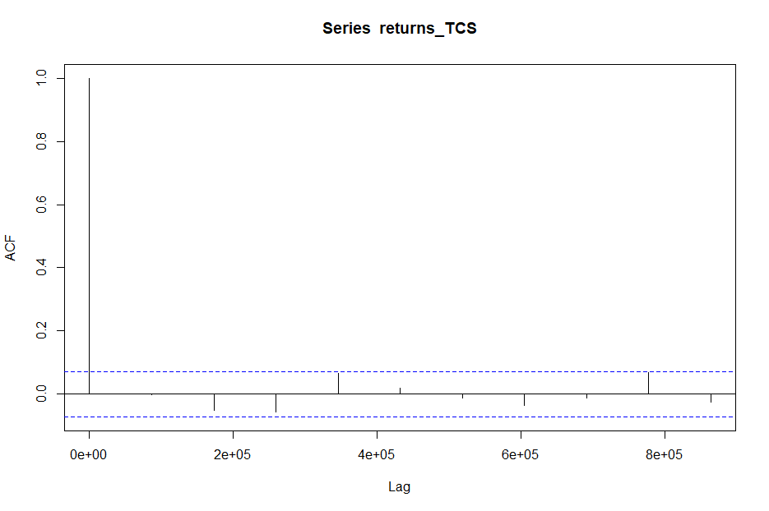

*Figure 137: ACF Plot TCS for Daily Returns*

From the above plot it can derived that the series is MA(0) model since no lag term except the 0th lag is significant,following values are not significant.

**11.2.3 PACF Plot**

It measures the correlation between an observation k periods ago and the current observation after controlling the observations at intermediate lags i.e., all the lags which are less than k. PACF plots are used to differentiate between AR & ARMA process. Figure 138 shows the formula for calculating PACF:

*Figure 138: PACF Formula*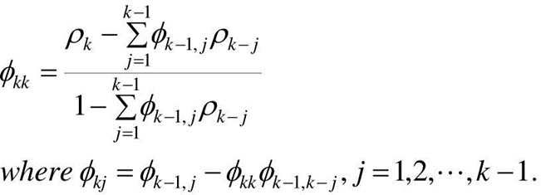

The results of PACF plot for TCS are depicted in Figure 139:

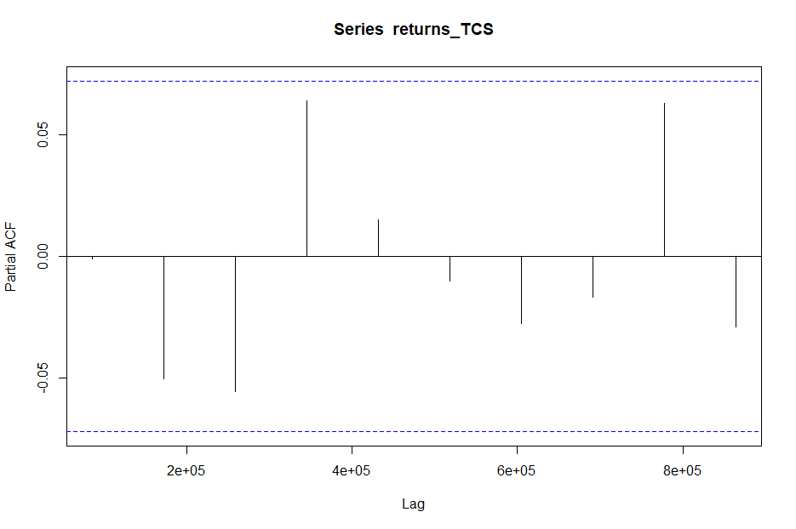

*Figure 139: PACF Plot* TCS *for Daily Return*

From the above plot it can derived that the series is AR(1) model since only one lag is significant.

**11.2.4 Identification and interpretation of ARIMA model:**

The diagnostic test of the model is shown in Figure.

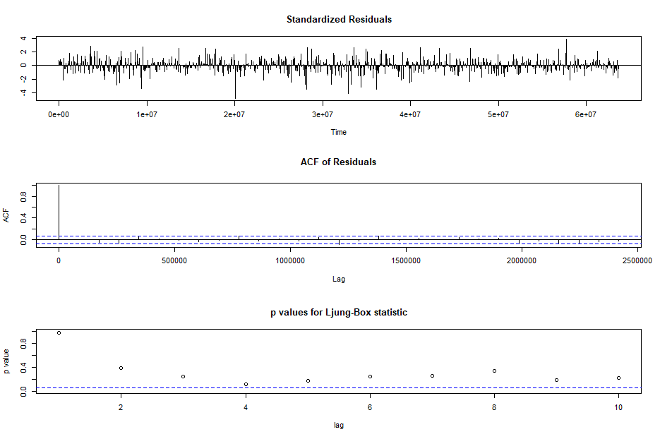

*Figure 140: Diagnostic Results for Daily Returns*

Ljung-Box Test is used for testing the distribution of residuals. Its null hypothesis is that the residuals are independently distributed while alternative hypothesis states that residuals are not independently residuals. From Figure 140(Chart 3) it can be seen that almost all p-values are greater than 0.05 which means that we can’t reject the null hypothesis i.e., residuals are distributed independently. The normalised residuals time series plot looks to be random and does not show a strong trend, therefore it fits the data well. Also, the Residual autocorrelations are all zero except for one spike.

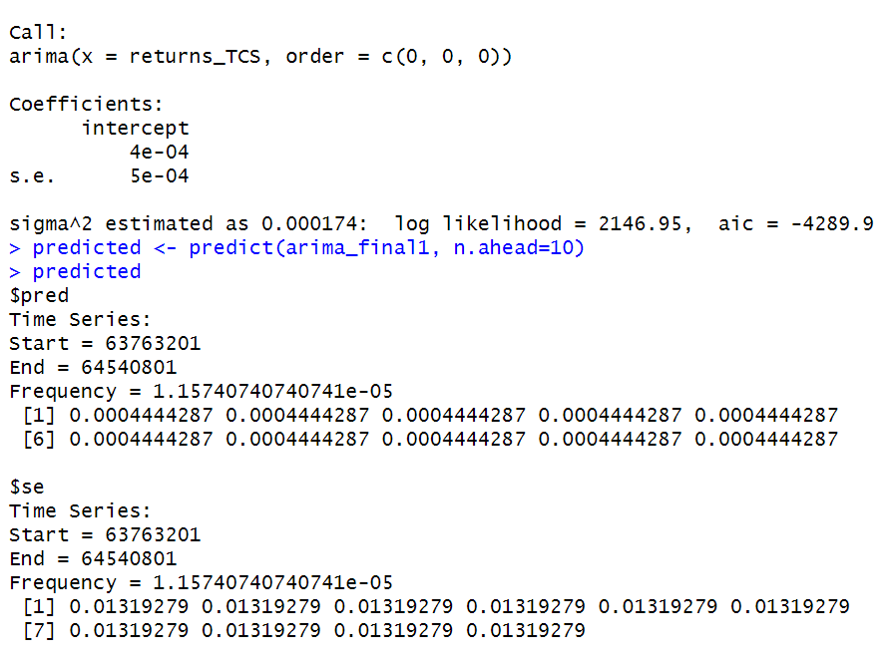

*Figure 141: Forecast for Daily Returns*

Since all the forecasts for returns are positive, the stock price will increase in the future weeks.

**2.3 GARCH and EGARCH models**

GARCH, or Generalised Autoregressive Conditional Heteroskedasticity, is a method for estimating market volatility while EGARCH (Exponential General Autoregressive Conditional Heteroskedasticity) is also a model for estimating market volatility but with less constraints on the parameters. GARCH (1,1) is the most popular GARCH model. Running GARCH on daily return of TCS yielded the result that are shown in Figure 142:

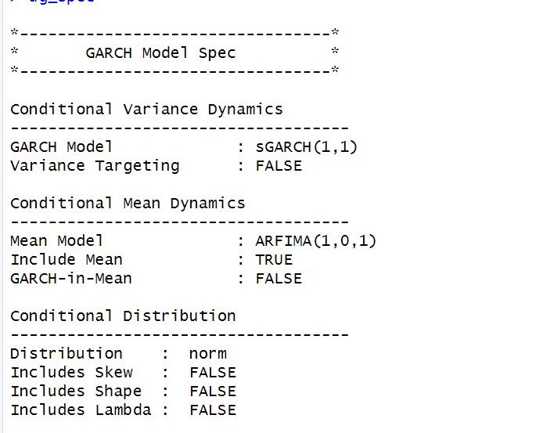

*Figure 142: GARCH Model for Daily Returns*

From the Figure 143, we can clearly see that GARCH (1,1) is the most appropriate model and by default, the mean model ARFIMA(1,0,1) is taken.

Now the daily returns of TCS were run against EGRACH model and the following results were obtained:



*Figure 143: EGARCH Model for Daily Returns*

From Figure 143, we can see that EGARCH (1,1) model is obtained and again by default ARFIMA (1,0,1) is taken. The results are similar to that of GARCH model.

After creating both GARCH and EGARCH models now we fit the model using

ugarchfit function which yielded the results that are shown in Figure 144. The interpretation of the results are given after Figure 144.

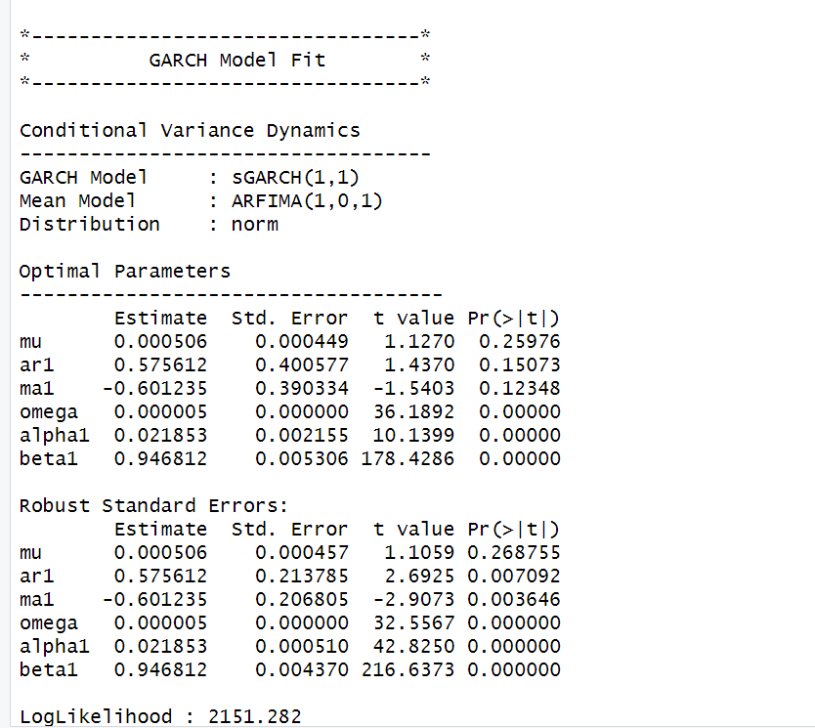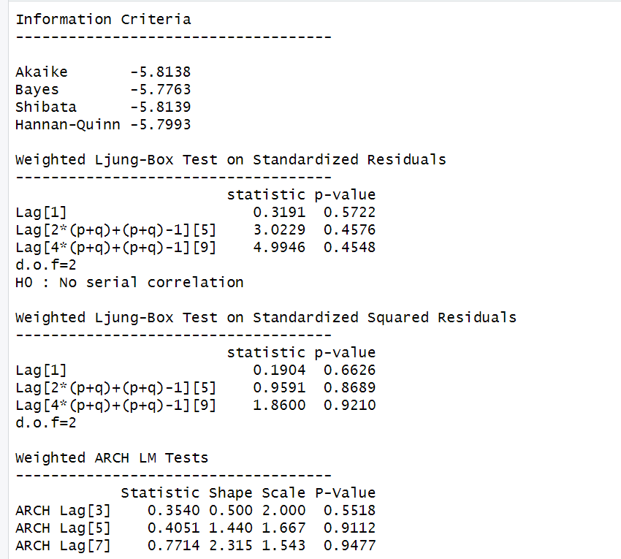

### **11.3.1 Interpretation**

• The Log Likelihood obtained from the model is 2151.282.

• GARCH(1,1) is the best fit model for TCS daily returns. • The optimal parameters alpha and beta have significant value while omega is insignificant.

• The Alpha, Omega and Beta obtained from estimated robust standard error shows that omega and alpha are insignificant because p-value is greater than 0.05.

• This model provides the best fit with the fewest parameters because its AIC and BIC values are the lowest of all potential models.

• The p-value for both Standardized Residuals and Squared Residuals are greater than 0.05 which means null hypothesis will be accepted i.e., there is no serial correlation which is good for the model.

• Adjusted Pearson Goodness of Fit Test gave all the p-values greater than 0.05 which implies that null hypothesis can’t be rejected which means there is no significant difference between observed value and expected value.

### **11.3.2** **Forecast using GARCH**

The forecasted results using GARCH model are shown in Figure 145. The results show that the returns will be positive for the next 10 days with a value of around 0.052% having a standard deviation close to 1.246%. Positive return means that TCSstock price will rise in the next 10 days which is same as what was suggested by ARIMA model.

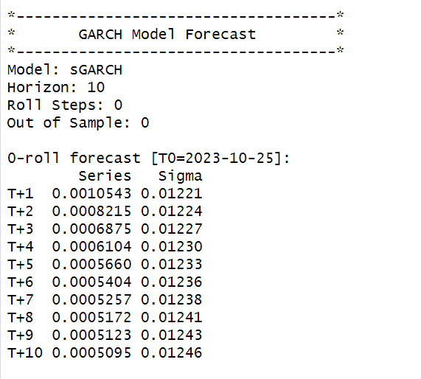

# **SECTION 12: TCS (Weekly Returns)**

Figure 147 shows the weekly returns of the TCS stock price from 2nd November 2020 to 25th October 2023, and the CLOSING prices were used to calculate the returns, which are shown in Figure 146.

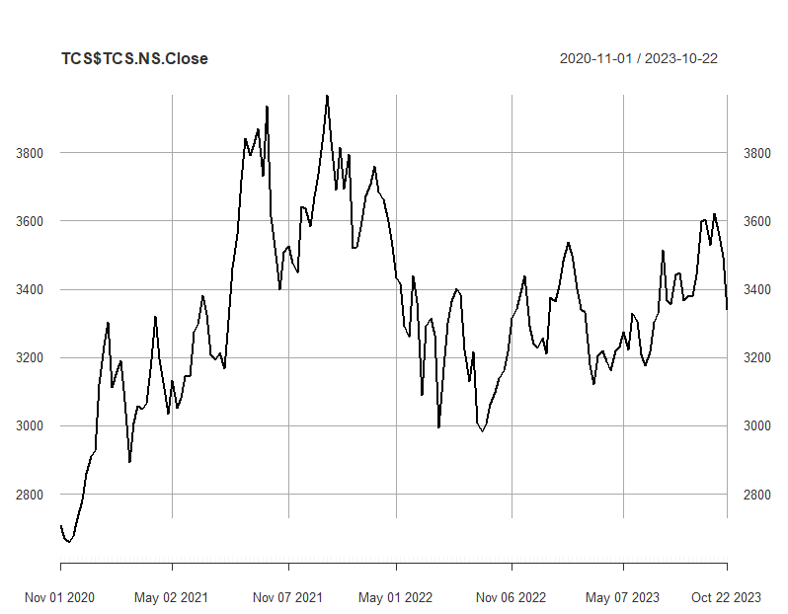

*Figure 146: Weekly Prices of TCS*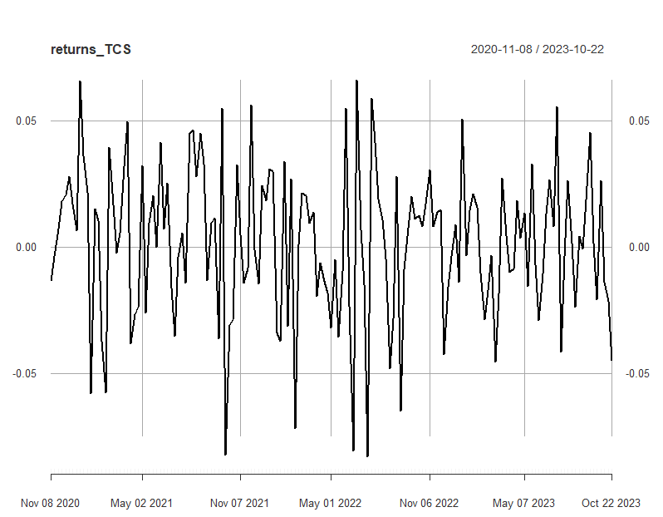

*Figure 147: Weekly Returns of TCS*

Next, the excess returns, denoted as E(R) - R_f, are subjected to regression against the market risk premium R_m - R_f. The outcomes of this regression are illustrated in Figure 19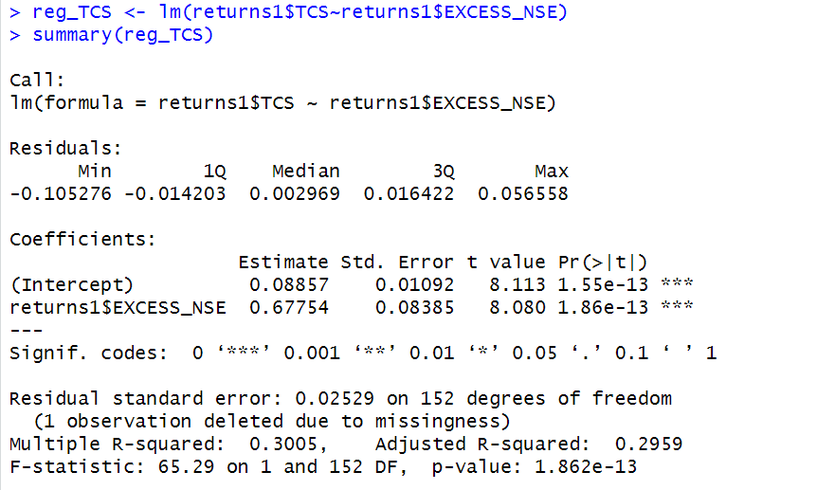

*Figure 148: Regression results of CAPM for Weekly Returns*

**12.1.1 CAPM Model - Interpretation of Results**

The above figure shows that the Beta for weekly returns (risk unadjusted) is 0.58602, which means that if the market index portfolio’s daily returns rise by 1%, then the daily returns of TCS will increase by 0.67754%. Also, the beta value is significant at 95% but not at 99% since the p-value is greater than 0.01 but less than 0.05 (0.05> p > 0.01)The intercept value derived from the regression is 0.09238 which means that if the market return is 0%, then TCS will show a 0.09238% return.

## **12.2** **Estimating AR and MA coefficients using ARIMA**

The AR and MA coefficients are obtained using the ACF (Auto-correlation function) and PACF (Partial Auto-correlation function) plots. From Figure 17 it can be seen that stock price data is non-stationary while from Figure 18 we can interpret that the returns of the stock seems to be stationary of integrated or order 1 which means first difference is stationary.

**12.2.1 Augmented Dickey-Fuller Test**

An augmented Dickey-Fuller (ADF) test is performed to check for stationarity, whose results are in Figure 149.

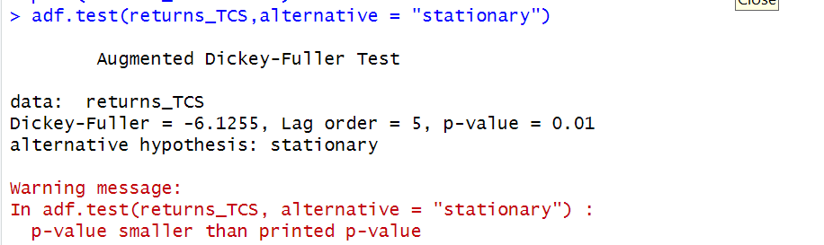

*Figure 149: ADF Test Results for Weekly Returns*

The Augmented Dickey-Fuller test null hypothesis states that a unit root exists, i.e. the series is not-stationary, and the corresponding alternative hypothesis is that the series is stationary. Since the p-value of the test shown above is 0.01, the null hypothesis can be rejected; thus, the series is stationary.The value of ADF Test-statistic: -6.1255.

**12.2.2 ACF Plot**

The sample Autocorrelation function (ACF) plot is used measure the correlation between the present and the lagged values in the series. Lagged values means the past values of the series. Figure 21 shows the formula for calculating ACF at lag k:



*Figure 150: ACF Formula*

The results for of ACF plot for TCS are depicted in Figure 151:

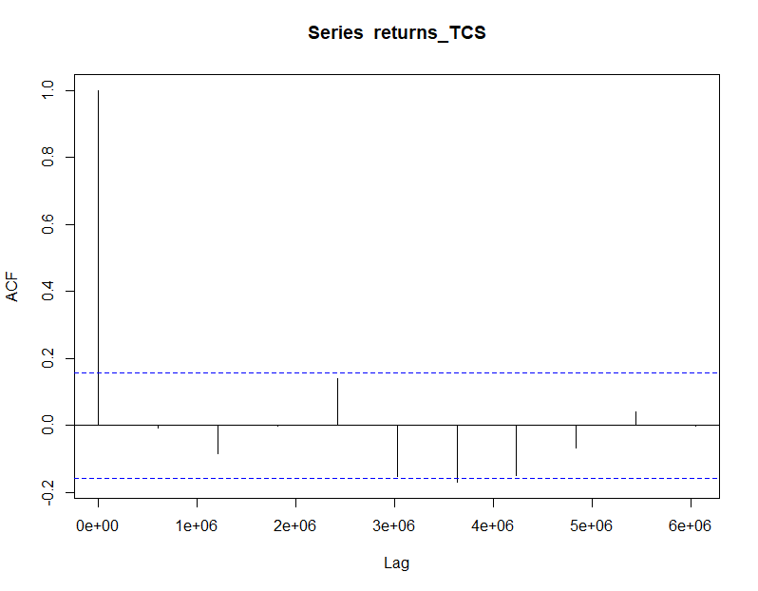

*Figure 151: ACF Plot TCS for Weekly Returns*

From the above plot it can derived that the series is MA(0) model since no lag term except the 0th lag is significant,following values are not significant.

**12.2.3 PACF Plot**

It measures the correlation between an observation k periods ago and the current observation after controlling the observations at intermediate lags i.e., all the lags which are less than k. PACF plots are used to differentiate between AR & ARMA process. Figure 152 shows the formula for calculating PACF:

*Figure 152: PACF Formula*

The results of PACF plot for TCS are depicted in Figure 153:

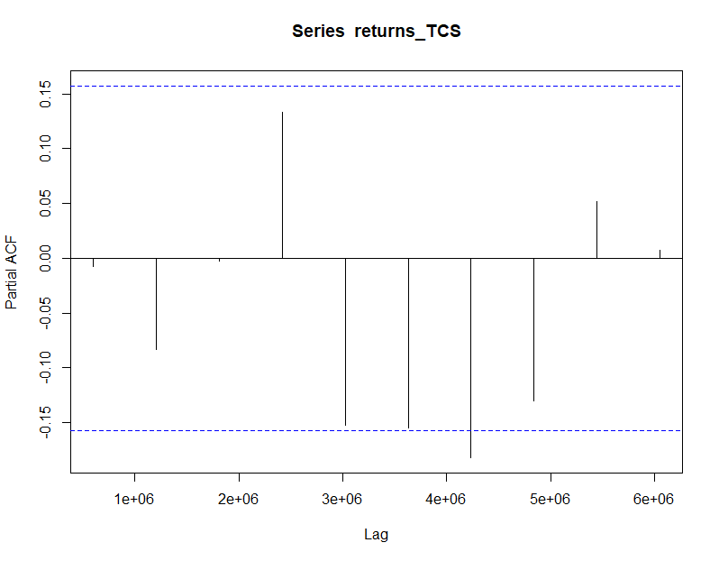

*Figure 153: PACF Plot TCS for Weekly Return*

From the above plot it can derived that the series is AR(0) model since only no lag is significant.

**12.2.4 Identification and interpretation of ARIMA model:**

The diagnostic test of the model is shown in Figure.

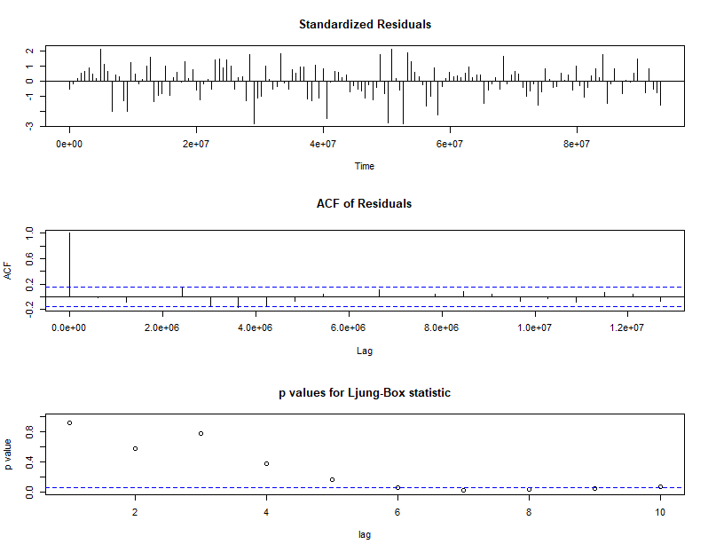

*Figure 155: Diagnostic Results for Daily Returns*

Ljung-Box Test is used for testing the distribution of residuals. Its null hypothesis is that the residuals are independently distributed while alternative hypothesis states that residuals are not independently residuals. From Figure 155(Chart 3) it can be seen that almost all p-values are greater than 0.05 which means that we can’t reject the null hypothesis i.e., residuals are distributed independently. The normalised residuals time series plot looks to be random and does not show a strong trend, therefore it fits the data well. Also, the Residual autocorrelations are all zero except for one spike.

### **12.2.5** **FORECAST WITH ARIMA MODEL**

Using the ARIMA (0,0,0) model the forecast results have been calculated are shown in Figure 156:

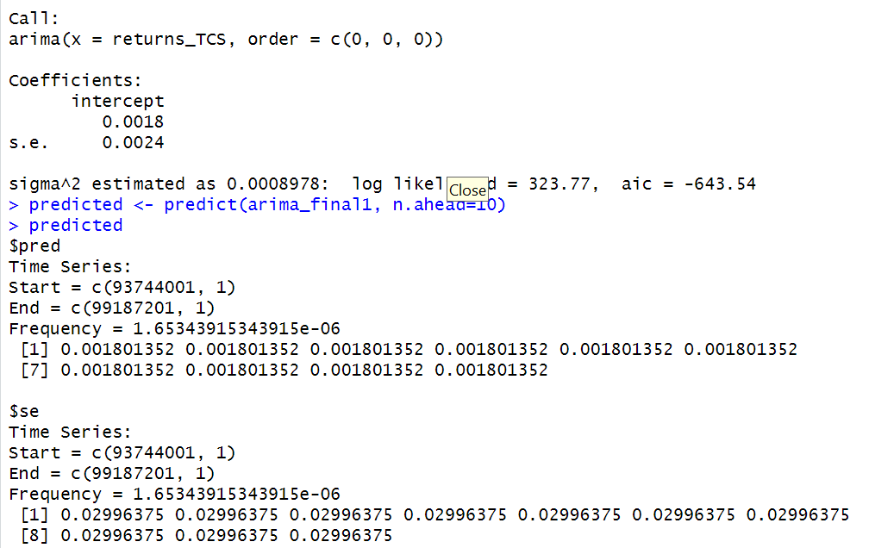

*Figure 156: Forecast for Weekly Returns*

Since all the forecasts for returns are positive, the stock price will increase in the future weeks.

**12.3 GARCH and EGARCH models**

GARCH, or Generalised Autoregressive Conditional Heteroskedasticity, is a method for estimating market volatility while EGARCH (Exponential General Autoregressive Conditional Heteroskedasticity) is also a model for estimating market volatility but with less constraints on the parameters. GARCH (1,1) is the most popular GARCH model. Running GARCH on daily return of TCS yielded the result that are shown in Figure 157: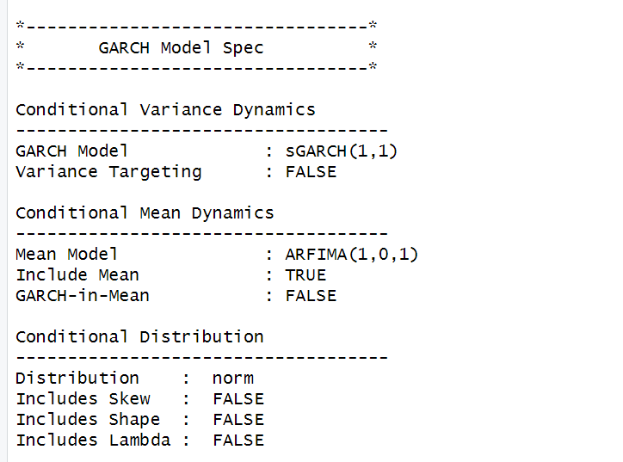

*Figure 157: GARCH Model for Weekly Returns*

From the Figure 157, we can clearly see that GARCH (1,1) is the most appropriate model and by default, the mean model ARFIMA(1,0,1) is taken.

Now the daily returns of TCS were run against EGRACH model and the following results were obtained: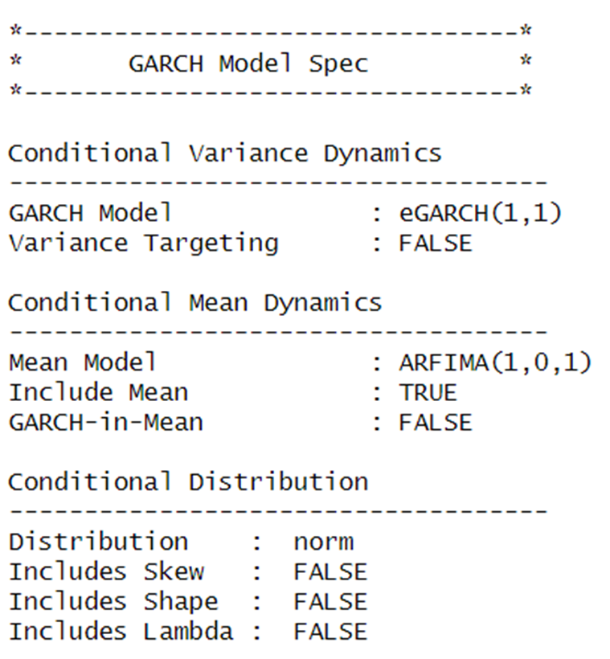

*Figure 158: EGARCH Model for Weekly Returns*

From Figure 158, we can see that EGARCH (1,1) model is obtained and again by default ARFIMA (1,0,1) is taken. The results are similar to that of GARCH model.

After creating both GARCH and EGARCH models now we fit the model using

ugarchfit function which yielded the results that are shown in Figure 159. The interpretation of the results are given after Figure 159.

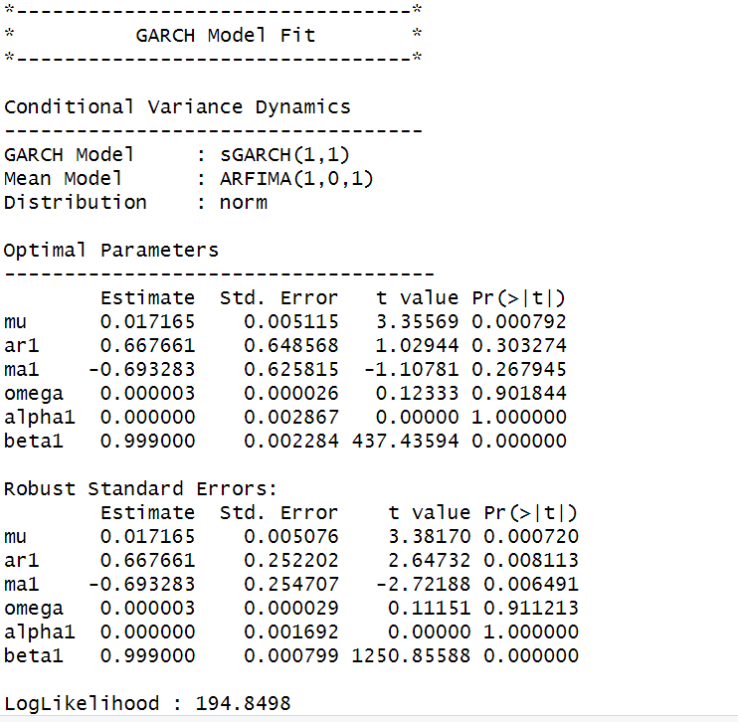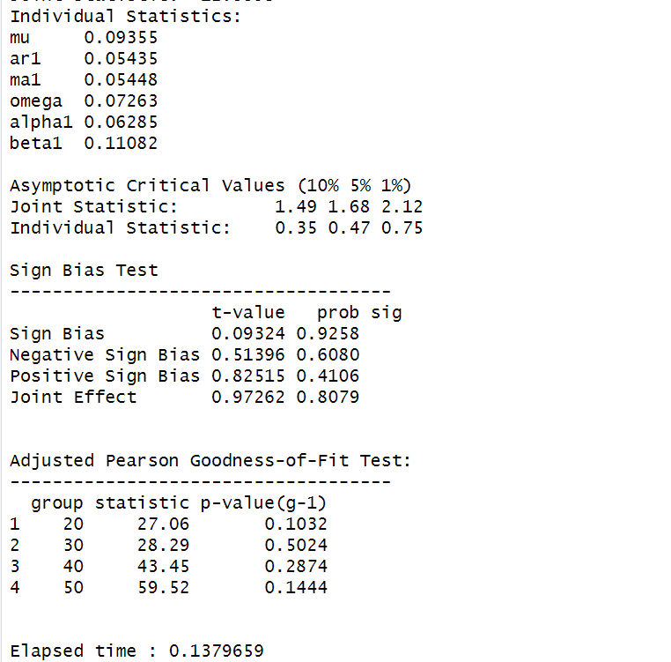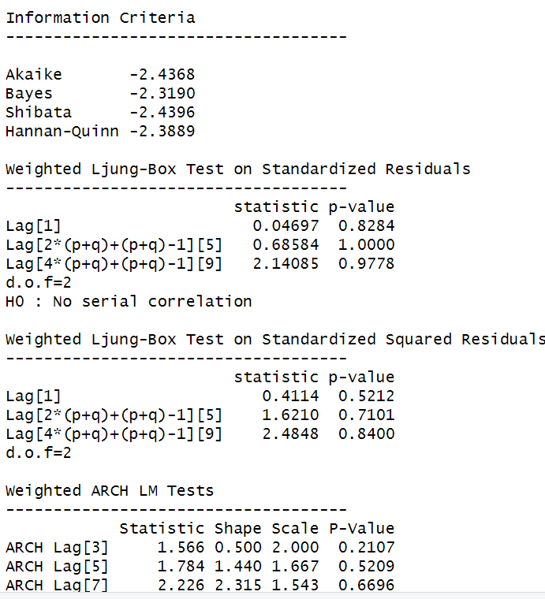

*Figure 159: GARCH Model Fitting for Weekly Returns*

### **12.3.1 Interpretation**

• The Log Likelihood obtained from the model is 194.8498.

• GARCH(1,1) is the best fit model for TCS weekly returns.

• The optimal parameters alpha and beta have significant value while omega is insignificant.

• The Alpha, Omega and Beta obtained from estimated robust standard error shows that omega and alpha are insignificant because p-value is greater than 0.05.

• This model provides the best fit with the fewest parameters because its AIC and BIC values are the lowest of all potential models.

• The p-value for both Standardized Residuals and Squared Residuals are greater than 0.05 which means null hypothesis will be accepted i.e., there is no serial correlation which is good for the model.

• Adjusted Pearson Goodness of Fit Test gave all the p-values greater than 0.05 which implies that null hypothesis can’t be rejected which means there is no significant difference between observed value and expected value.

### **12.3.2** **Forecast using GARCH**

The forecasted results using GARCH model are shown in Figure 31. The results show that the returns will be positive for the next 10 days with a value of around 1.72% having a standard deviation close to 6.719%. Positive return means that TCS stock price will rise in the next 10 days which is same as what was suggested by ARIMA model.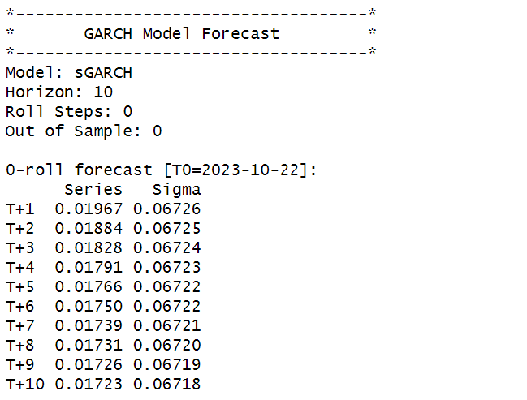

*Figure 160: GARCH Model Prediction for Weekly Return*

**SECTION 13: TCS (Monthly Returns)**

Figure 162 shows the monthly returns of the TCS stock price from 2nd November 2020 to 25th October 2023, and the CLOSING prices were used to calculate the returns, which are shown in Figure 161.

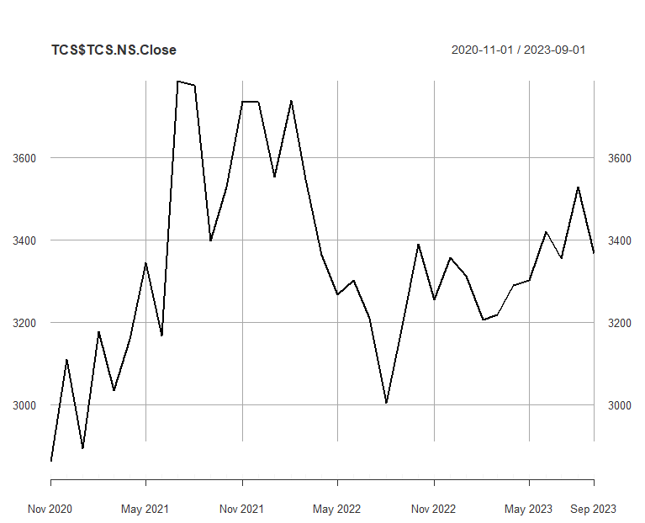

*Figure 161: Monthly Prices of TCS*

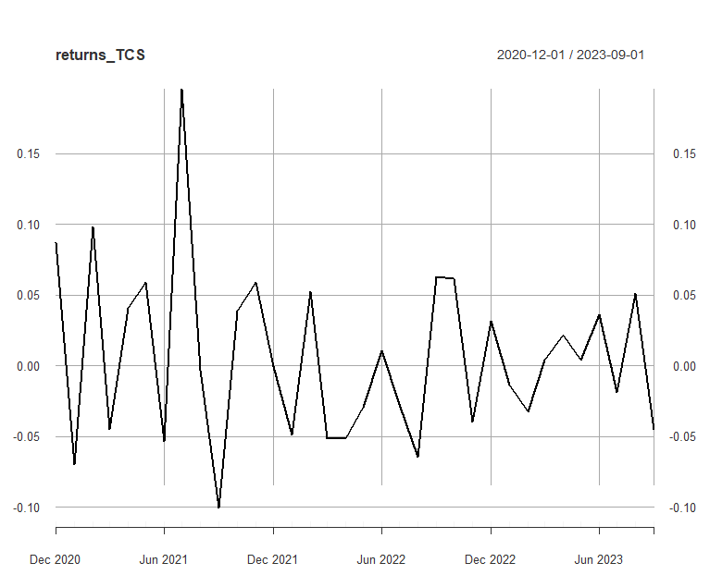

*Figure 162:Monthly Returns of TCS*

Next, the excessreturns, denoted as E(R) - R_f, are subjected to regression against the market risk premium R_m - R_f. The outcomes of this regression are illustrated in Figure 34

*Figure 163: Regression results of CAPM for Monthly Returns*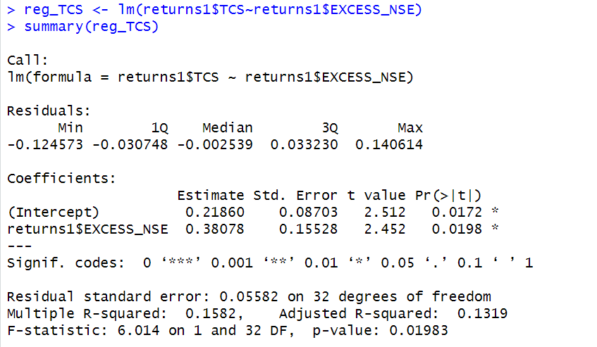

**13.1.1 CAPM Model - Interpretation of Results**

Figure shows that the Beta for monthly returns (risk unadjusted) is 0.38078, which means that if the market index portfolio’s daily returns rise by 1%, then the monthly returns of TCS will increase by 0.38078%.The intercept value derived from the regression is 0.2180, but it is also not statistically significant. Therefore, it may be appropriate to ignore or treat it as 0%, which means that if the market return is 0%, then TCS will show a 0.2186% return.

## **13.2** **Estimating AR and MA coefficients using ARIMA**

The AR and MA coefficients are obtained using the ACF (Auto-correlation function) and PACF (Partial Auto-correlation function) plots. From Figure 32 it can be seen that stock price data is non-stationary while from Figure 33 we can interpret that the returns of the stock seems to be stationary of integrated or order 1 which means first difference is stationary.

**13.2.1 Augmented Dickey-Fuller Test**

An augmented Dickey-Fuller (ADF) test is performed to check for stationarity, whose results are in Figure 35.

*Figure 164: ADF Test Results for Monthly Returns*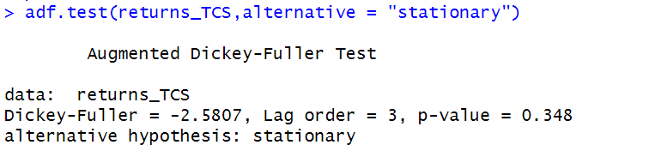

The Augmented Dickey-Fuller test null hypothesis states that a unit root exists, i.e. the series is not-stationary, and the corresponding alternative hypothesis is that the series is stationary. Since the p-value of the test shown above is 0.01, the null hypothesis can be rejected; thus, the series is stationary.The value of ADF Test-statistic: -2.5807.

**13.2.2 ACF Plot**

The sample Autocorrelation function (ACF) plot is used measure the correlation between the present and the lagged values in the series. Lagged values means the past values of the series. Figure 36 shows the formula for calculating ACF at lag k:



*Figure 165: ACF Formula*

The results for of ACF plot for TCS are depicted in Figure 166:

*Figure 166: ACF Plot TCS for MonthlyReturns*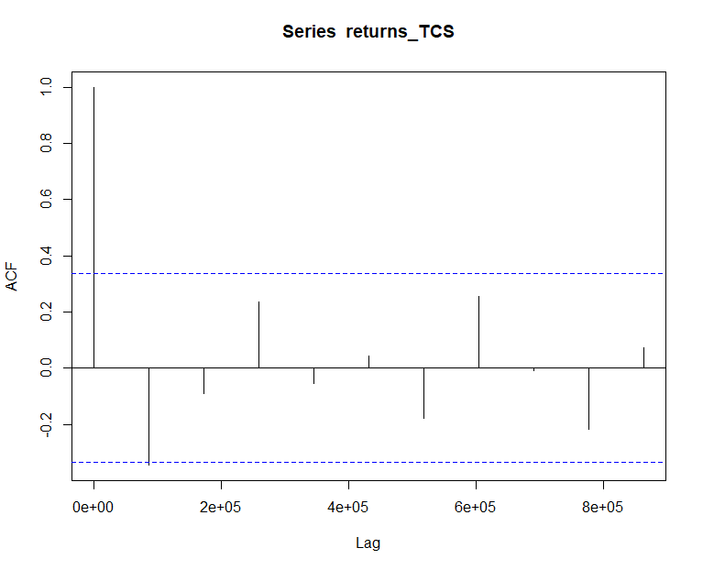

From the above plot it can derived that the series is MA(0) model since no lag term except the 0th lag is significant,following values are not significant.

**13.2.3 PACF Plot**

It measures the correlation between an observation k periods ago and the current observation after controlling the observations at intermediate lags i.e., all the lags which are less than k. PACF plots are used to differentiate between AR & ARMA process. Figure 167 shows the formula for calculating PACF:

*Figure 167: PACF Formula*

The results of PACF plot for TCS are depicted in Figure 168:

*Figure 168: PACF Plot TCS for Monthly Return*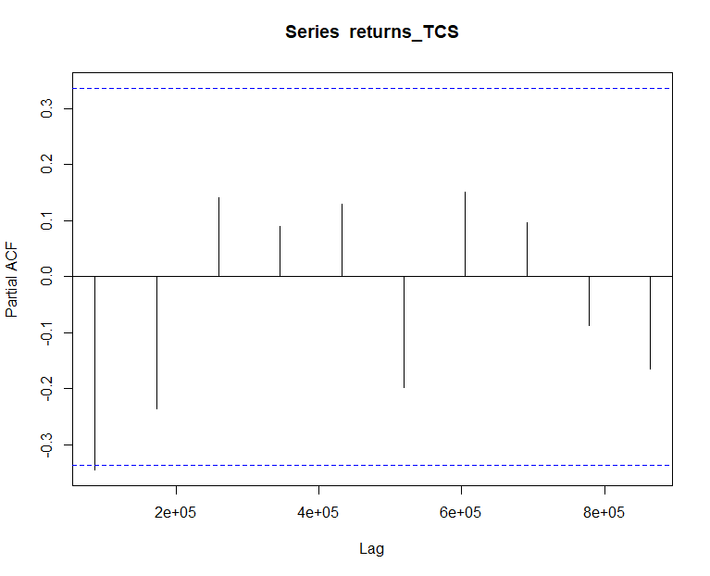

From the above plot it can derived that the series is AR(0) model since only no lag is significant.

**13.2.4 Identification and interpretation of ARIMA model:**

The diagnostic test of the model is shown in Figure.

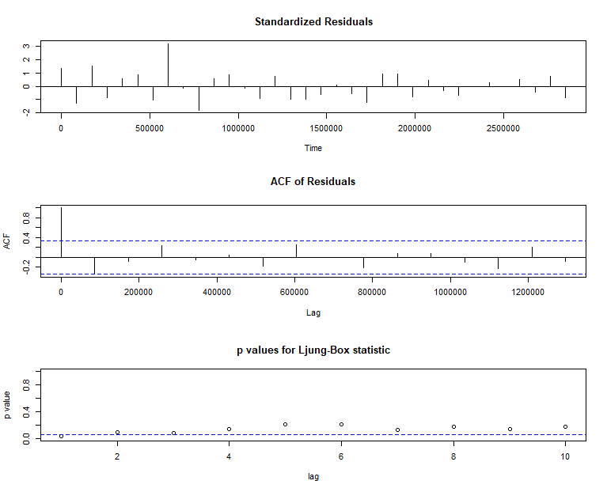

*Figure 169: Diagnostic Results for Monthly Returns*

Ljung-Box Test is used for testing the distribution of residuals. Its null hypothesis is that the residuals are independently distributed while alternative hypothesis states that residuals are not independently residuals. From Figure 169(Chart 3) it can be seen that almost all p-values are greater than 0.05 which means that we can’t reject the null hypothesis i.e., residuals are distributed independently. The normalised residuals time series plot looks to be random and does not show a strong trend, therefore it fits the data well. Also, the Residual autocorrelations are all zero except for one spike.

### **13.2.5** **FORECAST WITH ARIMA MODEL**

Using the ARIMA (0,0,0) model the forecast results have been calculated are shown in Figure 170:

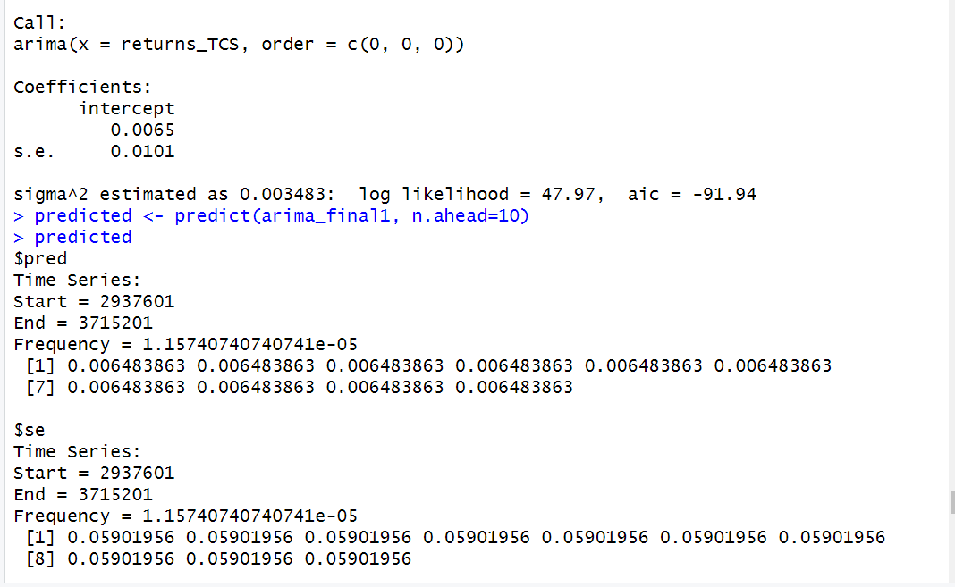

*Figure 170: Forecast for Monthly Returns*

Since all the forecasts for returns are positive, the stock price will increase in the future weeks.

**13.3 GARCH and EGARCH models**

GARCH, or Generalised Autoregressive Conditional Heteroskedasticity, is a method for estimating market volatility while EGARCH (Exponential General Autoregressive Conditional Heteroskedasticity) is also a model for estimating market volatility but with less constraints on the parameters. GARCH (1,1) is the most popular GARCH model. Running GARCH on monthly return of TCS yielded the result that are shown in Figure 171:

*Figure 171: GARCH Model for Monthly Returns*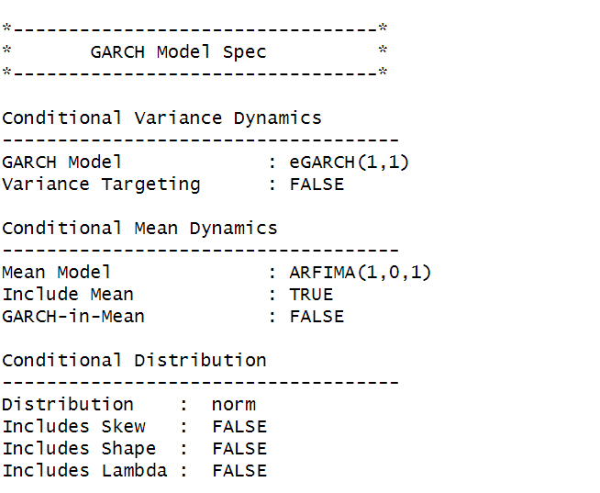

From the Figure 171. we can clearly see that GARCH (1,1) is the most appropriate model and by default, the mean model ARFIMA(1,0,1) is taken.

Now the monthly returns of TCS were run against EGRACH model and the following results were obtained:

*Figure 172: EGARCH Model for Monthly Returns*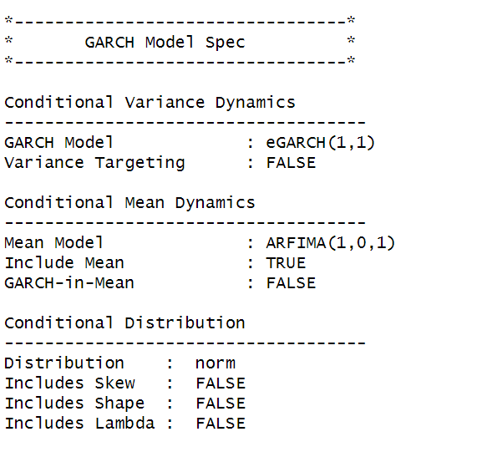

From Figure , we can see that EGARCH (1,1) model is obtained and again by default ARFIMA (1,0,1) is taken. The results are similar to that of GARCH model.

After creating both GARCH and EGARCH models now we fit the model using

ugarchfit function which yielded the results that are shown in Figure 173. The interpretation of the results are given after Figure 173.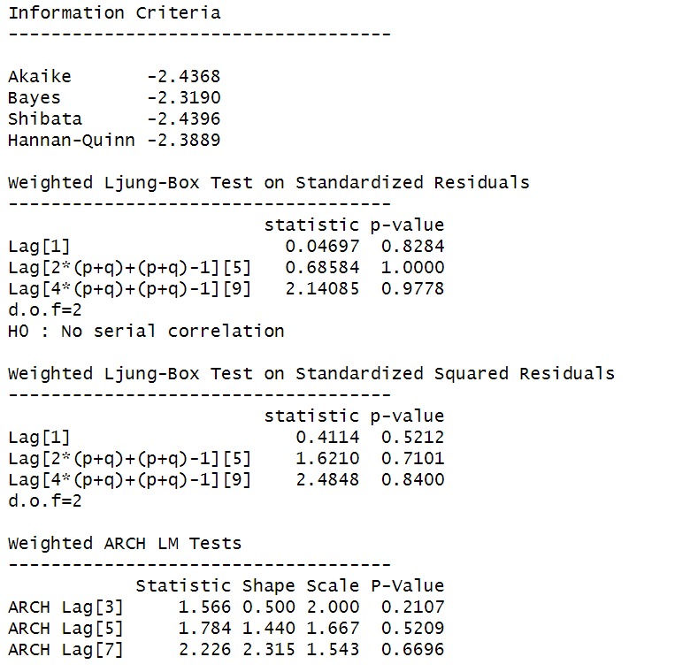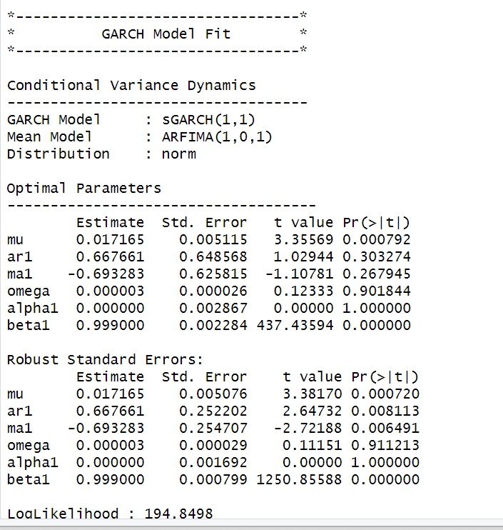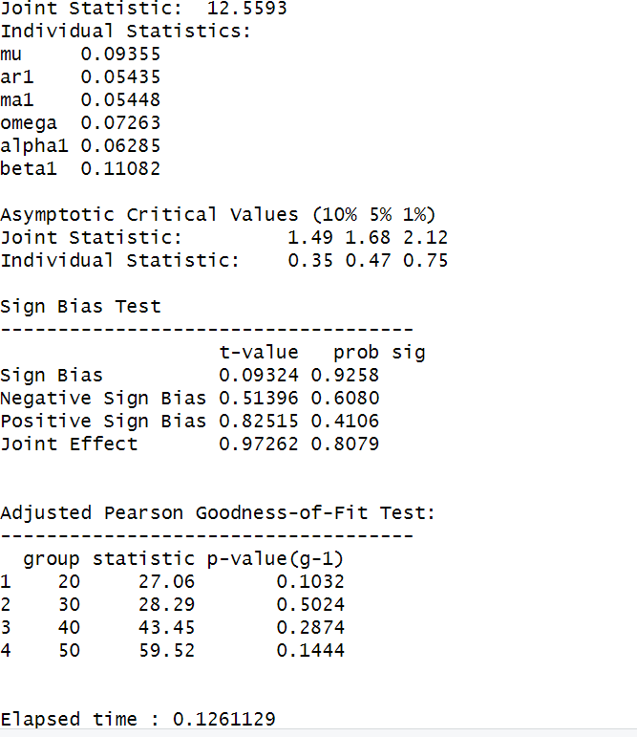

*Figure 173: GARCH Model Fitting for Monthly Returns*

**13.3.1 Interpretation**

• The Log Likelihood obtained from the model is 194.8498.

• GARCH(1,1) is the best fit model for TCS monthly returns.

• The optimal parameters alpha and beta have significant value while omega is insignificant.

• The Alpha, Omega and Beta obtained from estimated robust standard error shows that omega and alpha are insignificant because p-value is greater than 0.05.

• This model provides the best fit with the fewest parameters because its AIC and BIC values are the lowest of all potential models.

• The p-value for both Standardized Residuals and Squared Residuals are greater than 0.05 which means null hypothesis will be accepted i.e., there is no serial correlation which is good for the model.

• Adjusted Pearson Goodness of Fit Test gave all the p-values greater than 0.05 which implies that null hypothesis can’t be rejected which means there is no significant difference between observed value and expected value.

### **13.3.2** **Forecast using GARCH**

The forecasted results using GARCH model are shown in Figure 45. The results show that the returns will be positive for the next 10 days with a value of around 1.72% having a standard deviation close to 6.718%. Positive return means that TCS stock price will rise in the next 10 days which is same as what was suggested by ARIMA model.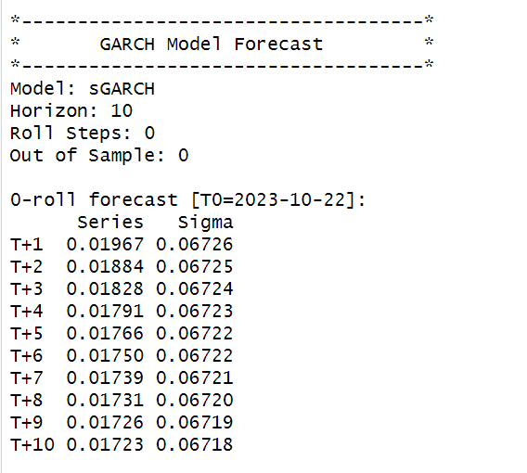

*Figure 174: GARCH Model Prediction for Monthly Return*



**About TVSSRICHAK**

In the tire industry, TVS Srichakra Ltd. is a well-known brand that stands for excellence, innovation, and quality. TVS Srichakra, which was founded in 1982, has grown to be a significant force in the international market by producing a wide variety of high-performance tires.

TVS Srichakra Ltd is a publicly traded company that functions under the prestigious TVS Group, representing honesty, integrity, and a dedication to providing high-quality products. The company was founded with the strategic goal of making a substantial contribution to the automotive sector by manufacturing tires that are exceptional in terms of performance, toughness, and safety.

TVS Srichakra Ltd. was founded by Sri T V Sundaram Iyengar in response to the automotive industry's growing need for dependable and cutting-edge tires. The circumstances surrounding its founding demonstrate a commitment to using innovation and state-of-the-art technology to remain at the forefront of tire manufacturing.

TVS Srichakra Ltd's extensive product portfolio, which includes off-road tires, three-wheelers, and two-wheelers, demonstrates the company's overall greatness. Whether in local or foreign markets, the company has continuously shown that it is committed to satisfying the wide range of needs of its clients.

Beyond just providing quality products, TVS Srichakra Ltd is dedicated to excellence. To ensure that its tires are both technologically advanced and environmentally conscious, the company places a high priority on research and development. TVS Srichakra is a conscientious participant in the tire industry, as demonstrated by its commitment to sustainable practices.

Conclusively, TVS Srichakra Ltd represents proficiency in tire production, inventiveness, and a dedication to client contentment. Established in 1982, the company upholds the values of the TVS Group and sets standards for the global tire manufacturing sector, all while propelling the automotive industry forward with its high-performance tire solutions.

# **SECTION 14: TVS (Daily Returns)**

The CAPM model is defined as:

E(R) = Rf + Beta(Rm-Rf)

where,

E(R): Expected return of the firm

Rf: Risk free rate

Rm: Returns of the market

Beta is calculated by regressing expected returns of the stock i.e., TVS on Market Risk Premium (Rm-Rf). It is the slope parameter that is evaluated from the regression model.

The beta is a measure of how sensitive the security is to the changes in the market index. For index portfolio National Stock Exchange (NSE) was taken into consideration.

For example, a beta of 1.5 means that our portfolio is 50% more sensitive when compared with market index.

**14.1 CAPM Model - Estimating the Beta of the Company**

Figure 176 shows the daily returns of the TVS stock price from 2nd November 2020 to 25th October 2023, and the CLOSING prices were used to calculate the returns, which are shown in Figure 175.

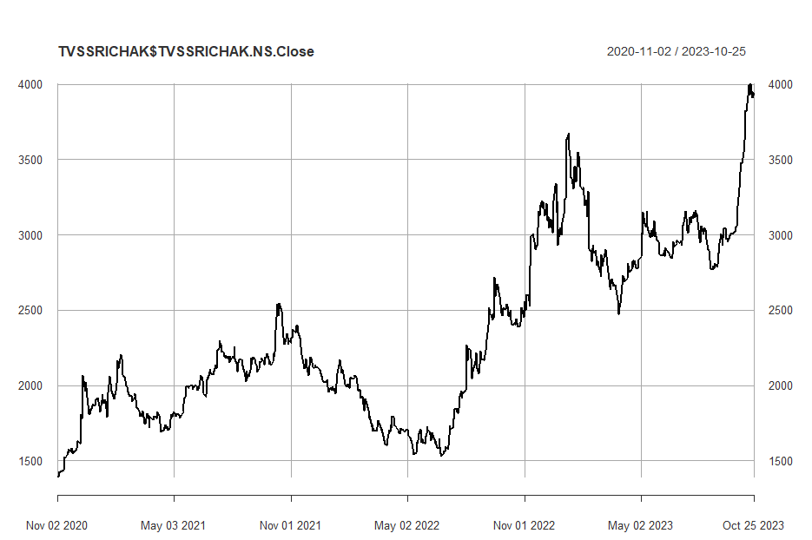

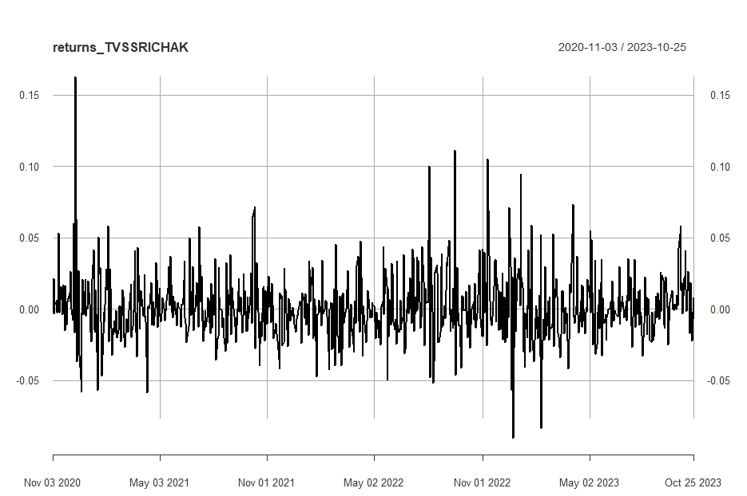

*Figure 176: Daily Returns of TVS*

Next, the excess returns, denoted as E(R) - R_f, are subjected to regression against the market risk premium R_m - R_f. The outcomes of this regression are illustrated in Figure 3

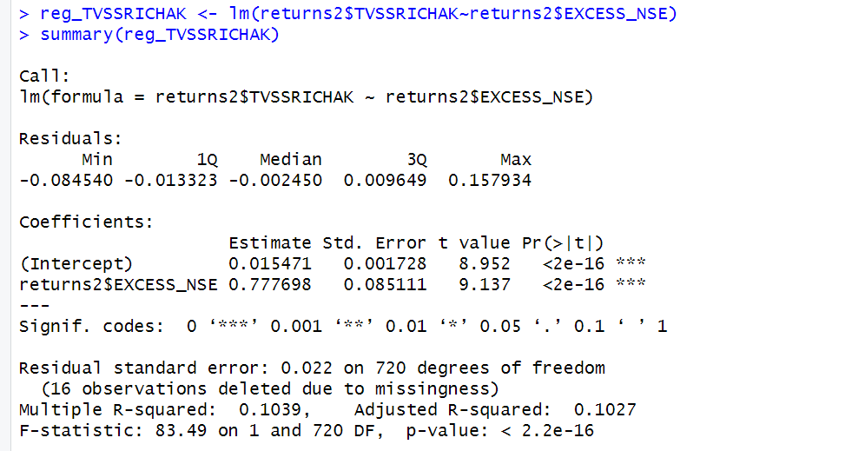

*Figure 177: Regression results of CAPM for Daily Returns*

**14.1.1 CAPM Model - Interpretation of Results**

Figure 4 shows that the Beta for daily returns (risk unadjusted) is 0.777698, which means that if the market index portfolio’s daily returns rise by 1%, then the daily returns of TVS will increase by 0.7%. Moreover, the beta value is statistically significant at both the 95% and 99% confidence levels, given that the p-value is less than 0.01 (p < 0.01).

The intercept value derived from the regression is 0.015471 which means that if the market return is 0%, then TVS will show a 0.01547% return.

**14.2 Estimating AR and MA coefficients using ARIMA**

The AR and MA coefficients are obtained using the ACF (Auto-correlation function) and PACF (Partial Auto-correlation function) plots. From Figure 2 it can be seen that stock price data is non-stationary while from Figure 3 we can interpret that the returns of the stock seem to be stationary of integrated or order 1 which means first difference is stationary.

**14.2.1 Augmented Dickey-Fuller Test**

An augmented Dickey-Fuller (ADF) test is performed to check for stationarity, whose results are in Figure 178.

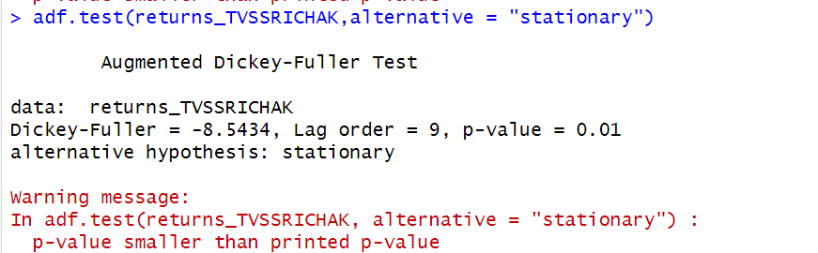

*Figure 178: ADF Test Results for Daily Returns*

The Augmented Dickey-Fuller test null hypothesis states that a unit root exists, i.e. the series is not-stationary, and the corresponding alternative hypothesis is that the series is stationary. Since the p-value of the test shown above is 0.01, the null hypothesis can be rejected; thus, the series is stationary.The value of ADF Test-statistic: -8.5434.

**14.2.2 ACF Plot**

The sample Autocorrelation function (ACF) plot is used measure the correlation between the present and the lagged values in the series. Lagged values means the past values of the series. Figure 179 shows the formula for calculating ACF at lag k:



*Figure 179: ACF Formula*

The results for of ACF plot for TVS are depicted in Figure 180:

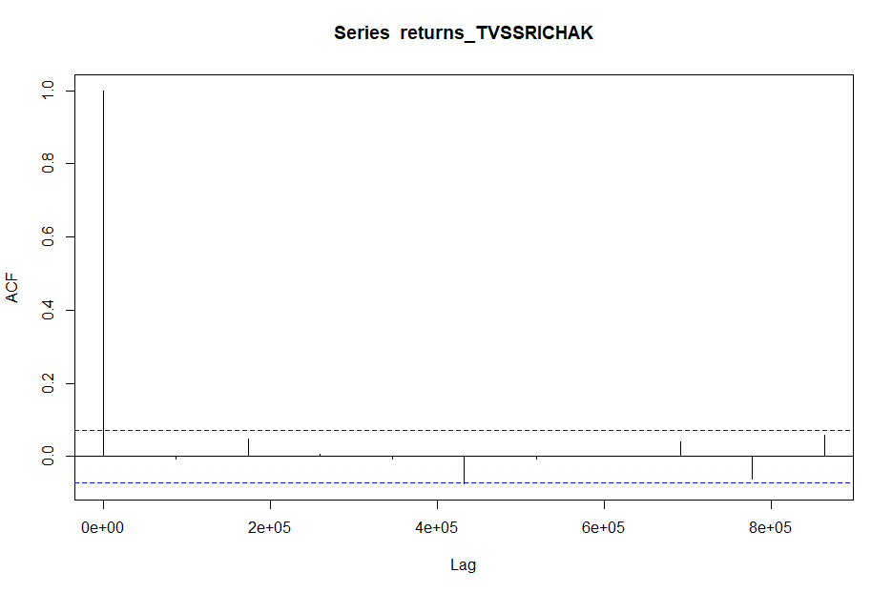

*Figure 180: ACF Plot TVS for Daily Returns*

From the above plot it can derived that the series is MA(0) model since no lag term except the 0th lag is significant,following values are not significant.

**14.2.3 PACF Plot**

It measures the correlation between an observation k periods ago and the current observation after controlling the observations at intermediate lags i.e., all the lags which are less than k. PACF plots are used to differentiate between AR & ARMA process. Figure 181 shows the formula for calculating PACF:

*Figure 181: PACF Formula*

The results of PACF plot for TVS are depicted in Figure 182:

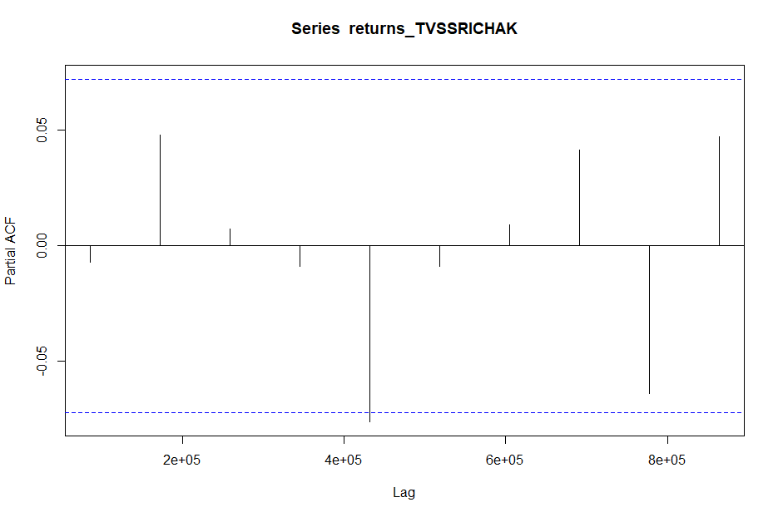

*Figure 182: PACF Plot* TVS *for Daily Return*

From the above plot it can derived that the series is AR(1) model since only one lag is significant.

**14.2.4 Identification and interpretation of ARIMA model:**

The diagnostic test of the model is shown in Figure.

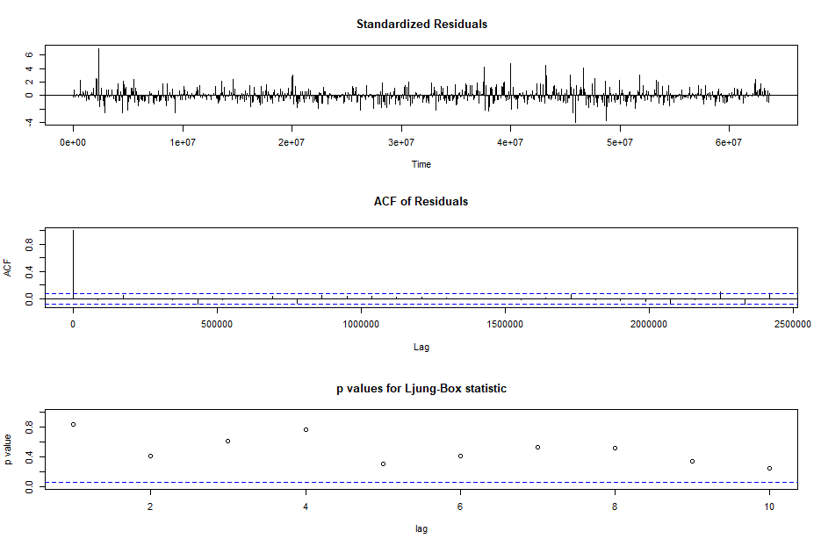

*Figure 183: Diagnostic Results for Daily Returns*

Ljung-Box Test is used for testing the distribution of residuals. Its null hypothesis is that the residuals are independently distributed while alternative hypothesis states that residuals are not independently residuals. From Figure 183(Chart 3) it can be seen that almost all p-values are greater than 0.05 which means that we can’t reject the null hypothesis i.e., residuals are distributed independently. The normalised residuals time series plot looks to be random and does not show a strong trend, therefore it fits the data well. Also, the Residual autocorrelations are all zero except for one spike.

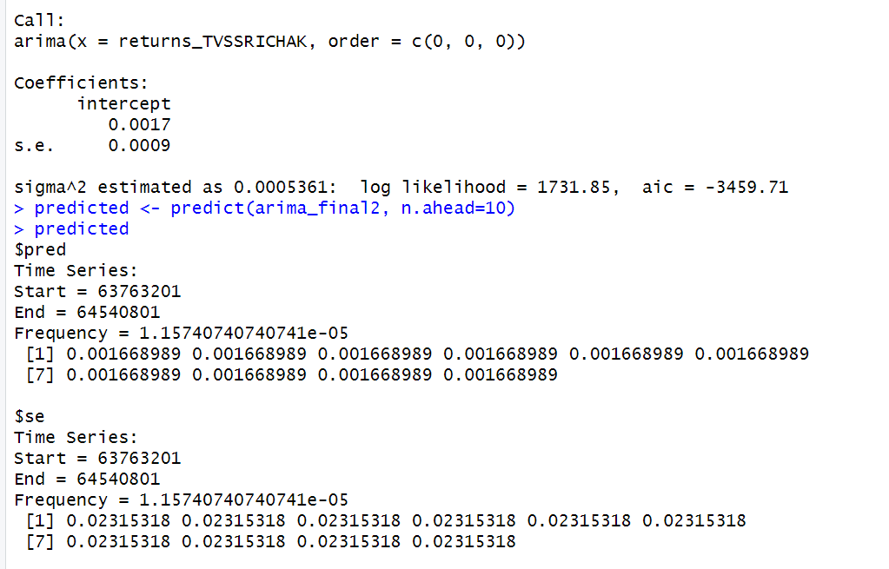

*Figure 184: Forecast for Daily Returns*

Since all the forecasts for returns are positive, the stock price will increase in the future weeks.

**14.3 GARCH and EGARCH models**

GARCH, or Generalised Autoregressive Conditional Heteroskedasticity, is a method for estimating market volatility while EGARCH (Exponential General Autoregressive Conditional Heteroskedasticity) is also a model for estimating market volatility but with less constraints on the parameters. GARCH (1,1) is the most popular GARCH model. Running GARCH on daily return of TVS yielded the result that are shown in Figure 185:

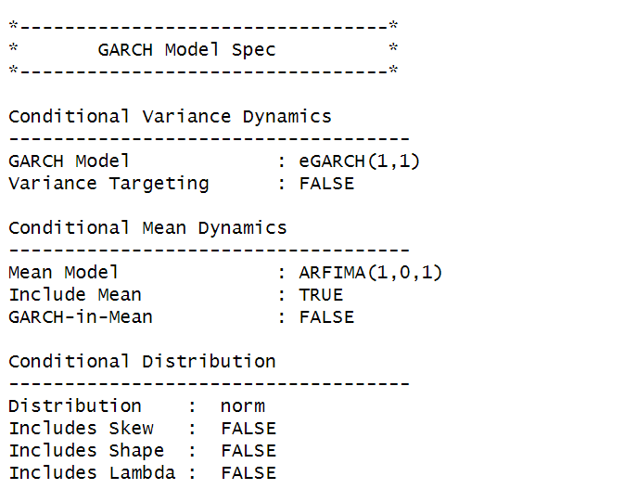

*Figure 185: GARCH Model for Daily Returns*

From the Figure 13, we can clearly see that GARCH (1,1) is the most appropriate model and by default, the mean model ARFIMA(1,0,1) is taken.

Now the daily returns of TVS were run against EGRACH model and the following results were obtained:



*Figure 186: EGARCH Model for Daily Returns*

From Figure 186, we can see that EGARCH (1,1) model is obtained and again by default ARFIMA (1,0,1) is taken. The results are similar to that of GARCH model.

After creating both GARCH and EGARCH models now we fit the model using

ugarchfit function which yielded the results that are shown in Figure 187. The interpretation of the results are given after Figure 187.

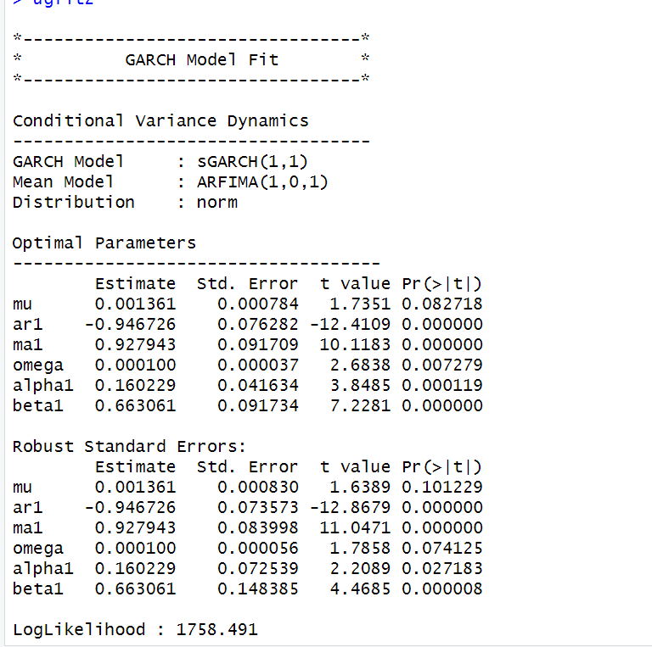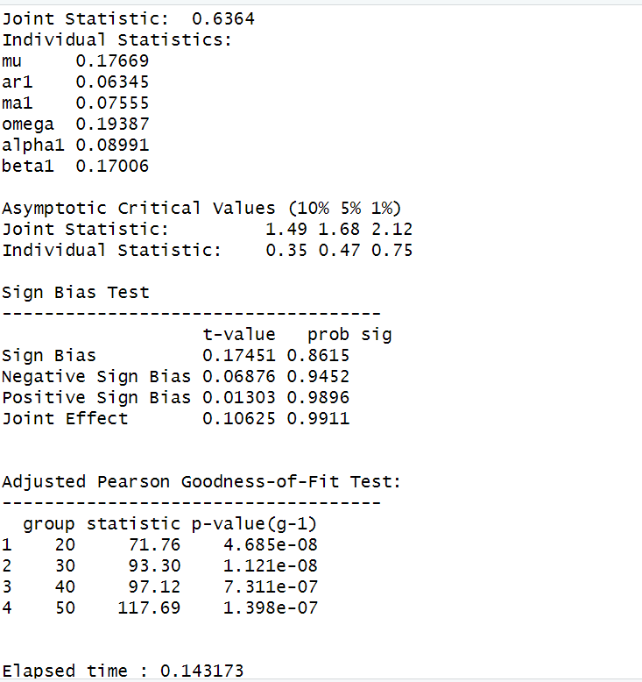

### **14.3.1 Interpretation**

• The Log Likelihood obtained from the model is 1758.491.

• GARCH(1,1) is the best fit model for TVS daily returns. • The optimal parameters alpha and beta have significant value while omega is insignificant.

• The Alpha, Omega and Beta obtained from estimated robust standard error shows that omega and alpha are insignificant because p-value is greater than 0.05.

• This model provides the best fit with the fewest parameters because its AIC and BIC values are the lowest of all potential models.

• The p-value for both Standardized Residuals and Squared Residuals are greater than 0.05 which means null hypothesis will be accepted i.e., there is no serial correlation which is good for the model.

• Adjusted Pearson Goodness of Fit Test gave all the p-values greater than 0.05 which implies that null hypothesis can’t be rejected which means there is no significant difference between observed value and expected value.

### **14.3.2** **Forecast using GARCH**

The forecasted results using GARCH model are shown in Figure 16. The results show that the returns will be positive for the next 10 days with a value of around 0.018% having a standard deviation close to 2.322%. Positive return means that TVSstock price will rise in the next 10 days which is same as what was suggested by ARIMA model.

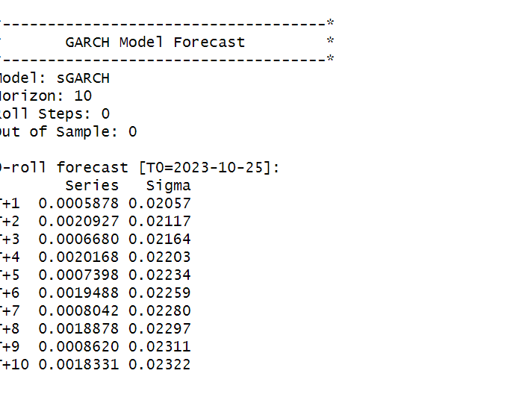

# **SECTION 15: TVS (Weekly Returns)**

Figure 189 shows the weekly returns of the TVS stock price from 2nd November 2020 to 25th October 2023, and the CLOSING prices were used to calculate the returns, which are shown in Figure 188.

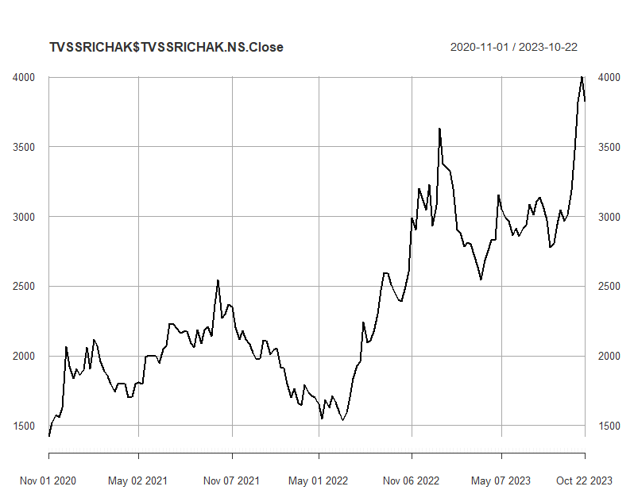

*Figure 188: Weekly Prices of TVS*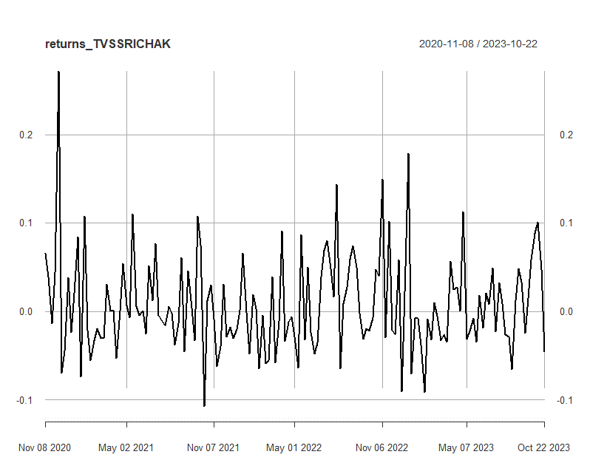

*Figure 189: Weekly Returns of TVS*

Next, the excess returns, denoted as E(R) - R_f, are subjected to regression against the market risk premium R_m - R_f. The outcomes of this regression are illustrated in Figure 190.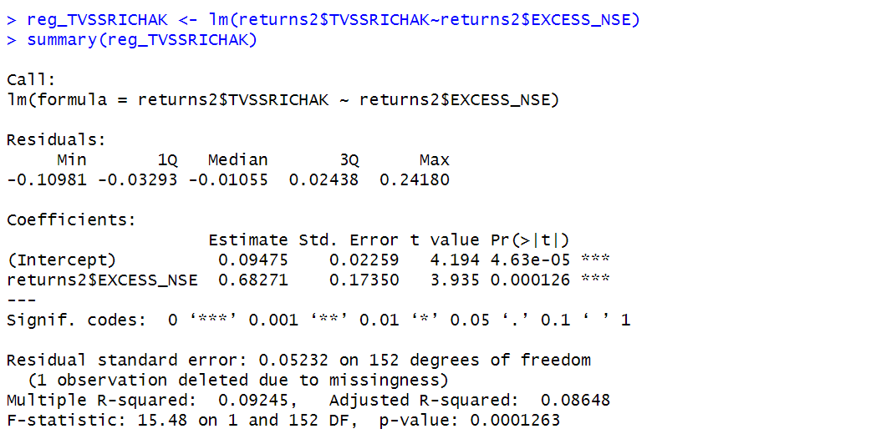

*Figure 190: Regression results of CAPM for Weekly Returns*

**15.1.1 CAPM Model - Interpretation of Results**

The above figure shows that the Beta for weekly returns (risk unadjusted) is 0.68271, which means that if the market index portfolio’s daily returns rise by 1%, then the daily returns of TVS will increase by 0.68271%. Also, the beta value is significant at 95% but not at 99% since the p-value is greater than 0.01 but less than 0.05 (0.05> p > 0.01)The intercept value derived from the regression is 0.09475 which means that if the market return is 0%, then TVS will show a 0.09475% return.

## **15.2** **Estimating AR and MA coefficients using ARIMA**

The AR and MA coefficients are obtained using the ACF (Auto-correlation function) and PACF (Partial Auto-correlation function) plots. From Figure 17 it can be seen that stock price data is non-stationary while from Figure 18 we can interpret that the returns of the stock seems to be stationary of integrated or order 1 which means first difference is stationary.

**15.2.1 Augmented Dickey-Fuller Test**

An augmented Dickey-Fuller (ADF) test is performed to check for stationarity, whose results are in Figure 191.

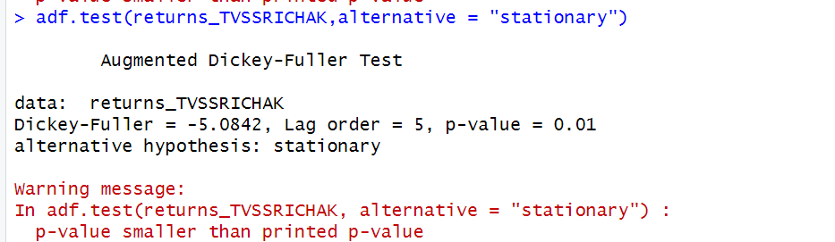

*Figure 191: ADF Test Results for Weekly Returns*

The Augmented Dickey-Fuller test null hypothesis states that a unit root exists, i.e. the series is not-stationary, and the corresponding alternative hypothesis is that the series is stationary. Since the p-value of the test shown above is 0.01, the null hypothesis can be rejected; thus, the series is stationary.The value of ADF Test-statistic: -5.0842.

**15.2.2 ACF Plot**

The sample Autocorrelation function (ACF) plot is used measure the correlation between the present and the lagged values in the series. Lagged values means the past values of the series. Figure 192 shows the formula for calculating ACF at lag k:



*Figure 192: ACF Formula*

The results for of ACF plot for TVS are depicted in Figure 193:

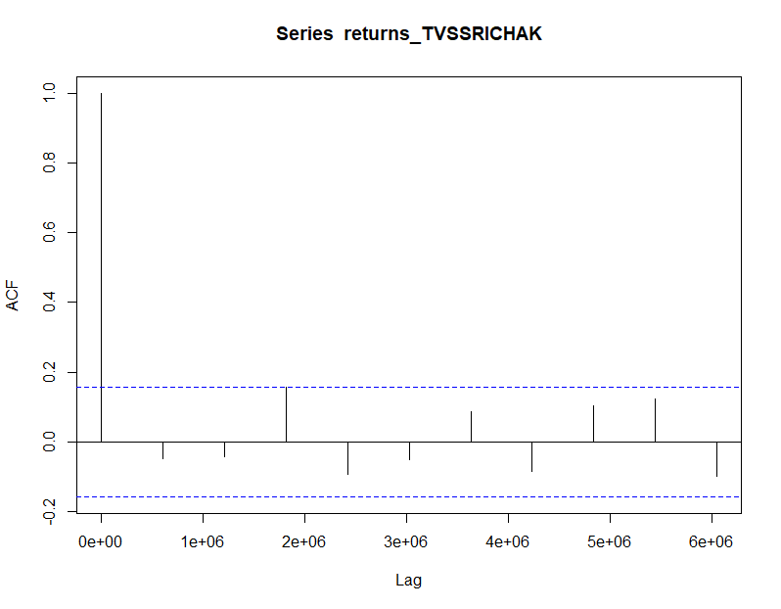

*Figure 193: ACF Plot TVS for Weekly Returns*

From the above plot it can derived that the series is MA(0) model since no lag term except the 0th lag is significant,following values are not significant.

**15.2.3 PACF Plot**

It measures the correlation between an observation k periods ago and the current observation after controlling the observations at intermediate lags i.e., all the lags which are less than k. PACF plots are used to differentiate between AR & ARMA process. Figure 194 shows the formula for calculating PACF:

*Figure 194: PACF Formula*

The results of PACF plot for TVS are depicted in Figure 195:

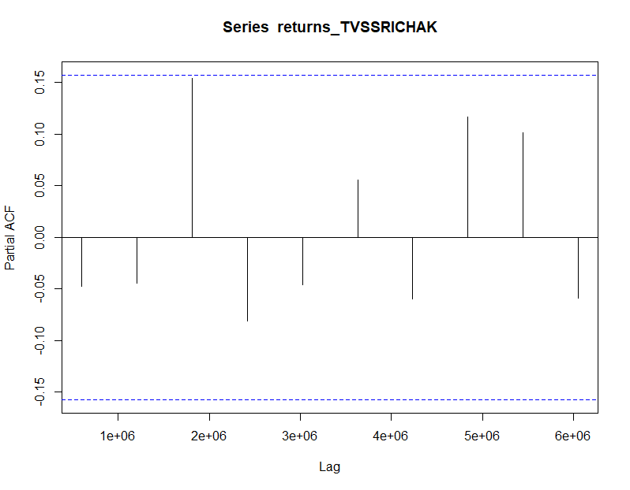

*Figure 195: PACF Plot TVS for Weekly Return*

From the above plot it can derived that the series is AR(0) model since only no lag is significant.

**15.2.4 Identification and interpretation of ARIMA model:**

The diagnostic test of the model is shown in Figure.

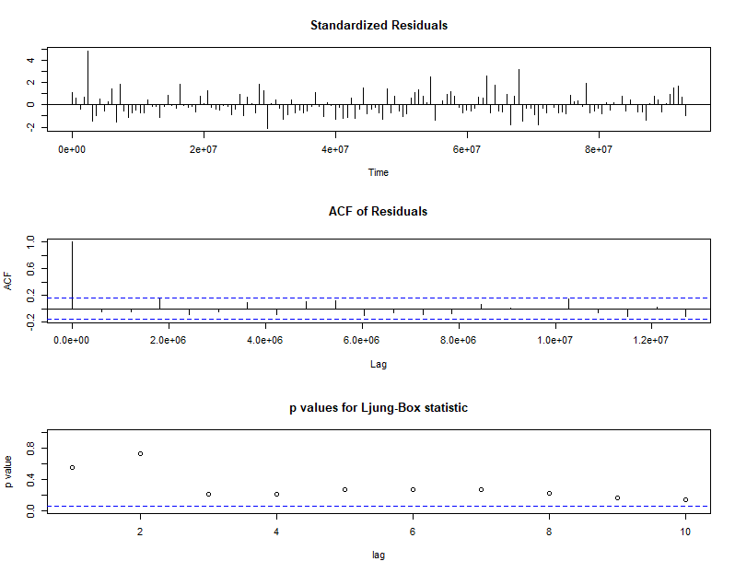

*Figure 196: Diagnostic Results for Daily Returns*

Ljung-Box Test is used for testing the distribution of residuals. Its null hypothesis is that the residuals are independently distributed while alternative hypothesis states that residuals are not independently residuals. From Figure 196 (Chart 3) it can be seen that almost all p-values are greater than 0.05 which means that we can’t reject the null hypothesis i.e., residuals are distributed independently. The normalised residuals time series plot looks to be random and does not show a strong trend, therefore it fits the data well. Also, the Residual autocorrelations are all zero except for one spike.

### **15.2.5** **FORECAST WITH ARIMA MODEL**

Using the ARIMA (0,0,0) model the forecast results have been calculated are shown in Figure 197:

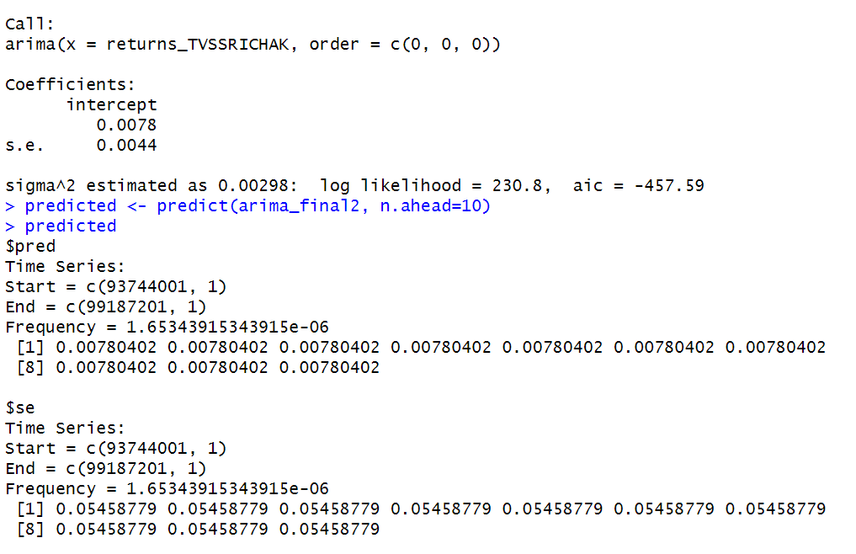

*Figure 197: Forecast for Weekly Returns*

Since all the forecasts for returns are positive, the stock price will increase in the future weeks.

**15.3 GARCH and EGARCH models**

GARCH, or Generalised Autoregressive Conditional Heteroskedasticity, is a method for estimating market volatility while EGARCH (Exponential General Autoregressive Conditional Heteroskedasticity) is also a model for estimating market volatility but with less constraints on the parameters. GARCH (1,1) is the most popular GARCH model. Running GARCH on daily return oTVyielded the result that are shown in Figure 28:

*Figure 198: GARCH Model for Weekly Returns*

From the Figure 198, we can clearly see that GARCH (1,1) is the most appropriate model and by default, the mean model ARFIMA(1,0,1) is taken.

Now the daily returns of TVS were run against EGRACH model and the following results were obtained:

*Figure 199: EGARCH Model for Weekly Returns*

From Figure 199, we can see that EGARCH (1,1) model is obtained and again by default ARFIMA (1,0,1) is taken. The results are similar to that of GARCH model.

After creating both GARCH and EGARCH models now we fit the model using

ugarchfit function which yielded the results that are shown in Figure 200. The interpretation of the results are given after Figure 200.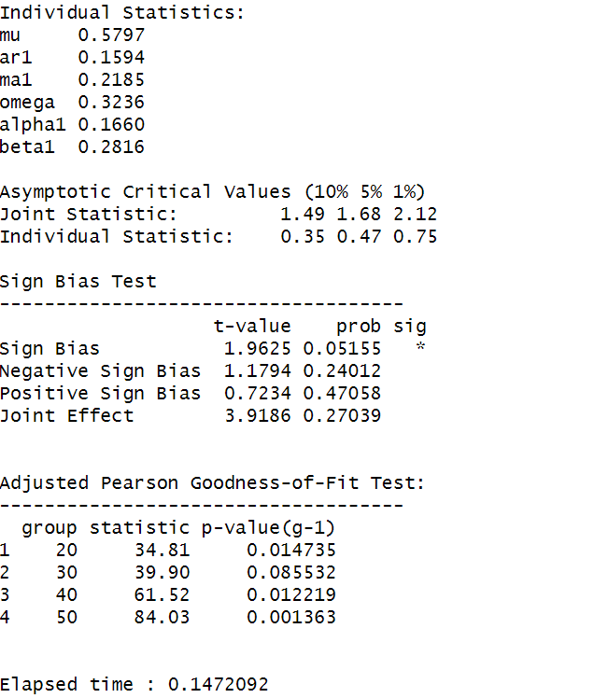

*Figure 200: GARCH Model Fitting for Weekly Returns*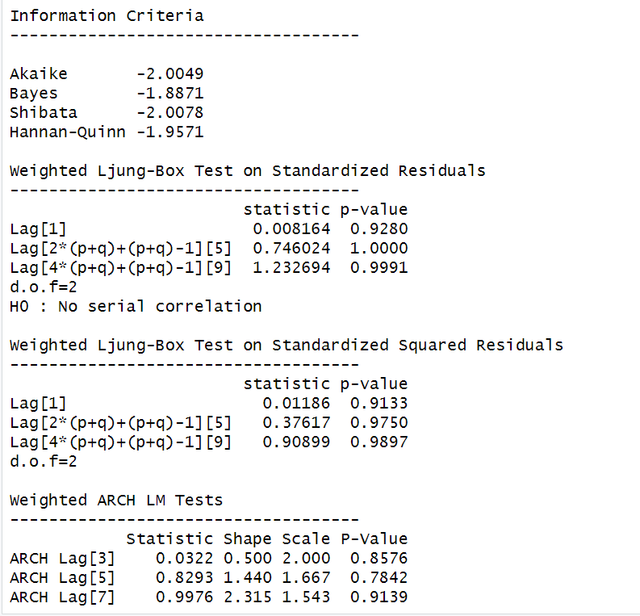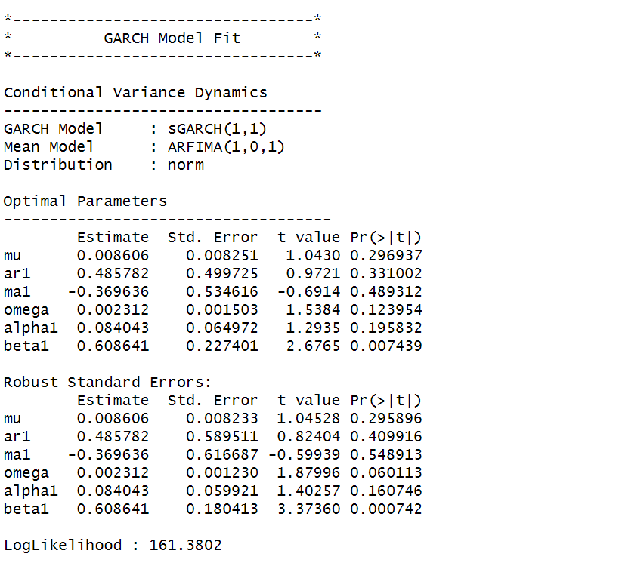

### **15.3.1 Interpretation**

• The Log Likelihood obtained from the model is 161.3802.

• GARCH(1,1) is the best fit model for TVS weekly returns.

• The optimal parameters alpha and beta have significant value while omega is insignificant.

• The Alpha, Omega and Beta obtained from estimated robust standard error shows that omega and alpha are insignificant because p-value is greater than 0.05.

• This model provides the best fit with the fewest parameters because its AIC and BIC values are the lowest of all potential models.

• The p-value for both Standardized Residuals and Squared Residuals are greater than 0.05 which means null hypothesis will be accepted i.e., there is no serial correlation which is good for the model.

• Adjusted Pearson Goodness of Fit Test gave all the p-values greater than 0.05 which implies that null hypothesis can’t be rejected which means there is no significant difference between observed value and expected value.

### **15.3.2** **Forecast using GARCH**

The forecasted results using GARCH model are shown in Figure 31. The results show that the returns will be positive for the next 10 days with a value of around 0.85% having a standard deviation close to 8.657%. Positive return means that TVS stock price will rise in the next 10 days which is same as what was suggested by ARIMA model.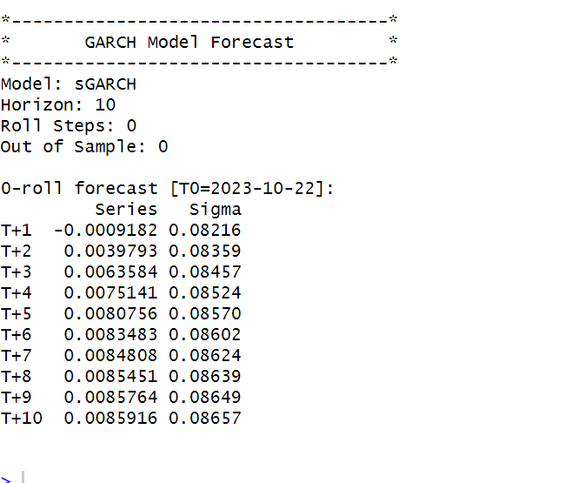

*Figure 201: GARCH Model Prediction for Weekly Return*

**SECTION 16: TVS (Monthly Returns)**

Figure 203 shows the monthly returns of the TVS stock price from 2nd November 2020 to 25th October 2023, and the CLOSING prices were used to calculate the returns, which are shown in Figure 202.

*Figure 202: Monthly Prices of TVS*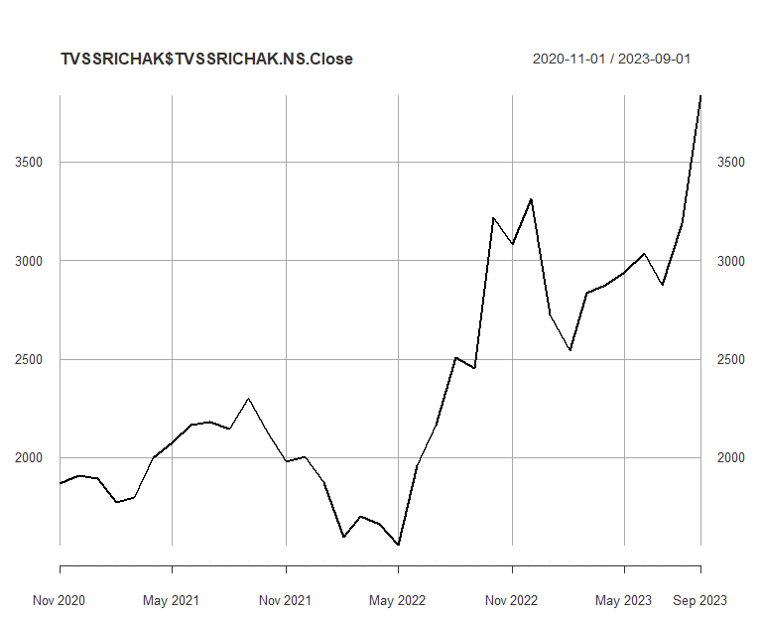

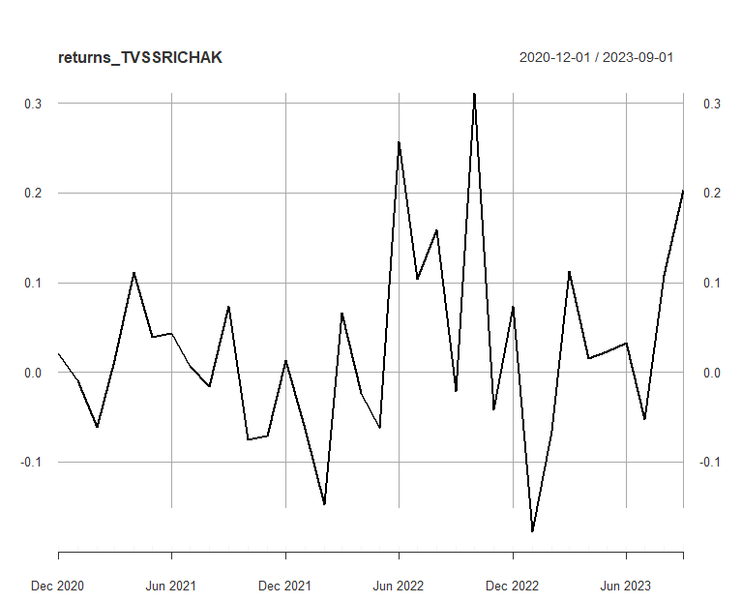

*Figure 203:Monthly Returns of TVS*

Next, the excessreturns, denoted as E(R) - R_f, are subjected to regression against the market risk premium R_m - R_f. The outcomes of this regression are illustrated in Figure 204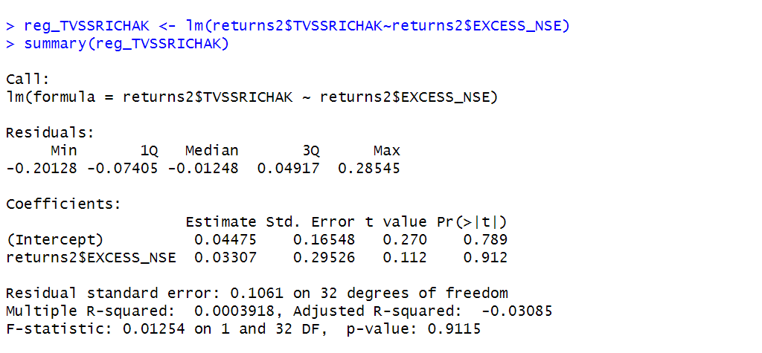

*Figure 204: Regression results of CAPM for Monthly Returns*

**16.1.1 CAPM Model - Interpretation of Results**

Figure shows that the Beta for monthly returns (risk unadjusted) is 0.33307, which means that if the market index portfolio’s daily returns rise by 1%, then the monthly returns of TVS will increase by 0.3307%.The intercept value derived from the regression is 0.04475 but it is also not statistically significant. Therefore, it may be appropriate to ignore or treat it as 0%, which means that if the market return is 0%, then TVS will show a 0.2845% return.

## **16.2** **Estimating AR and MA coefficients using ARIMA**

The AR and MA coefficients are obtained using the ACF (Auto-correlation function) and PACF (Partial Auto-correlation function) plots. From Figure 32 it can be seen that stock price data is non-stationary while from Figure 33 we can interpret that the returns of the stock seems to be stationary of integrated or order 1 which means first difference is stationary.

**16.2.1 Augmented Dickey-Fuller Test**

An augmented Dickey-Fuller (ADF) test is performed to check for stationarity, whose results are in Figure 205.

*Figure 205: ADF Test Results for Monthly Returns*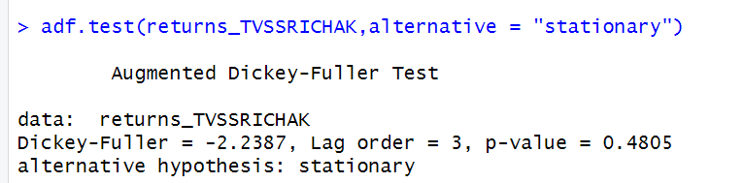

The Augmented Dickey-Fuller test null hypothesis states that a unit root exists, i.e. the series is not-stationary, and the corresponding alternative hypothesis is that the series is stationary. Since the p-value of the test shown above is 0.01, the null hypothesis can be rejected; thus, the series is stationary.The value of ADF Test-statistic: -2.2387.

**16.2.2 ACF Plot**

The sample Autocorrelation function (ACF) plot is used measure the correlation between the present and the lagged values in the series. Lagged values means the past values of the series. Figure 206 shows the formula for calculating ACF at lag k:



*Figure 206: ACF Formula*

The results for of ACF plot for TVS are depicted in Figure 207:

*Figure 207: ACF Plot TVS for MonthlyReturns*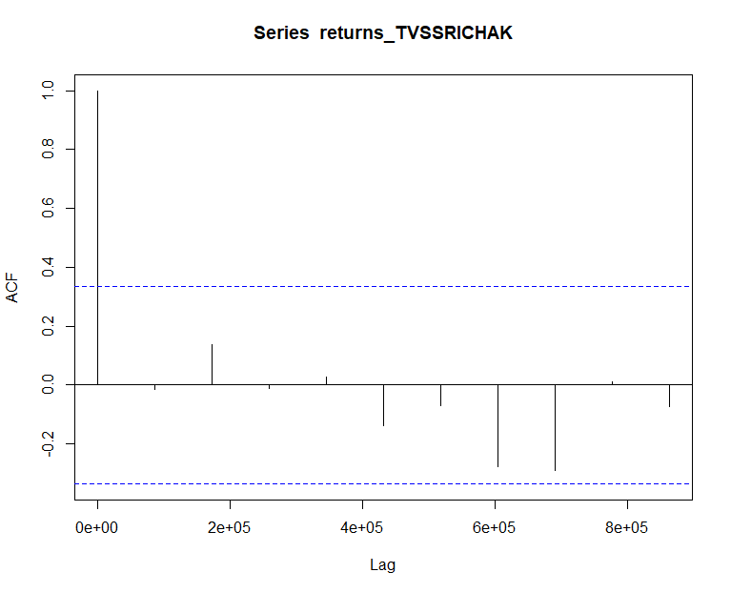

From the above plot it can derived that the series is MA(0) model since no lag term except the 0th lag is significant,following values are not significant.

**16.2.3 PACF Plot**

It measures the correlation between an observation k periods ago and the current observation after controlling the observations at intermediate lags i.e., all the lags which are less than k. PACF plots are used to differentiate between AR & ARMA process. Figure 208 shows the formula for calculating PACF:



*Figure 208: PACF Formula*

The results of PACF plot for TVS are depicted in Figure 209:

*Figure 209: PACF Plot TVS for Monthly Return*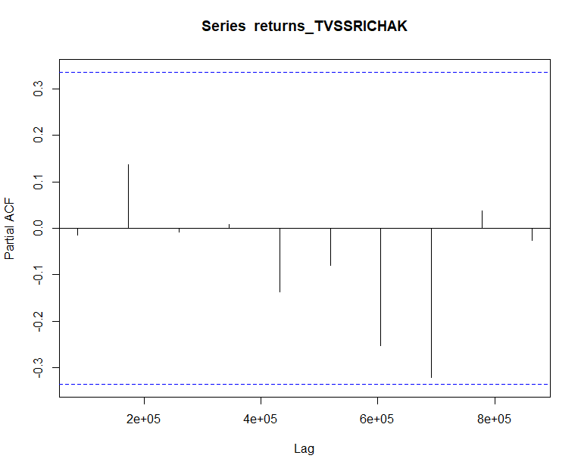

From the above plot it can derived that the series is AR(0) model since only no lag is significant.

**16.2.4 Identification and interpretation of ARIMA model:**

The diagnostic test of the model is shown in Figure.

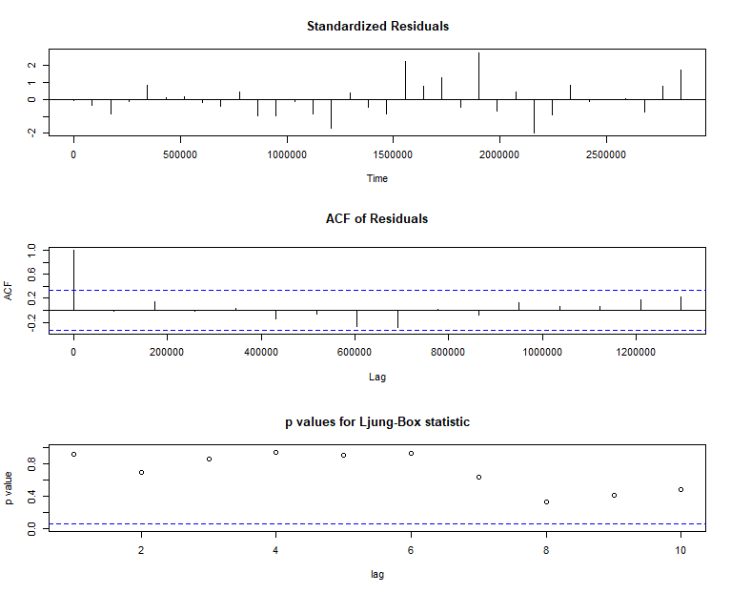

*Figure 210: Diagnostic Results for Monthly Returns*

Ljung-Box Test is used for testing the distribution of residuals. Its null hypothesis is that the residuals are independently distributed while alternative hypothesis states that residuals are not independently residuals. From Figure 210(Chart 3) it can be seen that almost all p-values are greater than 0.05 which means that we can’t reject the null hypothesis i.e., residuals are distributed independently. The normalised residuals time series plot looks to be random and does not show a strong trend, therefore it fits the data well. Also, the Residual autocorrelations are all zero except for one spike.

### **16.2.5** **FORECAST WITH ARIMA MODEL**

Using the ARIMA (0,0,0) model the forecast results have been calculated are shown in Figure 41:

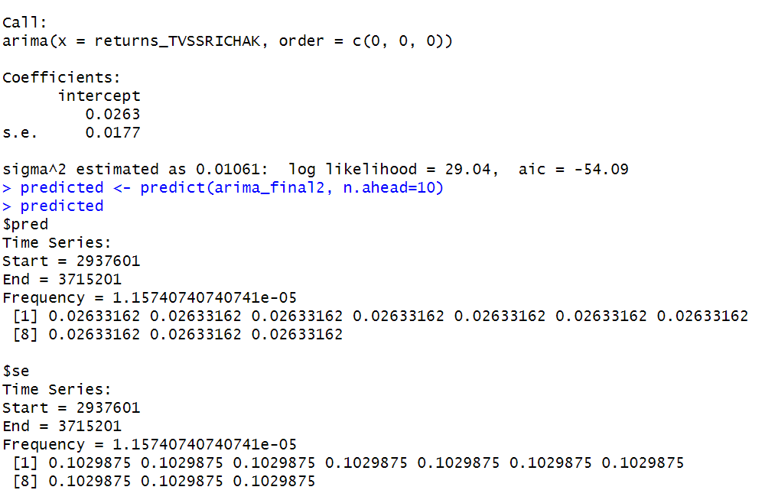

*Figure 211: Forecast for Monthly Returns*

Since all the forecasts for returns are positive, the stock price will increase in the future weeks.

**16.3 GARCH and EGARCH models**

GARCH, or Generalised Autoregressive Conditional Heteroskedasticity, is a method for estimating market volatility while EGARCH (Exponential General Autoregressive Conditional Heteroskedasticity) is also a model for estimating market volatility but with less constraints on the parameters. GARCH (1,1) is the most popular GARCH model. Running GARCH on monthly return of TVS yielded the result that are shown in Figure 212:

*Figure 212: GARCH Model for Monthly Returns*

From the Figure 212. we can clearly see that GARCH (1,1) is the most appropriate model and by default, the mean model ARFIMA(1,0,1) is taken.

Now the monthly returns of TVS were run against EGRACH model and the following results were obtained:

From Figure 213, we can see that EGARCH (1,1) model is obtained and again by default ARFIMA (1,0,1) is taken. The results are similar to that of GARCH model.

*Figure 213: EGARCH Model for Monthly Returns*

After creating both GARCH and EGARCH models now we fit the model using

ugarchfit function which yielded the results that are shown in Figure 44. The interpretation of the results are given after Figure 44.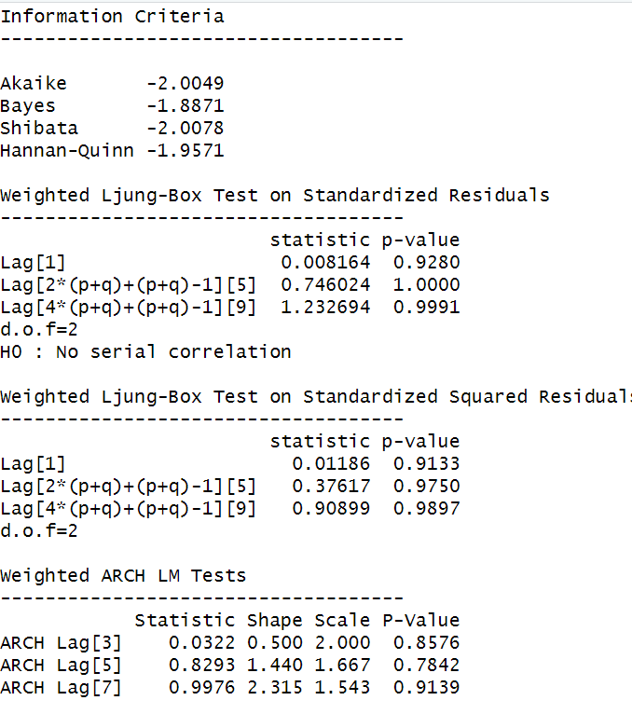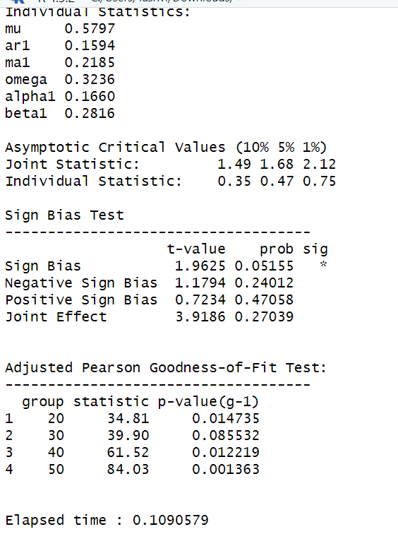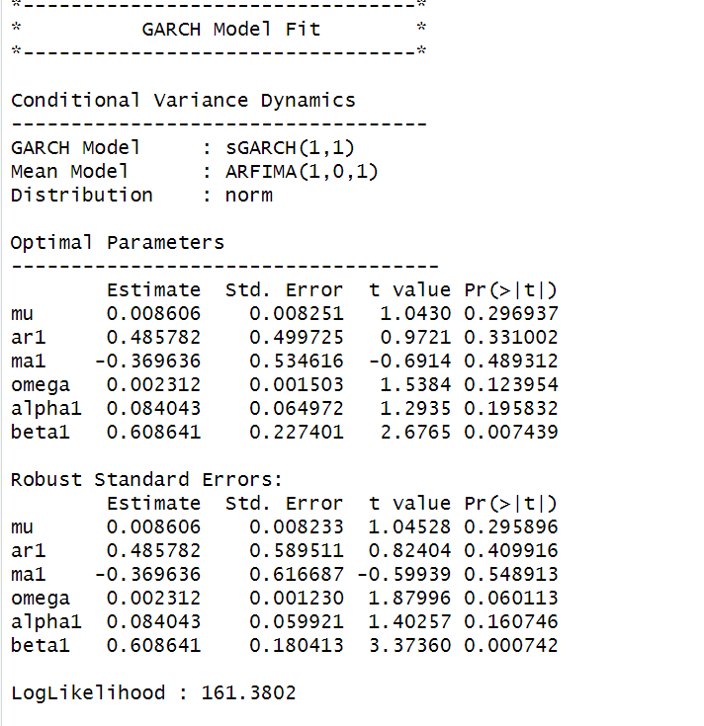

*Figure 214: GARCH Model Fitting for Monthly Returns*

**16.3.1 Interpretation**

• The Log Likelihood obtained from the model is 161.3802.

• GARCH(1,1) is the best fit model for TVS monthly returns.

• The optimal parameters alpha and beta have significant value while omega is insignificant.

• The Alpha, Omega and Beta obtained from estimated robust standard error shows that omega and alpha are insignificant because p-value is greater than 0.05.

• This model provides the best fit with the fewest parameters because its AIC and BIC values are the lowest of all potential models.

• The p-value for both Standardized Residuals and Squared Residuals are greater than 0.05 which means null hypothesis will be accepted i.e., there is no serial correlation which is good for the model.

• Adjusted Pearson Goodness of Fit Test gave all the p-values greater than 0.05 which implies that null hypothesis can’t be rejected which means there is no significant difference between observed value and expected value.

### **16.3.2** **Forecast using GARCH**

The forecasted results using GARCH model are shown in Figure 45. The results show that the returns will be positive for the next 10 days with a value of around 0.085% having a standard deviation close to 8.657%. Positive return means that TVS stock price will rise in the next 10 days which is same as what was suggested by ARIMA model.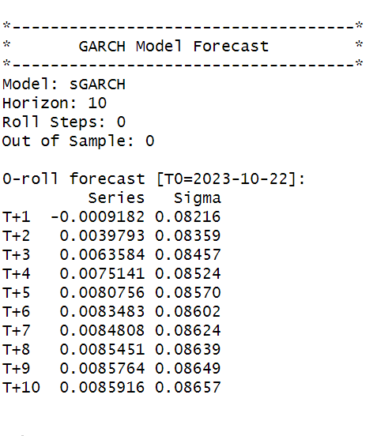

*Figure 215: GARCH Model Prediction for Monthly Return*



**About VISAKAIND:**

In the manufacturing and construction product sectors, Visaka Industries is a trailblazing company. Its founder, Dr. G. Vivekanand, provided visionary leadership that guided it. Since its founding in 1983, Visaka Industries has made a name for itself as a trailblazer in the building materials industry, known for its commitment to innovation, sustainability, and superior quality.

Under the direction of Dr. G. Vivekanand, Visaka Industries is a publicly traded business that is dedicated to providing value to its stakeholders, corporate governance, and transparency. Visaka Industries was established with the goal of revolutionising the construction industry by introducing innovative and environmentally sustainable building solutions that surpass current industry norms.

The events leading up to Visaka Industries' founding under the inspirational leadership of Dr. G Vivekanand demonstrate a thorough comprehension of the dynamics of the construction industry and a dedication to offering solutions that defy accepted wisdom.

The diverse product portfolio of Visaka Industries, which includes cutting-edge fiber cement boards, roofing solutions, and other sustainable building materials, demonstrates the company's overall greatness, which was shaped by Dr. G Vivekanand's leadership. The company sets industry standards with its constant integration of technology, durability, and environmental responsibility into its products.

Beyond business, Dr. G. Vivekanand's influence can be seen in community development and moral business conduct. As a reflection of its holistic approach to its impact on both industry and society, Visaka Industries actively participates in CSR initiatives.

Under the direction of Dr. G Vivekanand, Visaka Industries is a leading building and construction company with a global presence and a dedication to technological innovations. A relentless pursuit of excellence, a dedication to sustainability, and a vision to shape a future where construction solutions align with environmental responsibility are what define the company's legacy.

In conclusion, Dr. G. Vivekanand's Visaka Industries is a prime example of creativity and environmentally friendly methods in the building and manufacturing industries. Since its founding in 1983, the business has redefined industry norms and upheld the principles and vision of its founder for an ethical and forward-thinking future.

**SECTION 17: VISAKAIND (Daily Returns)**

The CAPM model is defined as:

E(R) = Rf + Beta(Rm-Rf)

where,

E(R): Expected return of the firm

Rf: Risk free rate

Rm: Returns of the market

Beta is calculated by regressing expected returns of the stock i.e., VISAKAIND on Market Risk Premium (Rm-Rf). It is the slope parameter that is evaluated from the regression model.

The beta is a measure of how sensitive the security is to the changes in the market index. For index portfolio National Stock Exchange (NSE) was taken into consideration.

For example, a beta of 1.5 means that our portfolio is 50% more sensitive when compared with market index.

**17.1 CAPM Model - Estimating the Beta of the Company**

Figure 217 shows the daily returns of the VISAKAIND stock price from 2nd November 2020 to 25th October 2023, and the CLOSING prices were used to calculate the returns, which are shown in Figure 216.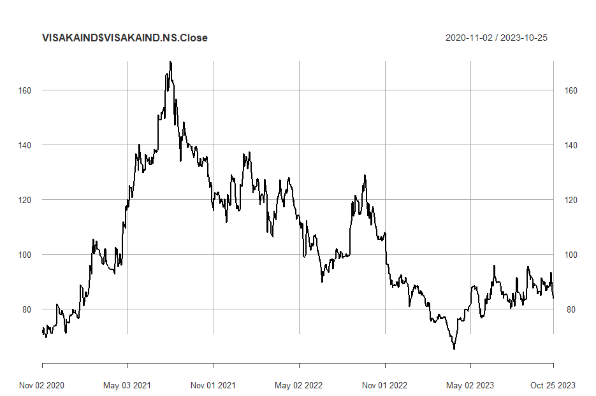

*Figure 216: Daily Returns of VISAKAIND*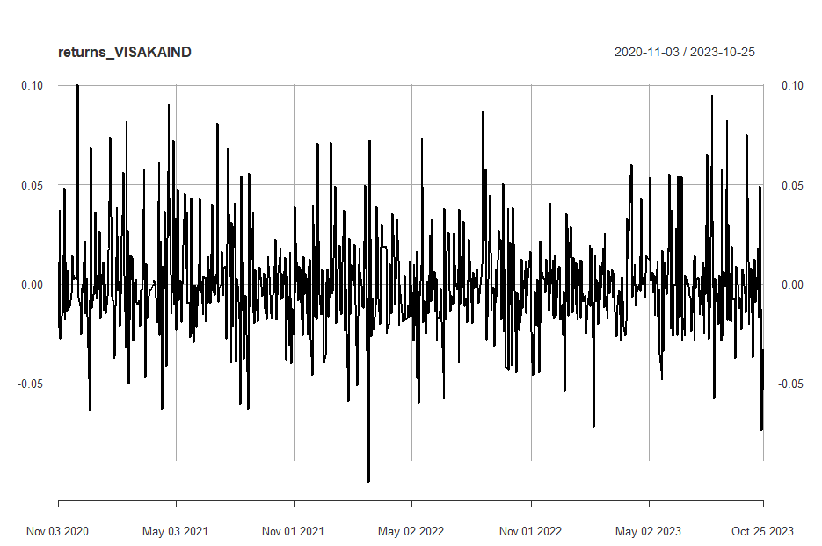

Next, the excess returns, denoted as E(R) - R_f, are subjected to regression against the market risk premium R_m - R_f. The outcomes of this regression are illustrated in Figure 217.

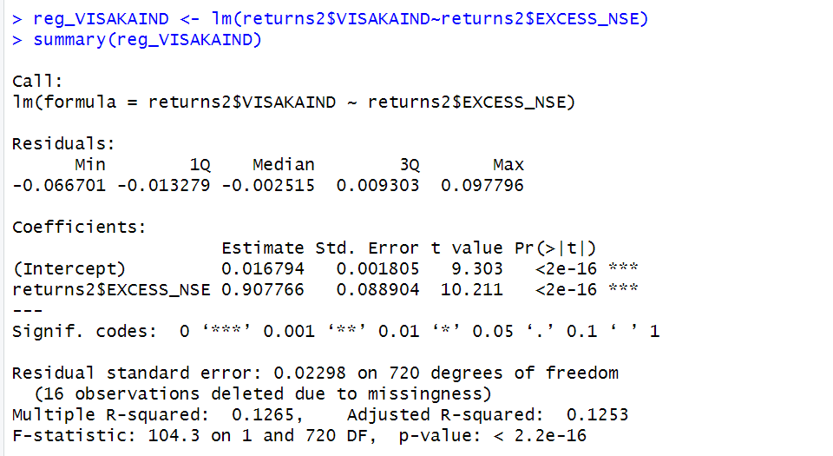 *Figure 217: Regression results of CAPM for Daily Returns*

**17.1.1 CAPM Model - Interpretation of Results**

Figure 4 shows that the Beta for daily returns (risk unadjusted) is 0.907766, which means that if the market index portfolio’s daily returns rise by 1%, then the daily returns of VISAKAIND will increase by 0.9%. Moreover, the beta value is statistically significant at both the 95% and 99% confidence levels, given that the p-value is less than 0.01 (p < 0.01).

The intercept value derived from the regression is 0.01679 which means that if the market return is 0%, then VISAKAIND will show a 0.01679% return.

**17.2 Estimating AR and MA coefficients using ARIMA**

The AR and MA coefficients are obtained using the ACF (Auto-correlation function) and PACF (Partial Auto-correlation function) plots. From Figure 2 it can be seen that stock price data is non-stationary while from Figure 3 we can interpret that the returns of the stock seem to be stationary of integrated or order 1 which means first difference is stationary.

**17.2.1 Augmented Dickey-Fuller Test**

An augmented Dickey-Fuller (ADF) test is performed to check for stationarity, whose results are in Figure 218.

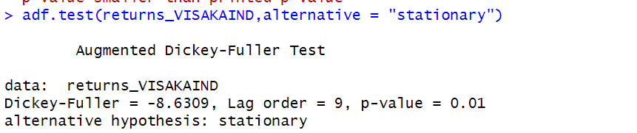

*Figure 218: ADF Test Results for Daily Returns*

The Augmented Dickey-Fuller test null hypothesis states that a unit root exists, i.e. the series is not-stationary, and the corresponding alternative hypothesis is that the series is stationary. Since the p-value of the test shown above is 0.01, the null hypothesis can be rejected; thus, the series is stationary.The value of ADF Test-statistic: -8.6309.

**17.2.2 ACF Plot**

The sample Autocorrelation function (ACF) plot is used measure the correlation between the present and the lagged values in the series. Lagged values means the past values of the series. Figure 7 shows the formula for calculating ACF at lag k:



*Figure 219: ACF Formula*

The results for of ACF plot for VISAKAIND are depicted in Figure 220:

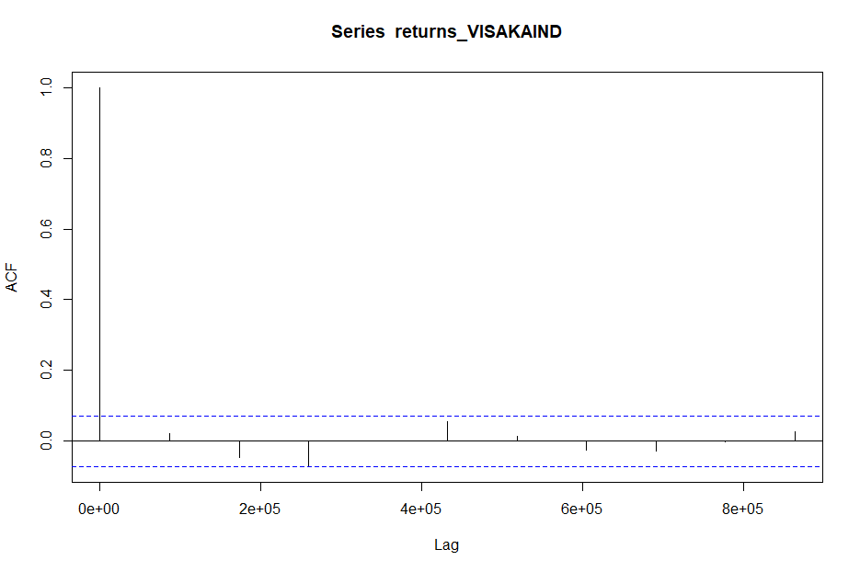

*Figure 220: ACF Plot VISAKAIND for Daily Returns*

From the above plot it can derived that the series is MA(0) model since no lag term except the 0th lag is significant,following values are not significant.

**17.2.3 PACF Plot**

It measures the correlation between an observation k periods ago and the current observation after controlling the observations at intermediate lags i.e., all the lags which are less than k. PACF plots are used to differentiate between AR & ARMA process. Figure 221 shows the formula for calculating PACF:



*Figure 221: PACF Formula*

The results of PACF plot for VISAKAIND are depicted in Figure 222:

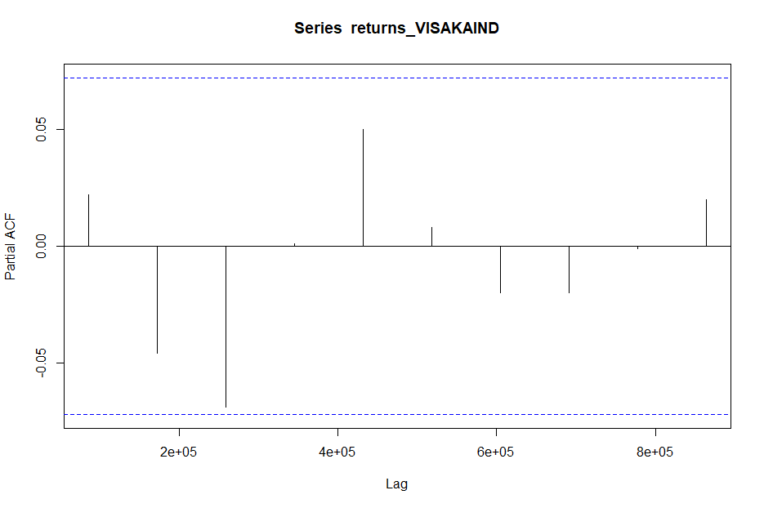

*Figure 222: PACF Plot VISAKAIND* *for Daily Return*

From the above plot it can derived that the series is AR(1) model since only one lag is significant.

**17.2.4 Identification and interpretation of ARIMA model:**

The diagnostic test of the model is shown in Figure.

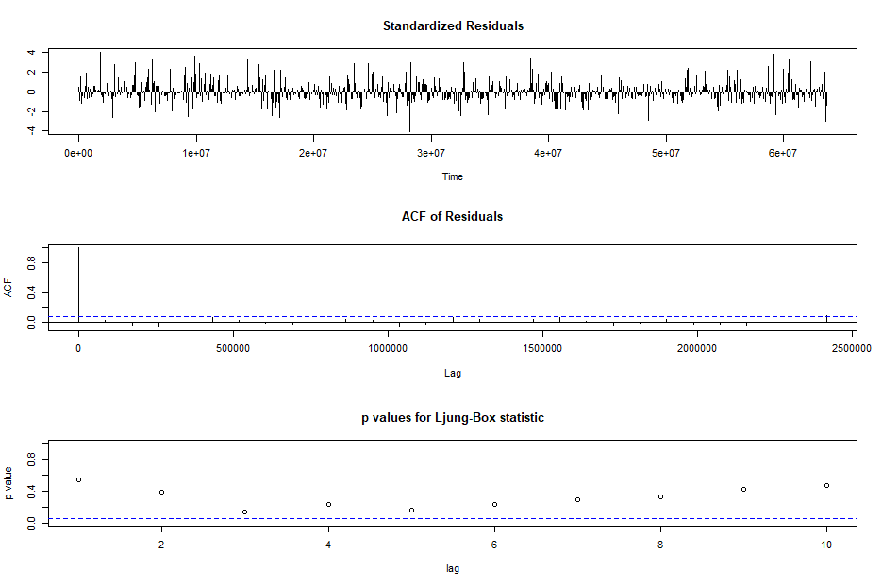

*Figure 223: Diagnostic Results for Daily Returns*

Ljung-Box Test is used for testing the distribution of residuals. Its null hypothesis is that the residuals are independently distributed while alternative hypothesis states that residuals are not independently residuals. From Figure 223(Chart 3) it can be seen that almost all p-values are greater than 0.05 which means that we can’t reject the null hypothesis i.e., residuals are distributed independently. The normalised residuals time series plot looks to be random and does not show a strong trend, therefore it fits the data well. Also, the Residual autocorrelations are all zero except for one spike.

### **17.2.5** **FORECAST WITH ARIMA MODEL**

Using the ARIMA (0,0,0) model the forecast results have been calculated are shown in Figure 224:

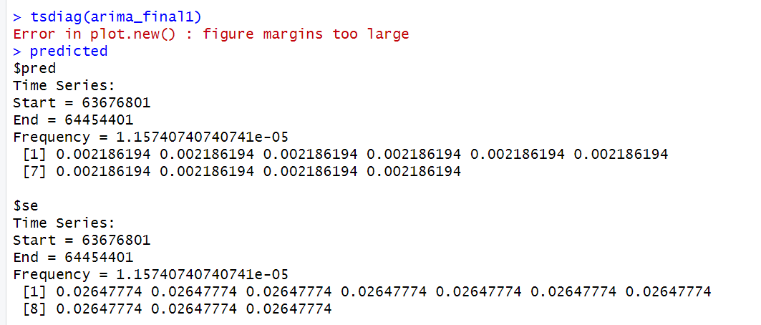

*Figure 224: Forecast for Daily Returns*

Since all the forecasts for returns are positive, the stock price will increase in the future weeks.

**17.3 GARCH and EGARCH models**

GARCH, or Generalised Autoregressive Conditional Heteroskedasticity, is a method for estimating market volatility while EGARCH (Exponential General Autoregressive Conditional Heteroskedasticity) is also a model for estimating market volatility but with less constraints on the parameters. GARCH (1,1) is the most popular GARCH model. Running GARCH on daily return of VISAKAIND yielded the result that are shown in Figure 225:

*Figure 225: GARCH Model for Daily Returns*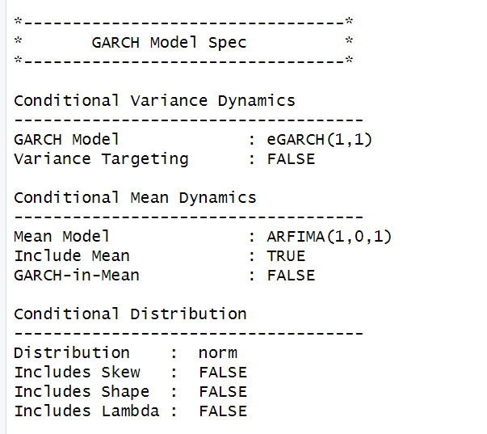

From the Figure 225, we can clearly see that GARCH (1,1) is the most appropriate model and by default, the mean model ARFIMA(1,0,1) is taken.

Now the daily returns of VISAKAIND were ru against EGRACH model and the following results were obtained:

*Figure 226: EGARCH Model for Daily Returns*

From Figure 226, we can see that EGARCH (1,1) model is obtained and again by default ARFIMA (1,0,1) is taken. The results are similar to that of GARCH model.

After creating both GARCH and EGARCH models now we fit the model using

ugarchfit function which yielded the results that are shown in Figure 227. The interpretation of the results are given after Figure 227.

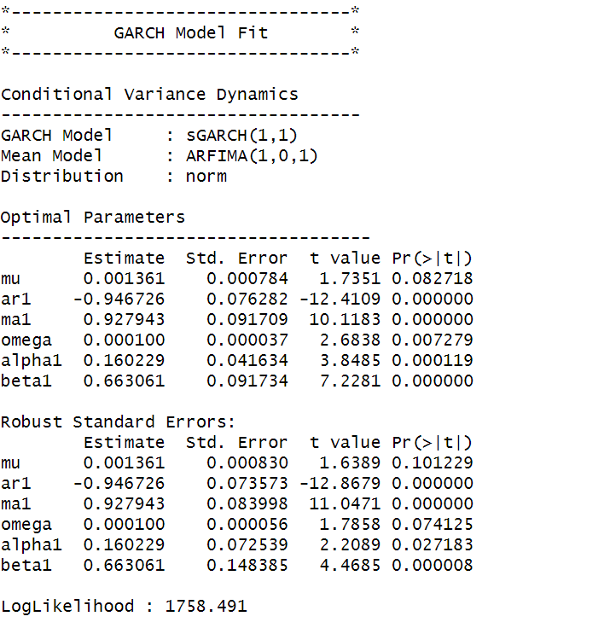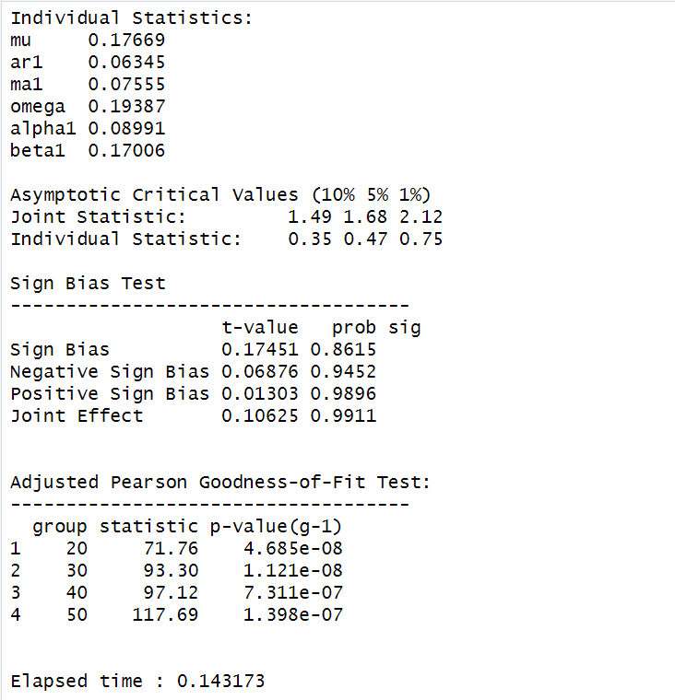



*Figure 227: GARCH Model Fitting for Daily Returns*

### **17.3.1 Interpretation**

• The Log Likelihood obtained from the model is 1758.491.

• GARCH(1,1) is the best fit model for VISAKAIND daily returns.

• The optimal parameters alpha and beta have significant value while omega is insignificant.

• The Alpha, Omega and Beta obtained from estimated robust standard error shows that omega and alpha are insignificant because p-value is greater than 0.05.

• This model provides the best fit with the fewest parameters because its AIC and BIC values are the lowest of all potential models.

• The p-value for both Standardized Residuals and Squared Residuals are greater than 0.05 which means null hypothesis will be accepted i.e., there is no serial correlation which is good for the model.

• Adjusted Pearson Goodness of Fit Test gave all the p-values greater than 0.05 which implies that null hypothesis can’t be rejected which means there is no significant difference between observed value and expected value.

### **17.3.2** **Forecast using GARCH**

The forecasted results using GARCH model are shown in Figure 228. The results show that the returns will be positive for the next 10 days with a value of around 0.183% having a standard deviation close to 2.322%. Positive return means that VISAKAIND stock price will rise in the next 10 days which is same as what was suggested by ARIMA model.

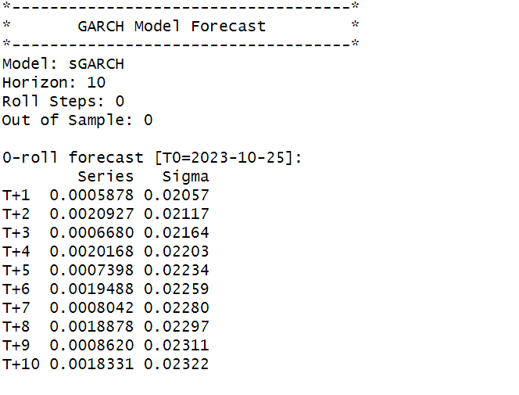

*Figure 228: GARCH Model Prediction for Daily Returns*

**SECTION 18: VISAKAIND (Weekly Returns)**

Figure 230 shows the weekly returns of the VISAKAIND stock price from 2nd November 2020 to 25th October 2023, and the CLOSING prices were used to calculate the returns, which are shown in Figure 229.

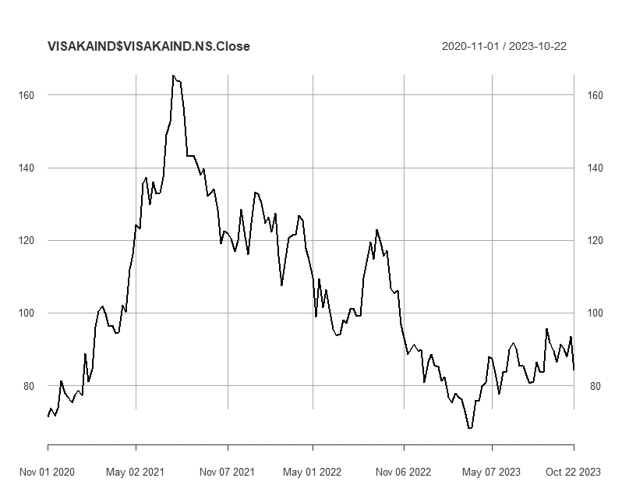

*Figure 229: Weekly Prices of VISAKAIND*

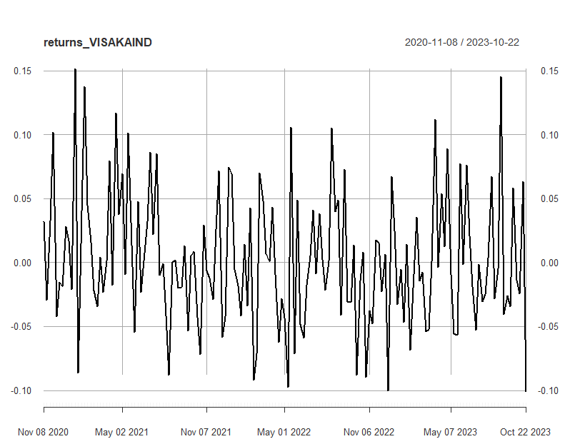

*Figure 230: Weekly Returns of VISAKAIND*

Next, the excess returns, denoted as E(R) - R_f, are subjected to regression against the market risk premium R_m - R_f. The outcomes of this regression are illustrated in Figure 231.

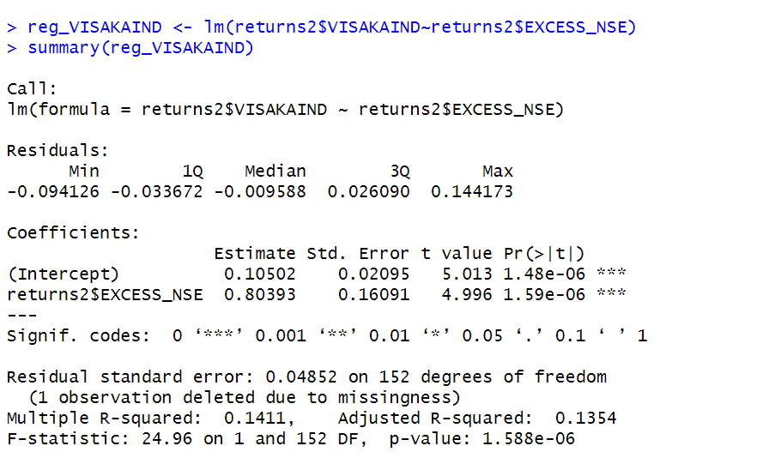  *Figure 231: Regression results of CAPM for Weekly Returns*

**18.1.1 CAPM Model - Interpretation of Results**

The above figure shows that the Beta for weekly returns (risk unadjusted) is 0.90104, which means that if the market index portfolio’s daily returns rise by 1%, then the daily returns of VISAKAIND will increase by 0.8039%. Also, the beta value is significant at 95% but not at 99% since the p-value is greater than 0.01 but less than 0.05 (0.05> p > 0.01)The intercept value derived from the regression is 0.10502 which means that if the market return is 0%, then VISAKAIND will show a 0.10502% return.

## **18.2** **Estimating AR and MA coefficients using ARIMA**

The AR and MA coefficients are obtained using the ACF (Auto-correlation function) and PACF (Partial Auto-correlation function) plots. From Figure 229 it can be seen that stock price data is non-stationary while from Figure 230 we can interpret that the returns of the stock seems to be stationary of integrated or order 1 which means first difference is stationary.

**18.2.1 Augmented Dickey-Fuller Test**

An augmented Dickey-Fuller (ADF) test is performed to check for stationarity, whose results are in Figure 232.

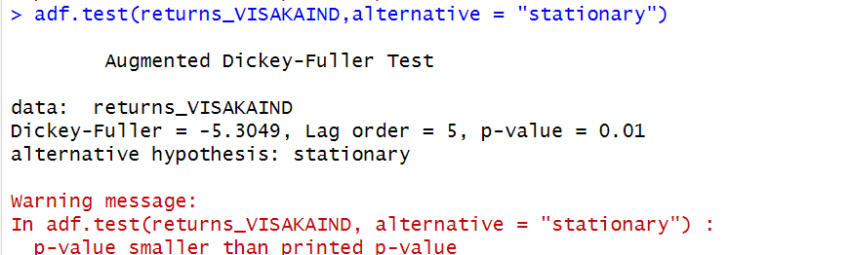

*Figure 232: ADF Test Results for Weekly Returns*

The Augmented Dickey-Fuller test null hypothesis states that a unit root exists, i.e. the series is not-stationary, and the corresponding alternative hypothesis is that the series is stationary. Since the p-value of the test shown above is 0.01, the null hypothesis can be rejected; thus, the series is stationary.The value of ADF Test-statistic: -5.3049.

**18.2.2 ACF Plot**

The sample Autocorrelation function (ACF) plot is used measure the correlation between the present and the lagged values in the series. Lagged values means the past values of the series. Figure 233 shows the formula for calculating ACF at lag k:



*Figure 233: ACF Formula*

The results for of ACF plot for VISAKAIND are depicted in Figure 234:

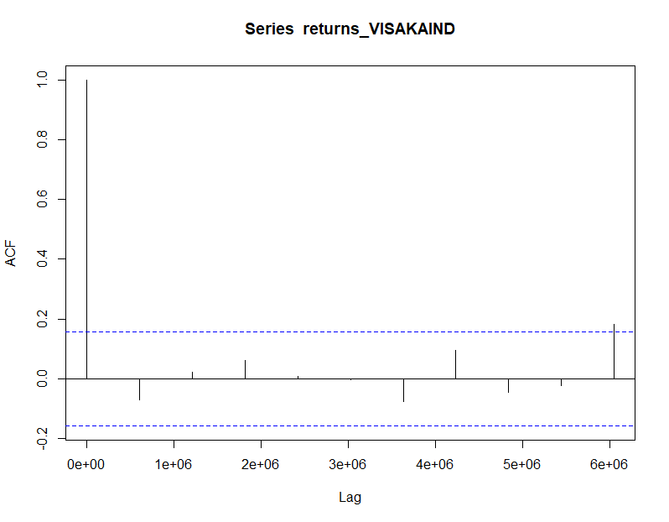

*Figure 234: ACF Plot VISAKAIND for Weekly Returns*

From the above plot it can derived that the series is MA(0) model since no lag term except the 0th lag is significant,following values are not significant.

**18.2.3 PACF Plot**

It measures the correlation between an observation k periods ago and the current observation after controlling the observations at intermediate lags i.e., all the lags which are less than k. PACF plots are used to differentiate between AR & ARMA process. Figure 235 shows the formula for calculating PACF:

*Figure 235: PACF Formula*

The results of PACF plot for VISAKAIND are depicted in Figure 235:

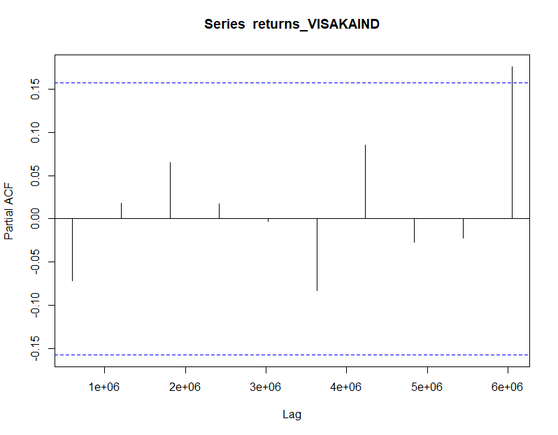

*Figure 235: PACF Plot VISAKAIND for Weekly Return*

From the above plot it can derived that the series is AR(0) model since only no lag is significant.

**18.2.4 Identification and interpretation of ARIMA model:**

The diagnostic test of the model is shown in Figure.

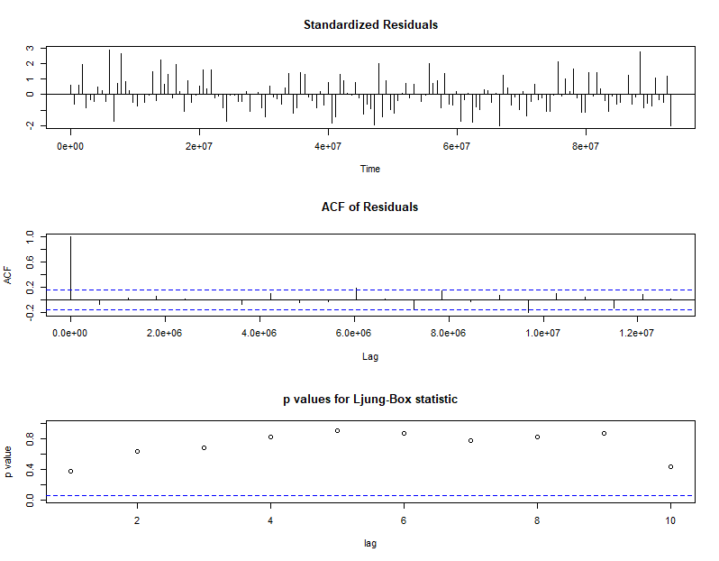

*Figure 236: Diagnostic Results for Weekly Returns*

Ljung-Box Test is used for testing the distribution of residuals. Its null hypothesis is that the residuals are independently distributed while alternative hypothesis states that residuals are not independently residuals. From Figure 236 (Chart 3) it can be seen that almost all p-values are greater than 0.05 which means that we can’t reject the null hypothesis i.e., residuals are distributed independently. The normalised residuals time series plot looks to be random and does not show a strong trend, therefore it fits the data well. Also, the Residual autocorrelations are all zero except for one spike.

### **18.2.5** **FORECAST WITH ARIMA MODEL**

Using the ARIMA (0,0,0) model the forecast results have been calculated are shown in Figure 237:

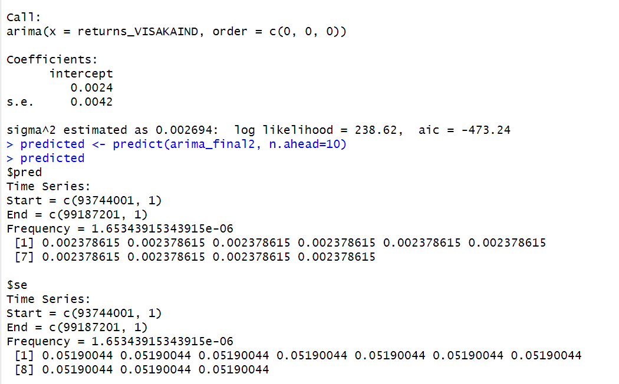

*Figure 237: Forecast for Weekly Returns*

Since all the forecasts for returns are positive, the stock price will increase in the future weeks.

**18.3 GARCH and EGARCH models**

GARCH, or Generalised Autoregressive Conditional Heteroskedasticity, is a method for estimating market volatility while EGARCH (Exponential General Autoregressive Conditional Heteroskedasticity) is also a model for estimating market volatility but with less constraints on the parameters. GARCH (1,1) is the most popular GARCH model. Running GARCH on daily return of VISAKAIND yielded the result that are shown in Figure 238:

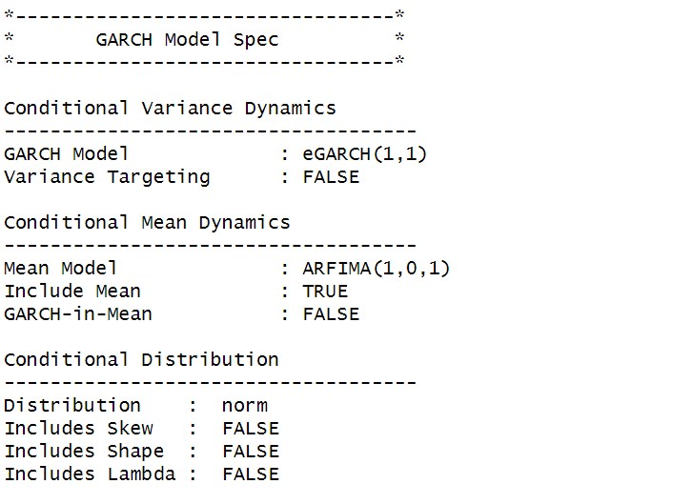

*Figure 238: GARCH Model for Weekly Returns*

From the Figure 238, we can clearly see that GARCH (1,1) is the most appropriate model and by default, the mean model ARFIMA(1,0,1) is taken.

Now the daily returns of VISAKAIND were run against EGRACH model and the following results were obtained:

*Figure 239: EGARCH Model for Weekly Returns*

From Figure 239, we can see that EGARCH (1,1) model is obtained and again by default ARFIMA (1,0,1) is taken. The results are similar to that of GARCH model.

After creating both GARCH and EGARCH models now we fit the model using

ugarchfit function which yielded the results that are shown in Figure 240. The interpretation of the results are given after Figure 240.

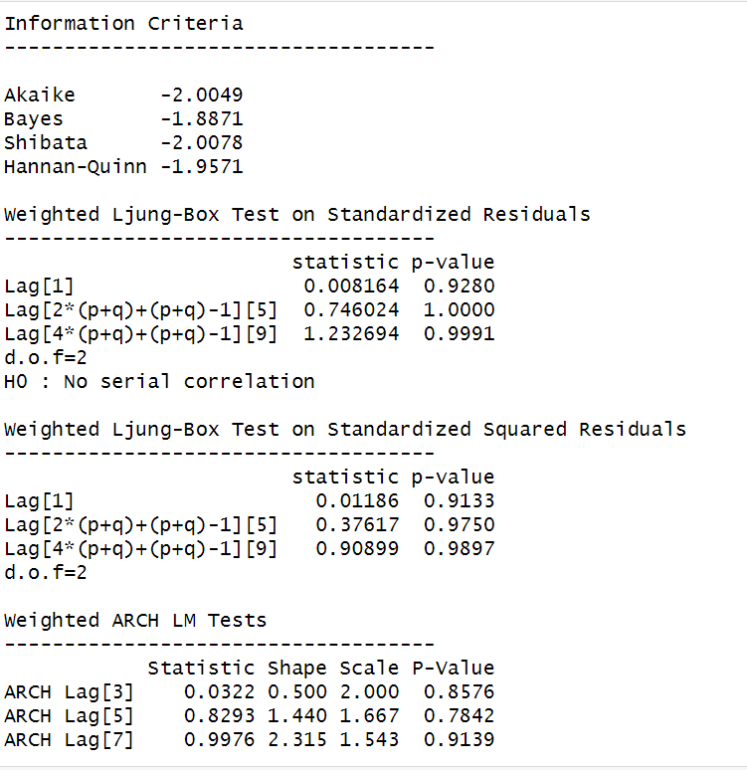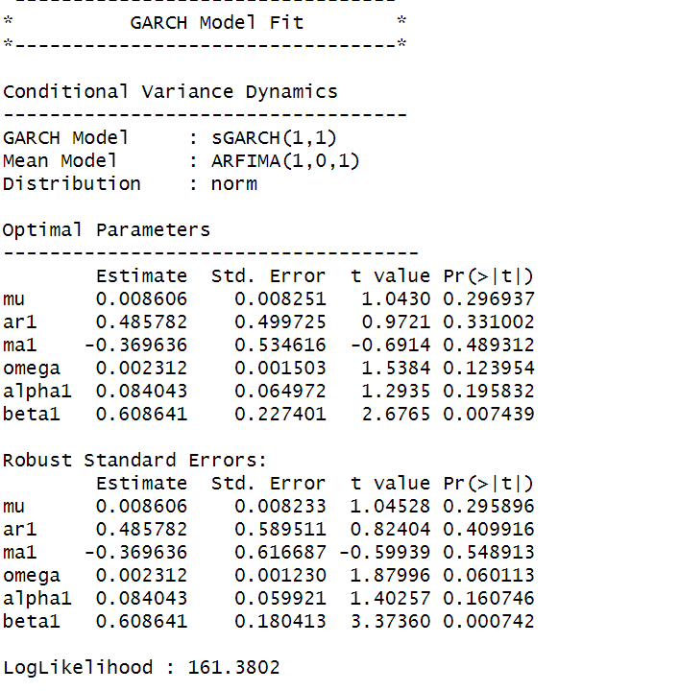

*Figure 240: GARCH Model Fitting for Weekly Returns*

### **18.3.1 Interpretation**

• The Log Likelihood obtained from the model is 161.3802.

• GARCH(1,1) is the best fit model for VISAKAIND weekly returns.

• The optimal parameters alpha and beta have significant value while omega is insignificant.

• The Alpha, Omega and Beta obtained from estimated robust standard error shows that omega and alpha are insignificant because p-value is greater than 0.05.

• This model provides the best fit with the fewest parameters because its AIC and BIC values are the lowest of all potential models.

• The p-value for both Standardized Residuals and Squared Residuals are greater than 0.05 which means null hypothesis will be accepted i.e., there is no serial correlation which is good for the model.

• Adjusted Pearson Goodness of Fit Test gave all the p-values greater than 0.05 which implies that null hypothesis can’t be rejected which means there is no significant difference between observed value and expected value.

**18.3.2** **Forecast using GARCH**

The forecasted results using GARCH model are shown in Figure 241. The results show that the returns will be positive for the next 10 days with a value of around 0.8591% having a standard deviation close to 8.657%. Positive return means that VISAKAIND stock price will rise in the next 10 days which is same as what was suggested by ARIMA model.

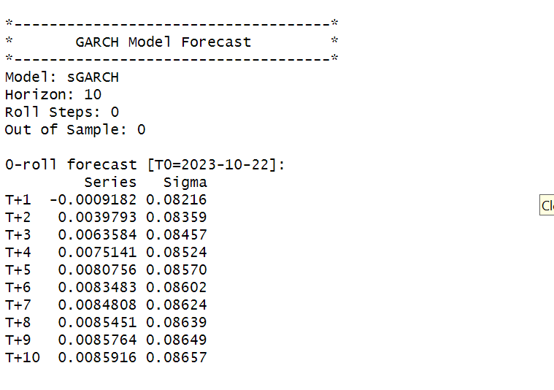

*Figure 241: GARCH Model Prediction for Weekly Return*

**SECTION 19: VISAKAIND (Monthly Returns)**

Figure 243 shows the monthly returns of the VISAKAIND stock price from 2nd November 2020 to 25th October 2023, and the CLOSING prices were used to calculate the returns, which are shown in Figure 242.

*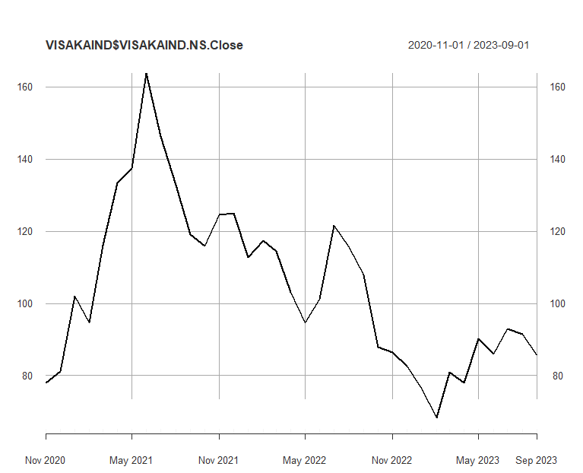 Figure 242: Monthly Prices of VISAKAIND*

*Figure 243:Monthly Returns of VISAKAIND*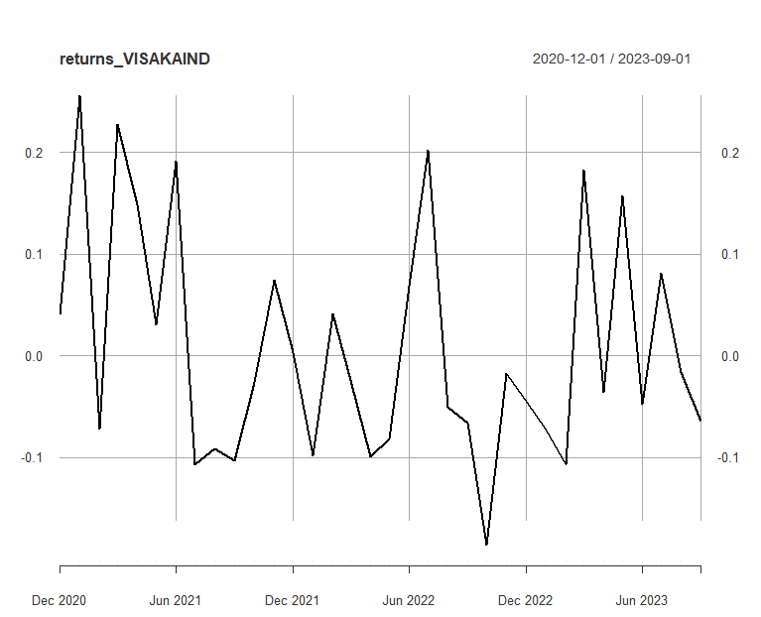

Next, the excess returns, denoted as E(R) - R_f, are subjected to regression against the market risk premium R_m - R_f. The outcomes of this regression are illustrated in Figure 244

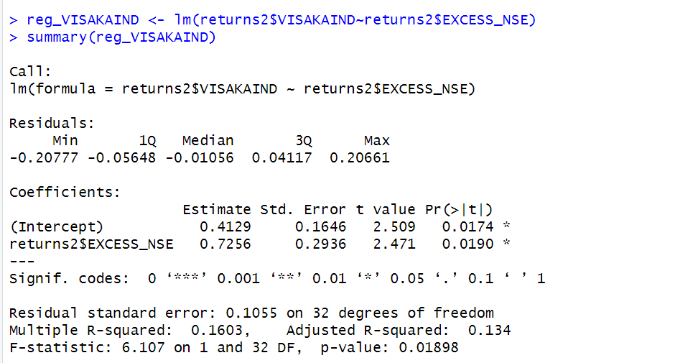

*Figure 244: Regression results of CAPM for Monthly Returns*

**19.1.1 CAPM Model - Interpretation of Results**

Figure shows that the Beta for monthly returns (risk unadjusted) is 0.7256, which means that if the market index portfolio’s daily returns rise by 1%, then the monthly returns of VISAKAIND will increase by 0.7256%.The intercept value derived from the regression is 0.4129, but it is also not statistically significant. Therefore, it may be appropriate to ignore or treat it as 0%, which means that if the market return is 0%, then VISAKAIND will show a 0.7256% return.

## **19.2** **Estimating AR and MA coefficients using ARIMA**

The AR and MA coefficients are obtained using the ACF (Auto-correlation function) and PACF (Partial Auto-correlation function) plots. From Figure 242 it can be seen that stock price data is non-stationary while from Figure 243 we can interpret that the returns of the stock seems to be stationary of integrated or order 1 which means first difference is stationary.

**19.2.1 Augmented Dickey-Fuller Test**

An augmented Dickey-Fuller (ADF) test is performed to check for stationarity, whose results are in Figure 245.

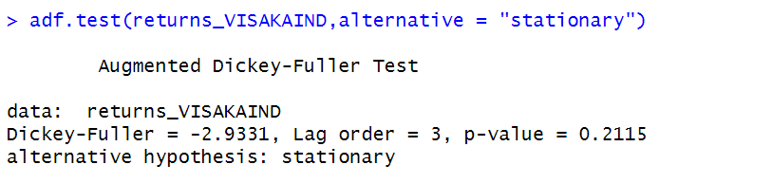 *Figure 246: ADF Test Results for Monthly Returns*

The Augmented Dickey-Fuller test null hypothesis states that a unit root exists, i.e. the series is not-stationary, and the corresponding alternative hypothesis is that the series is stationary. Since the p-value of the test shown above is 0.01, the null hypothesis can be rejected; thus, the series is stationary.The value of ADF Test-statistic: -2.9331.

**19.2.2 ACF Plot**

The sample Autocorrelation function (ACF) plot is used measure the correlation between the present and the lagged values in the series. Lagged values means the past values of the series. Figure 247 shows the formula for calculating ACF at lag k:



*Figure 247: ACF Formula*

The results for of ACF plot for VISAKAIND are depicted in Figure 248:

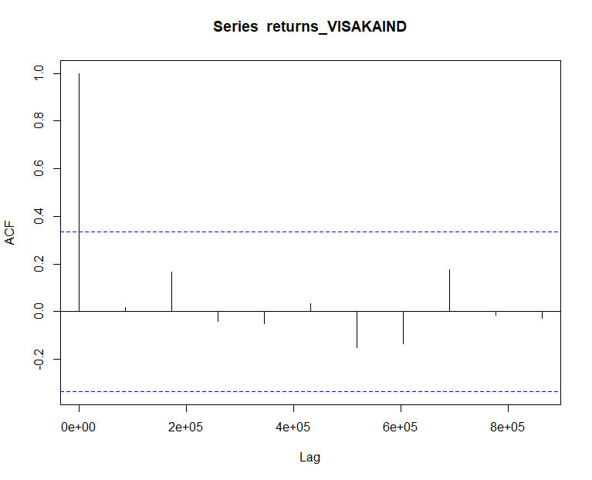 *Figure 248: ACF Plot VISAKAIND for MonthlyReturns*

From the above plot it can derived that the series is MA(0) model since no lag term except the 0th lag is significant,following values are not significant.

**19.2.3 PACF Plot**

It measures the correlation between an observation k periods ago and the current observation after controlling the observations at intermediate lags i.e., all the lags which are less than k. PACF plots are used to differentiate between AR & ARMA process. Figure 249 shows the formula for calculating PACF:

*Figure 249: PACF Formula*

The results of PACF plot for VISAKAIND are depicted in Figure 250:

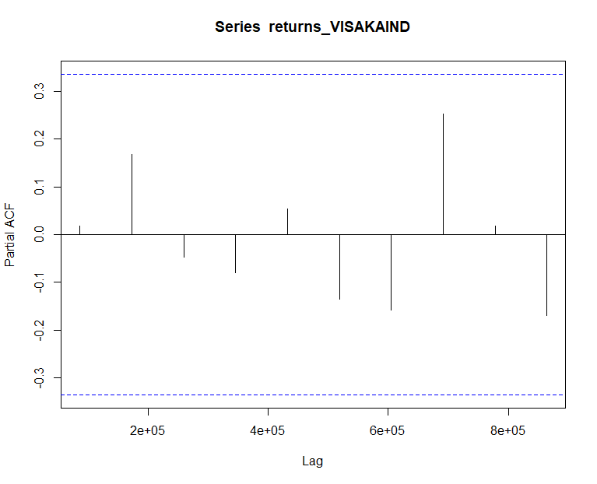 *Figure 250: PACF Plot VISAKAIND for Monthly Return*

From the above plot it can derived that the series is AR(0) model since only no lag is significant.

**19.2.4 Identification and interpretation of ARIMA model:**

The diagnostic test of the model is shown in Figure.

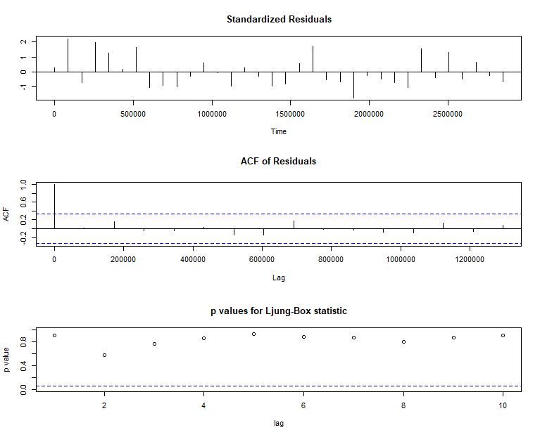 *Figure 251: Diagnostic Results for Monthly Returns*

Ljung-Box Test is used for testing the distribution of residuals. Its null hypothesis is that the residuals are independently distributed while alternative hypothesis states that residuals are not independently residuals. From Figure 251(Chart 3) it can be seen that almost all p-values are greater than 0.05 which means that we can’t reject the null hypothesis i.e., residuals are distributed independently. The normalised residuals time series plot looks to be random and does not show a strong trend, therefore it fits the data well. Also, the Residual autocorrelations are all zero except for one spike.

### **19.2.5** **FORECAST WITH ARIMA MODEL**

Using the ARIMA (0,0,0) model the forecast results have been calculated are shown in Figure 252:

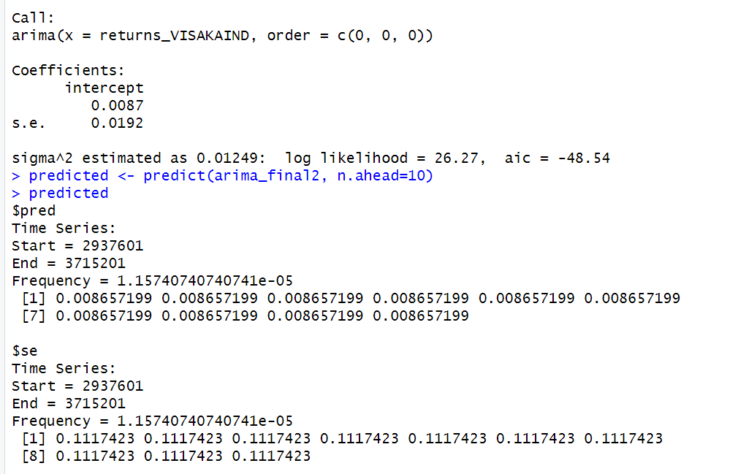 *Figure 252: Forecast for Monthly Returns*

Since all the forecasts for returns are positive, the stock price will increase in the future weeks.

**19.3 GARCH and EGARCH models**

GARCH, or Generalised Autoregressive Conditional Heteroskedasticity, is a method for estimating market volatility while EGARCH (Exponential General Autoregressive Conditional Heteroskedasticity) is also a model for estimating market volatility but with less constraints on the parameters. GARCH (1,1) is the most popular GARCH model. Running GARCH on monthly return of VISAKAIND yielded the result that are shown in Figure 253: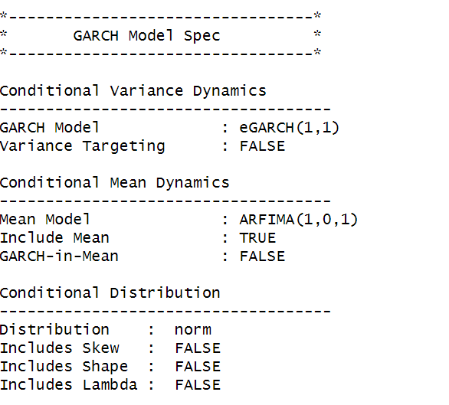

From the Figure 253. we can clearly see that GARCH (1,1) is the most appropriate model and by default, the mean model ARFIMA(1,0,1) is taken.

Now the monthly returns of VISAKAIND were run against EGRACH model and the following results were obtained:



*Figure 254: EGARCH Model for Monthly Returns*

From Figure 254, we can see that EGARCH (1,1) model is obtained and again by default ARFIMA (1,0,1) is taken. The results are similar to that of GARCH model.

After creating both GARCH and EGARCH models now we fit the model using

ugarchfit function which yielded the results that are shown in Figure 255. The interpretation of the results are given after Figure 255.

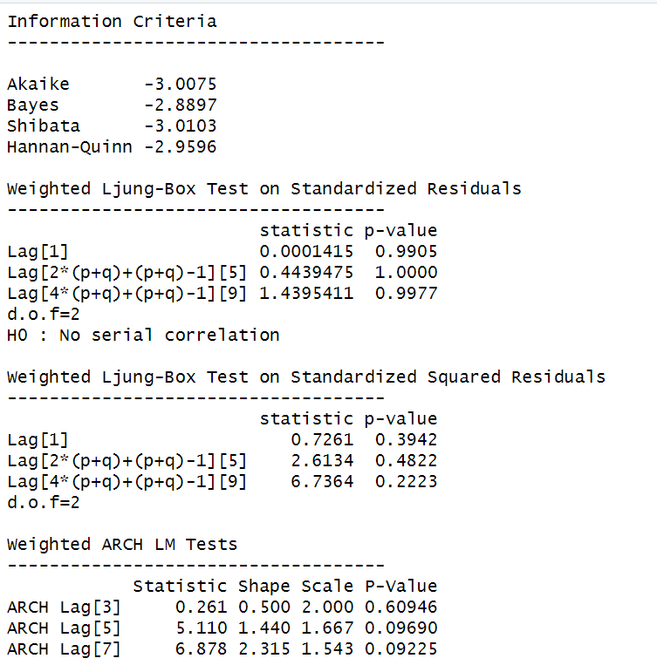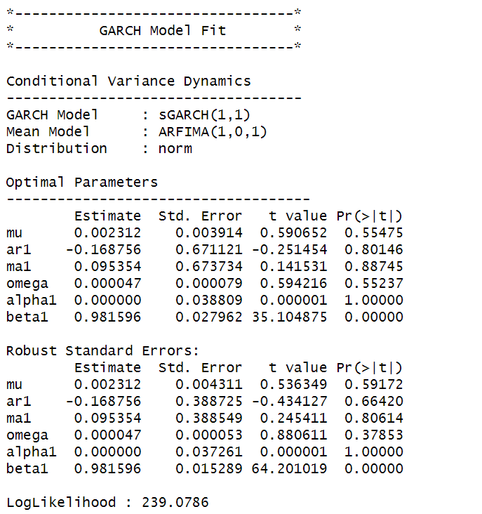

*Figure 256: GARCH Model Fitting for Monthly Returns*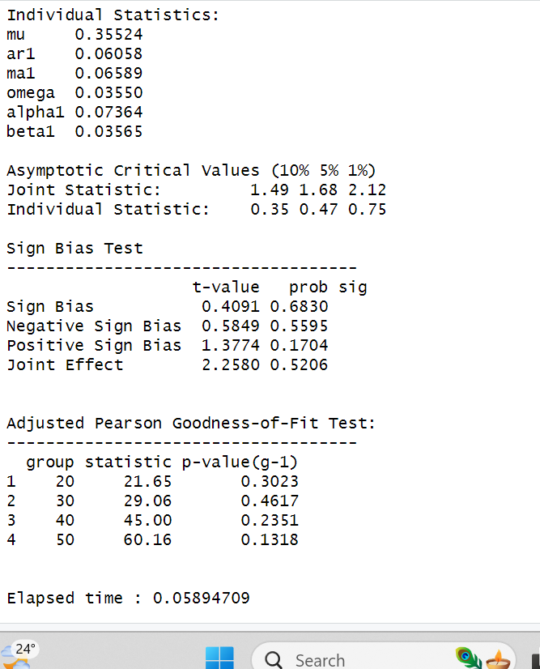

**19.3.1 Interpretation**

• The Log Likelihood obtained from the model is 239.07.

• GARCH(1,1) is the best fit model for VISAKAIND monthly returns.

• The optimal parameters alpha and beta have significant value while omega is insignificant.

• The Alpha, Omega and Beta obtained from estimated robust standard error shows that omega and alpha are insignificant because p-value is greater than 0.05.

• This model provides the best fit with the fewest parameters because its AIC and BIC values are the lowest of all potential models.

• The p-value for both Standardized Residuals and Squared Residuals are greater than 0.05 which means null hypothesis will be accepted i.e., there is no serial correlation which is good for the model.

• Adjusted Pearson Goodness of Fit Test gave all the p-values greater than 0.05 which implies that null hypothesis can’t be rejected which means there is no significant difference between observed value and expected value.

### **19.3.2** **Forecast using GARCH**

The forecasted results using GARCH model are shown in Figure 257. The results show that the returns will be positive for the next 10 days with a value of around .2312% having a standard deviation close to 5.064%. Positive return means that VISAKAIND stock price will rise in the next 10 days which is same as what was suggested by ARIMA model.

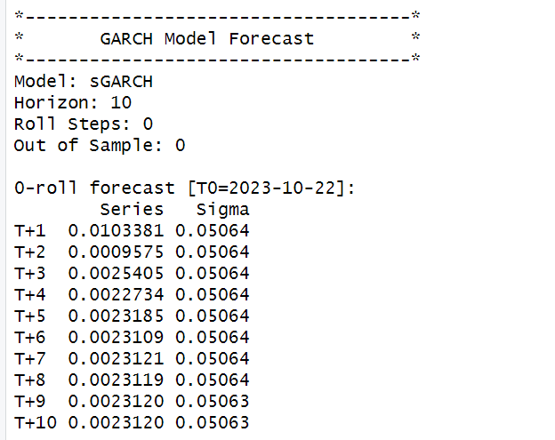

*Figure 257: GARCH Model Prediction for Monthly Return*

**SECTION 20 :VALUE AT RISK(VaR)**

Value at Risk (VaR) is used to quantify the extent of a financial risk/loss with a certain probability for a given portfolio over a specific period of time.

PORTFOLIO:

| **STOCKS** | **QUANTITY** |
| --- | --- |
| SAKSOFT | 250 |
| SHOPERSTOP | 100 |
| STEELXIND | 150 |
| TCS | 200 |
| TVSSRICHAK | 300 |
| VISAKAIND | 350 |

Confidence interval under observation - More than 75%.

These values were inputted into a Python code for analysis during the study period from November 2, 2020, to October 25, 2023.

To find the value at risk for our portfolio, first, the total money invested is calculated by multiplying the number of shares with the prices of the stocks respectively for both firms, then the VaR is applied, which calculates the maximum potential loss with different confidence intervals.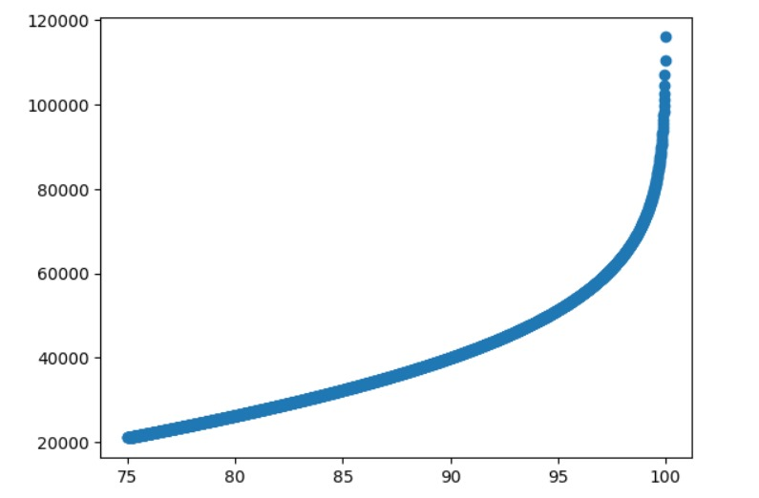

INTERPRETATION:

The graph in Figure 85 illustrates the different values at risk with respective confidence intervals. For instance, a maximum of 20,000 Rs can be lost with confidence of around 75%.

**SECTION 21: CONCLUSIONS**

1. Beta Analysis:

* The beta calculated by regressing excess stock returns on excess market returns on various frequencies for all of the above mentioned companies namely SAKSOFT, SHOPERSTOP, TCS, STEELXIND, TVSSRICHAK and VISAKAIND gave results with values less than 1. The beta values indicate the stock's sensitivity to market movements. A beta less than 1 suggests that the stock is less volatile than the market.

1. ARIMA Modelling:

* Based on the above mentioned results, we can infer that ARIMA (0, 0, 0) was found to be the best model for daily, weekly and monthly returns for SAKSOFT, SHOPERSTOP, TCS, STEELXIND, TVSSRICHAK and VISAKAIND.

1. GARCH Modelling:

* Utilizing the GARCH(1,1) model across all frequencies provided robust predictions for predicting conditional volatility and it was used to project volatility over the next 10 time periods. . The GARCH (1,1) model suggests that the stock exhibits volatility persistence, meaning past volatility affects future volatility.

1. Serial Correlation Analysis:

* The p-values for both Standardized Residuals and Squared Residuals were well above 0.05 for all frequencies which implies no serial correlation in all the 3 models.

From the above findings, I recommend a long-term investment strategy for this diversified portfolio. Both GARCH and ARIMA models predict positive returns for future time periods. Therefore ,this portfolio is well-suited for investors who have a long-term perspective.

**SECTION 22: REFERENCES**

1. [https://in.finance.yahoo.co](https://in.finance.yahoo.com/)m
2. [https://www.saksoft.com](https://www.saksoft.com/)
3. <https://www.tcs.com/>
4. <https://www.moneycontrol.com/india/stockpricequote/tyres/tvssrichakra/TVS03>
5. <https://www.moneycontrol.com/india/stockpricequote/cement-productsbuilding-materials/visakaindustries/VI11>
6. <https://www.screener.in/>
7. <https://en.wikipedia.org/wiki/Shoppers_Stop>
8. https://www.businesstoday.in/stocks/steel-exchange-india-ltd-steelxind-share-price-363731